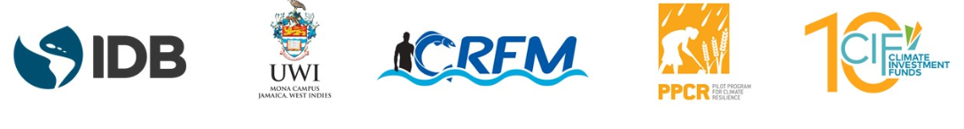
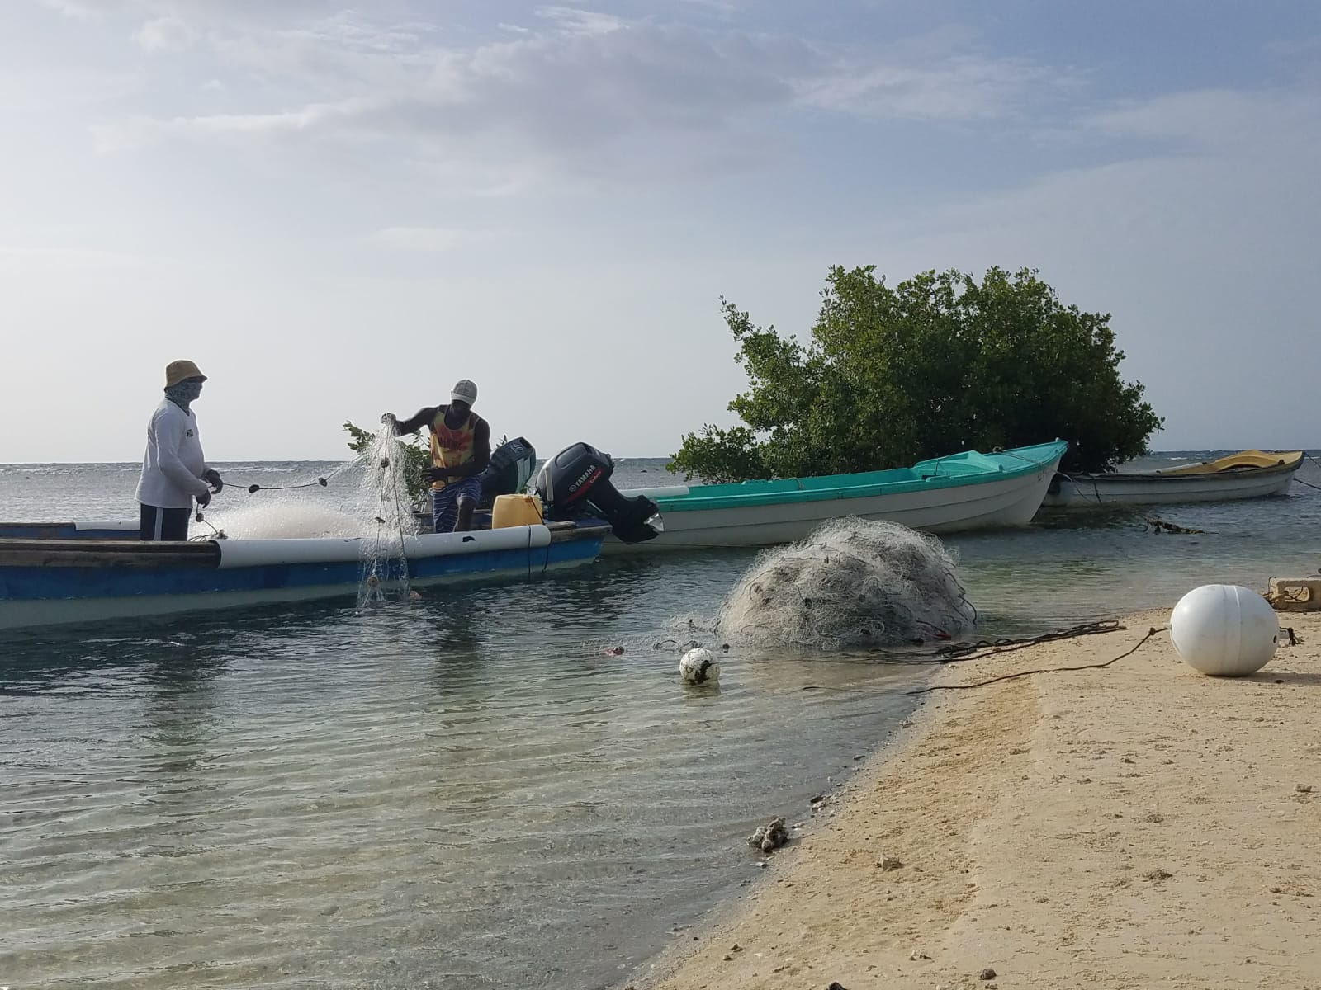

Fishery-Related Ecological and Socio-Economic Impact Assessments and Monitoring System
Work Package 3: Knowledge-Attitudes-Practice Study
Contract No.:CF13/C4.02-1

 |  | Fishery-Related Ecological and Socio-Economic Impact Assessments and Monitoring System
Prepared for:  The University of the West Indies, Mona, and the Caribbean Regional Fisheries Mechanism |  | Work Package 3: Facilitating Stakeholder Access and Contribution to the Information Base for Climate Change Adaptation and Disaster Risk Management in Fisheries  Knowledge-Attitudes-Practice Study  November 2018; Revised January 2019; Revised February 2019; Finalized March 2019

Contact:

Ms. Jimena Eyzaguirre, International Team Director, ESSA Technologies Ltd.

jeyzaguirre@essa.com
+1.613.798.1300 x 3 |  | Suggested citation:  Eyzaguirre, J., Campbell, D. and Gardiner, A-G. (2019). Toward Climate-Smart Practices across the Fish Value Chain - Knowledge-Attitudes-Practice Study, February 2019.
 |  | Cover Photo: A. Khan, Fish Landing Site in Montego Bay, Jamaica, 2018
© 2019 ESSA Technologies Ltd.  No part of this document may be reproduced, stored in a retrieval system, or transmitted, in any form or by any means, electronic, mechanical, photocopying, recording, or otherwise, without prior written permission from the authors. | ESSA Technologies Ltd.  Vancouver, BC Canada V6H 3H4  www.essa.com

Table of Contents
Abstract 4
1. About this study 5
1.1 Study objectives 5
1.2 Target audiences and research approaches 5
2. Methods 7
2.1 Research design and data collection 7
2.2 Data processing and analysis 9
2.3 Limitations and challenges 16
3. Respondent profiles 18
3.1 Fisherfolk 18
3.2 Managers 26
3.3 Policy Actors 28
4. Climate change results 29
4.1 Fisherfolk 29
4.2 Managers 47
4.3 Policy Actors 56
5. Key Findings, Conclusions and Recommendations 61
References 68
Annex 1: Agenda for training of field assessors 69
Annex 2: Data collection instruments 70
Annex 3: Additional information on fisherfolk activities 71

Abstract
This Knowledge, Attitudes and Practice Study (KAP Study) is a first output of Work Package 3 (WP3) of the Fishery-Related Ecological and Socio-Economic Impact Assessments and Monitoring System project (the Project), funded under the Caribbean track of the Pilot Program on Climate Resilience (PPCR). The main purpose of the KAP Study was to measure knowledge levels, prevailing attitudes and behavioural practices relating to adaptation to climate change and disaster risk reduction among a sample of the audiences the Project plans to target for communications activities. These audiences are fisherfolk, policy actors and other sectoral representatives that routinely interface with fisherfolk across the six countries with national PPCR initiatives.
Although guided by common areas of inquiry, the KAP Study employed different approaches to reach the three audiences, with data collection taking place from June to September 2018. The primary focus of the study and related level of effort of the team was on deploying and analyzing results from 161 questionnaires directly administered to fisherfolk by trained assessors in three fishing communities: Montego Bay (Jamaica), Kingstown (St. Vincent and the Grenadines) and Roseau (Dominica). This target group was dominated by mature fishermen with some basic level of education. The Roseau (Dominica) subset was different from Montego Bay (Jamaica) and Kingstown (St Vincent and the Grenadines) subsets in that the fishing population skewed slightly younger and more educated. Secondary investigations of the KAP Study included completion of in-depth interviews with senior-level fisheries authorities in government and a self-administered online questionnaire completed or partially completed by 28 sectoral representatives in managerial-level roles.
This report presents information on respondent profiles and on results related to (1) knowledge of climate change –its definition, causes, impacts and vulnerable groups; (2) attitudes on climate change as a salient issue, roles and responsibilities to address it and on satisfaction with current action; and (3) use of information and other measures to adapt to climate hazards. The KAP Study also draws together perspectives on perceived risk from climate change impacts, feasibility and importance of a range of adaptation measures and preferred communication formats and media to reach fisherfolk for climate change communications. The KAP Study ends with a discussion on key findings, conclusions and high-level recommendations to inform the Project’s communication activities.

About this study
Work Package 3 (WP3) of the Fishery-Related Ecological and Socio-Economic Impact Assessments and Monitoring System project focuses on the development of and reporting on a dynamic communications and stakeholder engagement strategy to deliver practical information on how climate change is affecting the Caribbean fisheries sector, in a manner that engages and mobilizes the diverse target populations toward strategic action. The Knowledge-Attitudes-Practice Study (KAP Study) represents the first step in the project’s strategic communication and engagement process and was designed to capture fisheries stakeholders’ knowledge and understanding of climate change, including its main causes and how it is impacting their livelihoods and the sector in general. This baseline assessment also gauges perceptions and attitudes toward climate change, including concern about observed changes, perceptions on differential vulnerabilities among value chain actors and the importance and perceived feasibility of various actions that can be taken to address climate change and variability in the fisheries sector. Additionally, it sheds light on barriers to climate change adaptation and disaster risk reduction, and on media use, prominence and effective ways to reach communities with key messages.
Results summarized in this KAP Study have informed the project’s Stakeholder Engagement and Communications Strategy and Action Plan (SECSAP) and will continue to inform project activities across the four Work Packages in all six countries with Pilot Programme on Climate Resilience (PPCR) initiatives.

Study objectives
The broad objective of the KAP Study is to measure knowledge levels, prevailing attitudes and behavioural practices relating to adaptation to climate change and disaster risk reduction (1) among fisherfolk (harvesters) in three coastal-fishing areas in Jamaica, St. Vincent and the Grenadines and Dominica; (2) among policy actors in the six PPCR countries; and (3) among sectoral representatives (government, NGO and private-sector stakeholders) in the six PPCR communities.
Specifically, the KAP Study sought to measure:
- Current levels of knowledge, attitudes, and practices of target audiences with respect to fisheries, climate change adaptation and disaster risk reduction;
- Stakeholders perceptions on the relevance and feasibility of a range of options to reduce climate change impacts in the fisheries sector (e.g., conservation and marine spatial planning, diversification of livelihoods / markets / products, optimizing fishing effort);
- Stakeholder perceptions on challenges in addressing climate change issues related to fisheries;
- The means of communication and engagement (e.g., media, artistic expression) suitable for promoting climate-smart fisheries management for enhanced community resilience.

Target audiences and research approaches
In developing KAP studies key decisions include who to target for information gathering and how. The report stemming from the Regional Planning Workshop held in Kingstown in April 2018 identified the target audiences for inclusion in the KAP Study. Members of the project Working Group approved the following groups on which to centre the KAP Study and stakeholder engagement and communications activities overall (Table 1). For each target audience we determined the most effective and cost-efficient way to approach information gathering for the KAP Study. Approaches included face-to-face deployment of structured questionnaires, key-informant interviews (KIIs) via Skype and deployment of an online survey; we collected quantitative, semi-quantitative and qualitative data. Further detail on our methods appears in Section 2.
Fisherfolk are a critical link in the fish value chain and their activities are most sensitive to climate change impacts and disaster risks. Therefore, we focused our effort and budget on ensuring the voices of fisherfolk were sufficiently represented in the KAP Study. Primary data collection in fishing communities across the 6 PPCR countries was not possible due to budget constraints. Instead we focused these efforts on the 3 pilot study sites identified and approved by the Client Task Team and the project Working Group in June 2018. These sites are: Montego Bay, Kingstown and Roseau.
Table 1: Groups we targeted through this KAP Study and approaches we used to gather information from them
Target group | Approach
Fisherfolk – harvesters, vendors, ensuring good levels of youth representation | - Questionnaire administered to 40 fisherfolk in Montego Bay (Jamaica), 60 fisherfolk in Kingstown (St. Vincent and the Grenadines) and 61 fisherfolk in and around Roseau (Dominica). Two strategies were used to sample fishers (total population sampling and maximum variance sampling).  - The budgeted sample size was 150 respondents, distributed equally among the 3 fishing sites. Recruiting respondents in Montego Bay proved challenging relative to the other 2 sites. The final sample of respondents was 161, with 10 less than the target 50 for Montego Bay and 10 and 11 more for Kingstown and Roseau, respectively.
Policy actors – the CRFM Ministerial Council and Caribbean Fisheries Forum | - Key informant interviews (KII) administered over Skype or the telephone with 4 Chief Fisheries Officers (Grenada, Jamaica, Saint Lucia and St. Vincent and the Grenadines).  - We submitted interview requests to all members of the CRFM Ministerial Council and the Caribbean Fisheries Forum representing the 6 PPCR countries, but secured interviews with 4 out of the 12.
Other sector representatives – technocrats, industry, NGOs | - Online survey sent to representatives of PPCR countries and the CRFM (total 13) during the project’s Regional Planning Workshop in April 2018.  - Online survey sent to a purposeful sample (Palinkas et al. 2015) of 99 managers and operators in the fisheries sector, representing government, self-employed individuals and non-governmental organizations (NGOs).  - We achieved a low response rate (24%, 27 of 112), unfortunately, despite great care in designing the survey to minimize respondent burden and repeated reminders. Others have faced similar challenges in deploying KAP surveys on climate change online (Belize Environmental Technologies nd).
The structure of the rest of this report is as follows. Section 2 describes the methods we applied in this study, including design considerations and data-collection instruments. Section 3 characterizes the respondent profiles. Section 4 focuses on results and analysis. The report concludes in Section 5 main findings, conclusions and recommendations.

Methods
This section summarizes our study methods. It describes the research design, including discussions on sampling, data collection and analytical aspects of quantitative and qualitative components of the study. It also outlines limitations and challenges in executing the research and related implications on the interpretation of results.

Research design and data collection
We employed a mixed-methods approach to meet the research objectives and tailor data-collection methods to target audiences (fisherfolk, policy actors and managers in the sector). This combination of methods gave the insights necessary to develop a robust stakeholder engagement and communication strategy for the project, while providing for a research plan that was feasible and cost-efficient. Our methodology involved the following:
- A fisherfolk questionnaire to capture quantitative baseline data concerning (1) knowledge of climate change (definition, cause, impacts), attitudes and practice around climate change adaptation and disaster risk reduction (DRR); (2) local observations on climate impacts and perspectives on the feasibility of options to adapt; (3) day-to-day fishing activities; and (4) media use and communications preferences.
- An online survey targeting managers (government, NGO and private) in the sector, to capture quantitative baseline data (1) on climate change knowledge, attitudes and practices related to adaptation and (2) on perspectives on the feasibility and importance of a range of options to reduce climate change impacts in the fisheries sector.
- Semi-structured interviews targeting the CRFM Ministerial Council and Caribbean Fisheries Forum (“policy actors”) to learn about the knowledge, attitudes and practices around climate change, impacts on the sector, perceived urgency and challenges in responding to the changes to marine environments, the fishing industry and those who depend on it.
Fisherfolk are a key audience for outreach through project communications and engagement activities – either directly through our own efforts or indirectly via use of “amplifiers”. Therefore, our level of effort and resourcing focused on this group. Results from the managers’ survey and interviews with policy actors complement findings from the quantitative survey with fisherfolk.
The rest of the section provides information on sampling and data collection instruments used for the research.

Sampling strategy
Fisherfolk
A KAP questionnaire was administered to fisherfolk in three fishing areas (Montego Bay, Jamaica; Kingstown, St. Vincent and the Grenadines; and Roseau, Dominica) by locally-based assessors at each site. The Social Science & Fisheries Extension Expert on the project team, Dr. Donovan Campbell, recruited two assessors from Fisheries Divisions or Universities in Jamaica, St. Vincent and the Grenadines and Dominica, respectively, and trained each group of assessors in the conduct of the questionnaire. We undertook three training sessions with field assessors on June 25, 2018 (Montego Bay), August 25, 2018 (Roseau) and September 1, 2018 (Kingstown). These sessions lasted about two hours each and covered the following topics: research objectives, the role of the field assessor, ethics and good practice in conducting interviews (see Annex 1: Agenda for training of field assessors). Training sessions also included role-playing exercises so field assessors could become familiar with the questionnaire instrument and receive critical feedback on their approach.
By necessity, the sampling strategy paid particular attention to four key principles that govern all forms of sampling (Kemper et al., 2003): feasibility, efficiency, possibility of drawing inferences from the data and transferability to other settings. Budget considerations limited the total number of questionnaires to be completed to 150. Within the project framework we had already selected “pilot study sites” for the exact purpose of primary data collection at the site level, among other purposes. Therefore, we focused data collection efforts at the three pilot study sites and undertook to recruit 50 fishers at each site using a purposive sampling approach guided by two associated strategies (1) total population sampling and (2) maximum variance sampling. In Montego Bay and Roseau we applied the former and in Kingstown the latter. The samples for Montego Bay and Roseau, therefore, reflect all the fishers that were available and willing to participate in the survey. In Kingstown, the number of fishers significantly exceeded resources to conduct the survey. We therefore sought to capture a cross-section of the active fishers in the area with a focus on variations according to age, fishing techniques, fishing status, location and target species. This amounted to an overall response rate of 107%, although we came in under our target for Montego Bay and over for the other two sites.
Managers
Although fisherfolk were the main focus of primary data collection and research activities, we also deployed a self-administered survey for completion online by government, NGO and private-sector stakeholders with a role in fisheries management and related sectors (tourism, disaster risk management, coastal zone management). We employed a stratified purposeful sample, attempting to capture differences in knowledge, attitudes, practices and perspectives between government / NGO and private-sector stakeholders. Based on extensive desk-based research, we compiled two contact lists – one per manager grouping – and distributed the online survey via email, for completion between September 11 and October 5, 2018. We sent 99 invitations to complete the online survey (68 government / NGO; 31 private sector) and received 18 completed and partially-completed surveys. To these responses we added the 8 collected through on online survey completed by fisheries liaison officers and other representatives at the project’s Regional Planning Workshop in April 2018 (8 completed responses out of 13 sent). The full response rate was 24% (28 out of 112).
Policy actors
We conducted semi-structured interviews with members of the CRFM Ministerial Council and Caribbean Fisheries Forum representing PPCR countries. Our target was the full complement of 12 representatives (6 Ministers and 6 Chief Fisheries Officers) and, with the CRFM Secretariat’s support, a request for participation went out on September 9, 2018, for interview completion within the following 10 days. We sent interview themes to confirmed interviewees via email. The Communications Expert on the project team, Ms. Ava-Gail Gardener, completed 4 in-depth interviews with Chief Fisheries officers and Directors of Fisheries from Grenada, Jamaica, St. Lucia, and St. Vincent and the Grenadines over Skype or telephone. Therefore, we achieved a response rate of 33% and obtained input from 4 of the 6 PPCR countries.

Data collection instruments
We prepared a series of data collection instruments tailored to the three target groups. Copies of these instruments are in Annex 2: Data collection instruments.
Despite differences in organization, number of questions, phrasing and response options, we designed these instruments to facilitate comparative analysis. Importantly, all data collection instruments included the following questions (Table 2):
- Please explain what you understand by the term climate change?
- What do you think are the main causes of climate change?
- How concerned are you about the impacts climate change?
- On a scale of 1 to 5, how much would you say the following [climate hazards] have negatively affected your country’s fishing area / the fisheries sector in the country / countries where you work?
- Which group(s) of fishers would you describe as being most vulnerable to the impacts of climate change in your community?
- How satisfied are you with the steps being taken to address climate change impacts on the fisheries sector?
- Who is responsible for taking action to address climate change impacts on the fisheries sector?
- What are some of the things you think fishers can do to reduce the impacts of climate change on your community?
- What do you think are the best ways to provide information about climate change to fishers?
Table 2: Common questions across data-collection instruments

Data processing and analysis
Fisherfolk
Upon completion of data collection using paper questionnaires in the field, the team performed sequential data entry of the 40, 60, and 61 questionnaires (100+ variables / questionnaire) in SPSS as well as checks for data quality (e.g., reviewing raw data when SPSS entries looked anomalous) and then exported to Excel to allow for coding of open-ended responses and data analysis by other team members. We used a consolidated dataset integrating all 161 responses to (1) provide summary statistics on demographics, local observations on climate impacts and perspectives on the feasibility of options to adapt, day-to-day fishing activities and media use and communications preferences and (2) estimate knowledge, attitude and practice scores and levels. We conducted data analysis using frequency tables and measures of association (Chi-square tests) for categorical data and correlation for interval data. Socio-demographic variables included for analysis were: age, education, registration status, employment status and length of time involved in fishing. Only 3 of 161 respondents were female, so gender-based analysis was not possible. Statistics on the relative participation of women and men in fisheries activities across the value chain in the Caribbean are scarce. Yet, anecdotal information and some studies suggest that fishing activity continues to be male-dominated, with low levels of participation of women in harvesting relative to women’s important roles as input suppliers and in post-harvest activities, marketers and processors (CRFM, 2012; Beltran, 2017).
We estimated KAP scores guided by the approach outlined in the Knowledge, Attitude and Practice Survey Consultancy for the Belize Marine Conservation and Climate Adaptation Project (BET, nd), with some modifications. Table 3 outlines the indicators and related survey elements used to estimate knowledge, attitude and practice scores. The table also highlights the key assumptions and limitations in measuring each indicator. Figure 1 is a conceptual diagram showing the hierarchical relationship between assessment areas (e.g., knowledge), indicators and survey elements.

Area / indicators | Survey elements (and points allocated for responses) | Assumptions and limitations
Knowledge
Climate change knowledge | Assessed understanding of climate change based on definition provided by respondent (2=yes, 1=somewhat, 0=no / don’t know)
 | Open ended question on causes of climate change (2=relevant response; 1=relevant aspects; 0=irrelevant / highly inaccurate)
Knowledge of climate change impacts & responses | Open-ended question on environmental condition to use as example to explain climate change to peer (2=example that connects relevant physical change to biological / socio-economic impact, 1=somewhat relevant example; 0 for inaccurate example or examples of non-climate stressors) | Question not included in questionnaire used in Eastern Caribbean
 | Awareness of gender-differentiated impact (2= yes, climate change affects women and men differently, 0= no or don’t know)
 | Open-ended question on things fishers can do to reduce climate change impacts / hurricane impacts (2= relevant, specific action; 1= vague or general actions; 0= nothing / don’t know / inaccurate)
Awareness of current action | Open-ended question on programs or projects the government is undertaking to improve the livelihood of fishers (2=specific example; 1=generic; 0=nothing / don’t know / not relevant)
Attitudes
On urgency & importance (of addressing climate change) | Whether climate change is selected as among the most serious problems facing fisheries (1=selected; 0=not selected)
 | Stated level of concern about the impacts of climate change (2=very concerned; 1=somewhat; 0=unconcerned)
On roles & responsibilities | Stated level of responsibility to address climate change impacts assigned to range of stakeholder groups (maximum points for indicating all groups have major responsibility)
On ability to act / be protected | Stated level of satisfaction with the steps being taken to address climate change impacts in the fisheries sector (2=Satisfied or neutral; 1=dissatisfied; 0=very dissatisfied / don’t know) | Low levels of satisfaction could reflect a sophisticated understanding of the risks versus actions taken to address them or a “gut feeling”. Satisfaction indicates a feeling of sufficient action relative to the risk, but respondents could have varied appreciations of risk and actions.  The question focuses on how respondents feel about actions being taken.
 | Whether anyone reached out to help respondent after the recent storm hit (2=yes; 0=no) | Questions only pertain to questionnaire used in Eastern Caribbean.  The assumption is that assistance / social safety nets help people become whole again after an event like a hurricane
 | Ease of getting extra cash to pay for damages after a storm (2=very easy, easy; 1=neutral, difficult; 0=very difficult)
 | Ability to depend on close family/friends if respondent needs extra help after a storm (2=yes, 0=no)
Practice
On adaptation & disaster risk reduction | - Open-ended question on actions by the community to deal with climate change (2=specific, relevant action; 1=generic; 0=nothing / don’t know / not relevant)  - Open-ended question on actions taken by respondent upon finding out about imminent storm (2=specific, relevant action; 1=generic; 0=nothing / don’t know / not relevant) | Questionnaire for Montego Bay  Questionnaire for use in Eastern Caribbean
 | Whether respondent had an emergency kit and other protection supplies when the recent storm hit (2=yes; 0=no) | Questions only pertain to questionnaire used in Eastern Caribbean. Although Jamaica and Haiti have been adversely affected by hurricanes in the recent past (especially 2016’s Hurricane Matthew) this series of questions focused on the recent storms that affected the Eastern Caribbean. Stated levels of concern are indirect measures of practice since respondents were told to think about actions taken and outcomes related to the recent storms (2017 and 2018).
 | Whether the respondent had ever received training in how to manage disaster risk (2=yes; 0=no)
 | Whether the respondent has insurance to protect their home or property from damage (2=yes; 0=no)
 | Stated level of concern over current level of preparedness (2=very little, little, neutral; 0=concern, serious concern)
 | Stated level of concern over preparedness of neighbours (2=very little, little, neutral; 0=concern, serious concern)
On use of information | Stated interest in receiving more information about the impact of climate change on fisheries in respondent’s country/community (2=yes; 0=no, don’t know, no answer) | Assumes interest in receiving information would translate into actual uptake.
 | Information sources through which respondent found out about the recent storm (2=consulted at least three sources likely to carry official warnings; 1= consulted at least one source likely to carry official information + trusted, informal source; 0=one informal source, no sources, no answer) | Question only pertain to questionnaire used in Eastern Caribbean.  Internet and social media were included as response options. But these media could both transmit official information and misinformation.
Table 3: Indicators, survey elements and rules for assigning points used to estimate composite scores for climate change knowledge, attitudes and practices of fisherfolk
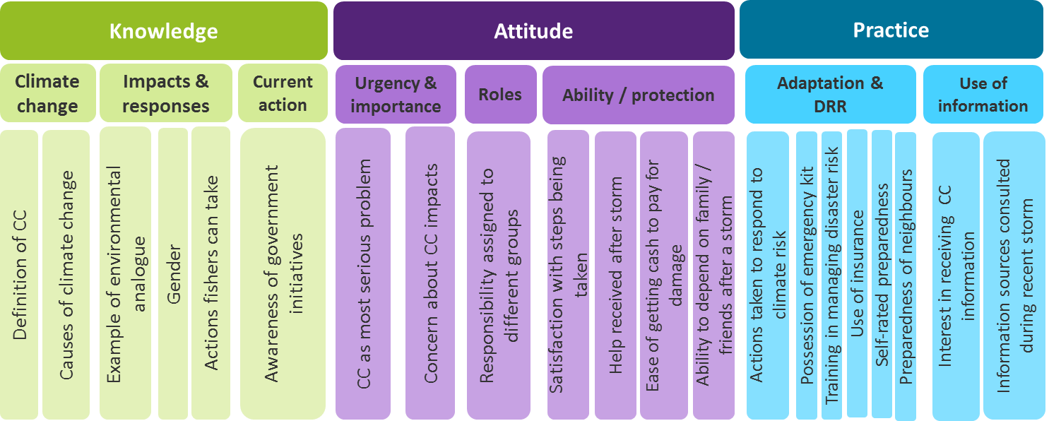
Area
Survey element
Indicator
Figure 1: Hierarchy of areas (e.g., knowledge), indicators (e.g., climate change) and survey elements (e.g., definition of climate change) used to estimate scores at the individual-respondent level, site level and across all three fishing sites

By allocating scores according to the point system outlined in Table 3, we estimated a composite knowledge score, attitude score and practice score for each respondent, expressed as a percentage. Figure 2 below is screenshot to illustrate how responses to survey elements are assigned points, summed for each indicator and expressed as a score in percentages by dividing assigned points by total possible points. In some cases total possible points vary by fishing site, mirroring the variation in survey questions explained in Table 3. Composite knowledge scores (%) per respondent are averages of underlying indicator scores. We treated blank responses in one of two ways. If all survey elements pertaining to indicators of knowledge, attitude or practice were blank for a given respondent we removed that respondent’s record (row) from the dataset. If some survey elements were complete we retained the respondent’s record and assigned the minimum points possible for blank survey elements. With this rule we assume that fisherfolk declined to answer questions if they did not know the answer or were not interested in the issue being discussed. Since field assessors were specifically trained to encourage fisherfolk to complete all questions in the questionnaire and to ensure fisherfolk understood what was being asked of them we consider it unlikely for non-responses to signify a lack of understanding of the question.
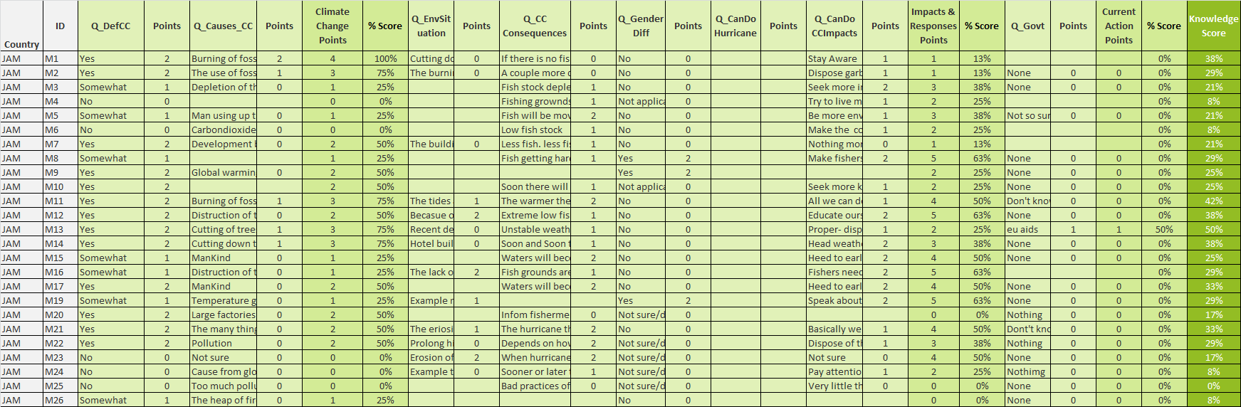
Figure 2: Screenshot of worksheet to calculate the composite knowledge score per respondent, as an average of three scores for each of the underlying indicators (climate change knowledge; impacts & responses; awareness of current action). Responses to each survey element are allocated points and then added. A percentage score for each indicator is then calculated by dividing the points allocated over total possible points.

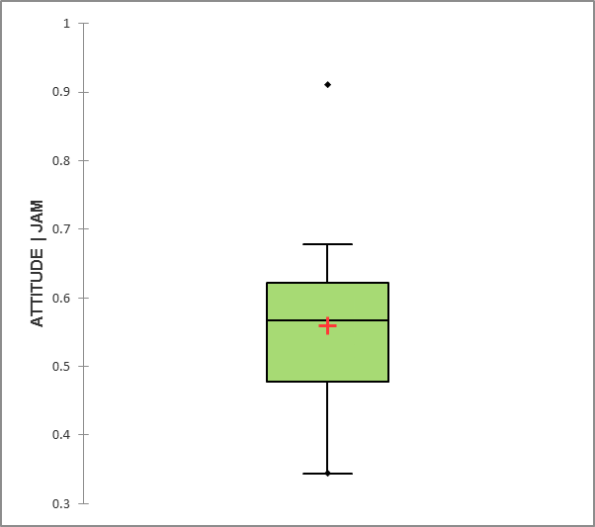
Outlier: More than 3/2 times of upper quartile
Maximum: greatest value, excluding outliers
Upper quartile: 25% of data greater than this value
Median: 50% of data greater than this value
Lower quartile: 25% of data less than this value
Minimum: least value, excluding outliers
Figure 3: Example of a box and whisker plot
We use descriptive statistics – box and whisker plots specifically – to characterize the set of Knowledge, Attitude and Practice scores across all fisherfolk and for fisherfolk from each fishing site. In the box plots used, the cross (+) represents the mean (average) value, and the line inside the box represents the median value (see Figure 3). The ends of the box represent the upper and lower quartiles. The ends of the box whiskers represent the minimum and maximum values, respectively, excluding outliers. Any point outside the whiskers can be considered an outlier (usually shown as a point). The spacing across quartiles is indicative of the spread and skewness of the data. The length of the box and whiskers is indicative of the spread in the data, so that a short plot indicates very little change or variability in the variable being shown.
Section 4 reports indicator scores pertaining to knowledge, attitudes and practice, per fishing site. It also reports median values of composite scores for the areas of knowledge, attitudes and practice, per fishing site. With this approach, comparisons can be drawn across target audiences (in this study) and over time if the same or a very similar survey instrument is used.
Managers
We exported online results from the SurveyMonkey platform to an Excel workbook. A majority of survey questions were close-ended (27 out of 32), requiring no to minimal transformation for analysis. For the few open-ended questions, we reviewed the content in detail and applied open coding first, developing a framework for each question iteratively and deductively.
Despite the low response rate for this stakeholder group, we estimated knowledge, attitude and practice (KAP) scores and statistics in case we could draw out any useful patterns and further questions to explore through other project activities. KAP scores and statistics for this dataset are only indicative. We applied a parallel approach to determining KAP scores for Managers as we did for fisherfolk, with some differences in underlying survey elements. Table 4 outlines the indicators and related online survey elements used to estimate knowledge, attitude and practice scores.
Area / indicators | Survey elements (points allocated for responses) | Assumptions and limitations
Knowledge
Climate change knowledge | Open ended question on the definition of climate change (2=reference to change in atmospheric variables and temporal aspect; 1=has accurate elements; 0=wrong or not relevant)
 | Causes of climate change (2=selects burning of fossil fuels, land clearing and industrial emissions; 1=selects one to two right options; 0=selects wrong answers, don’t know, no answer)
Knowledge of climate change impacts & responses | Open-ended question on consequences to the fisheries sector of climate change impacts (2=all three examples are accurate; 1=mentions 1 accurate example OR has a mistake among two to three examples; 0=all else)
 | Awareness of gender-differentiated impact (2= yes, climate change affects women and men differently, 0= no or don’t know)
 | Open-ended question on climate-change related messages to highlight to small-scale fishers (2=all three examples are accurate; 1=mentions 1 accurate example OR has a mistake among two to three examples; 0=all else)
Awareness of current action | Open-ended question on government programs or projects the government is undertaking to reduce the impacts of climate change and extreme weather on the fisheries sector (2=specific climate change adaptation examples; 1=fisheries management examples that build resilience, or only one adaptation example; 0=all else)
 | Awareness of CRFM PPCR project (2=yes, 0=no)
Attitudes
On urgency & importance (of addressing climate change) | Stated level of concern over threats to the fisheries sector (1=climate change is scored 5; 0=all else)
 | Stated level of concern about the impacts of climate change (2=very concerned; 1=somewhat; 0=unconcerned)
On roles & responsibilities | Stakeholder groups mainly responsible for addressing climate change in the fisheries sector (2=everyone selected; 1=three or more groups selected; 0=all else)
 | Stated level of responsibility to address climate change impacts assigned to range of stakeholder groups (maximum points for indicating all groups have major responsibility)
On ability to act / be protected | Stated level of satisfaction with the steps being taken to address climate change impacts in the fisheries sector (2=Satisfied or neutral; 1=dissatisfied; 0=very dissatisfied / don’t know) | Low levels of satisfaction could reflect a sophisticated understanding of the risks versus actions taken to address them or a “gut feeling”. Satisfaction indicates a feeling of sufficient action relative to the risk, but respondents could have varied appreciations of risk and actions.  The question focuses on how respondents feel about actions being taken.
Practice
On adaptation & disaster risk reduction | - Actions people in the fisheries sector are currently taking to deal with climate change (maximum points for indicating all actions being taken)  - Open-ended question on actions people in the fisheries sector are currently taking to deal with climate change (2= relevant, specific action; 1= vague or general actions; 0= nothing / don’t know) | Survey deployed in September 2018  Survey deployed in April 2018
 | Whether respondent currently incorporates climate change into strategic or operational decisions (2=yes; 0=no)
 | Open ended question on strategies and operational measures to consider to reduce the impacts of climate change on the fisheries sector in the country / countries where respondents work (2= relevant, specific action; 1= general environmental initiatives, things to address non-climate stressors; 0= all else)
On use of information | Sources respondent consults to get information related to climate change (2= consults CRFM and 5Cs; 1=consults more than one source; 0=all else)
Table 4: Indicators, survey elements and rules for assigning points used to estimate composite scores for climate change knowledge, attitudes and practices of managers
Policy Actors
The team’s Communication Expert took detailed notes while conducting interviews. Promptly after interviews she cleaned the raw notes to eliminate any shorthand and grammatical/spelling mistakes. We took the resulting 4 interview grids with responses and sorted the qualitative data in one Word document, separated into themes that largely mirror frameworks used for fisherfolk and managers:
- Climate change knowledge
  - Definition
  - Causes
- Attitudes
  - On roles and responsibilities for addressing climate change in the fisheries sector
  - On levels of capacity relative to risk
- Practice
  - Enabling policy
  - Potential measures to reduce risk and future impacts of climate change
  - Actions fishers can take to reduce the impacts of climate change on their communities
  - On use of information from this project
- Perceived impact of climate hazards on the fisheries sector
- Communications
  - Most effective methods for climate change communications with fisherfolk
  - Key climate change messages to impart to fisherfolk
  - Agencies to involve in a climate change awareness campaign
Our approach to data analysis and synthesis was iterative, inductive and interpretive. Our goal was to identify patterns, convergent and divergent points of view in order to (1) elucidate information needs and preferences for this important target group and (2) harness their knowledge of the sector and their constituents to inform the project’s communication activities.

Limitations and challenges
The main challenges encountered in developing this KAP Study were as follows.
- Comparability within and across target stakeholder groups. Research objectives and questions were common across the three target groups but we tailored survey instruments to the audience. Also, within the fisherfolk sample we used slightly different data-collection instruments for Jamaica and for Eastern Caribbean respondents. This was because fishing activities differ across the two fishing areas, with pelagic and FAD fisheries more prominent in the Eastern Caribbean and reef fisheries in Jamaica. This influenced response options, for example, number of hours for the average fishing trip. The additional questions and focus on extreme events and storm damage in the data-collection instrument for the Eastern Caribbean stemmed from that region’s recent experiences with damaging storms and the likely good recall of fisherfolk on their preparedness, perceptions and needs. Additionally, we took into account suggestions for modifications that came from representatives of the Fisheries Department during our training sessions with assessors. In fact, we used the training of field assessors as an opportunity to refine the instrument in each site. We consider not taking a “one-size fits all” approach an advantage for eliciting responses of higher quality but there were significant challenges in harmonizing the analysis across these variable instruments. A recommendation is to invest more time up front to develop a robust and detailed indicator framework of wide applicability.
- Hurricane Isaac (September 13, 2018) delayed data collection in Dominica and was a major setback in the timely completion of the KAP Study. Recruiting fishers to reply to questionnaires was a slower effort than expected mainly due to survey fatigue. Since Hurricane Maria (September 18, 2017), the fishers have participated in numerous surveys and we needed more effort to convince them than was foreseeable. Aside from survey fatigue, the exposure of fishers in Roseau to a recent storm may have also influenced survey results, as recent experience with a threat shapes risk perception and attitudes about risk. Climate change risk and extreme weather needs to be factored into all data collection and monitoring efforts.
- We achieved low response rates from non-fisherfolk audiences and, therefore, have included cautions throughout the report on the indicative nature of responses from managers and policy actors. We consider results from fisherfolk more reliable than the other two audiences. Particularly in the Caribbean, face-to-face interviews administered by a specialist are preferred to self-administered, online formats. Budget and time constraints guided the approaches we took but a recommendation is to improve budgeting in the pre-planning stage once target audiences have been identified.

Respondent profiles
This section characterizes the set of respondents engaged in the research, examining socio-demographic and occupational attributes. It provides context through which to interpret climate change-related findings. The focus is on two target groups –fisherfolk and managers—since the group of policy actors consisted of only four individuals.

Fisherfolk

Socio-demographics
The majority of fisherfolk engaged in the KAP research were male. Female fisherfolk comprised only 3 of 161 respondents. The survey focused on the direct users of the ecosystem services and females are primarily involved in post-harvest activities in the sector.
Respondents in the sample had an average age of 47 years, with the sample from Dominica younger by 2 years on average. Figure 4 illustrates the age distribution of respondents by frequency, indicating a concentration of fisherfolk in our sample of about 50 years in age. Thirty three respondents were between 47 and 54 years of age. The youngest respondent was 15 and the oldest 82.
About half of the sample had primary schooling as the highest education level attained, with secondary schooling a close second (Table 5). Education levels among the three samples differed markedly, with fisherfolk in Montego Bay having completed most schooling and those in Kingstown the least.
About half of the sample is either married or common law and the other half single. Fishers in Dominica were predominantly single. The majority of respondents considered themselves the heads of their households, with two dependents, on average, although the range of dependents varied from 0 to 12.

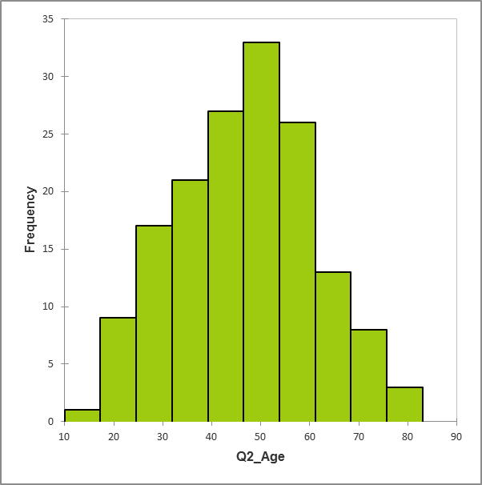
Figure 4: Age distribution of fisherfolk engaged in the KAP research (n=158). The median age is 48 and average age is 47. The age range is 15 to 82. Intervals are 7.3 years.

- Sex |  | Montego Bay (JAM) |  | Kingstown (SVG) |  | Roseau (DOM) |  | Total
 |  | Count | Column N % | Count | Column N % | Count | Column N % | Count | Column N %
 | Female | 0 | 0.0% | 1 | 1.7% | 2 | 3.3% | 3 | 1.9%
 | Male | 37 | 92.5% | 59 | 98.3% | 58 | 95.1% | 154 | 95.7%
 | N/A | 3 | 7.5% | 0 | 0.0% | 1 | 1.6% | 4 | 2.5%
 | Total | 40 | 100.0% | 60 | 100.0% | 61 | 100.0% | 161 | 100.0%
- Age |  | Montego Bay (JAM) |  | Kingstown (SVG) |  | Roseau (DOM) |  | Total
 |  | Count | Column N % | Count | Column N % | Count | Column N % | Count | Column N %
 | 30 and under | 3 | 7.5% | 5 | 8.3% | 12 | 19.7% | 20 | 12.4%
 | 31-45 | 13 | 32.5% | 18 | 30.0% | 19 | 31.1% | 50 | 31.1%
 | 46-60 | 16 | 40.0% | 24 | 40.0% | 18 | 29.5% | 58 | 36.0%
 | Over 60 | 8 | 20.0% | 13 | 21.7% | 9 | 14.8% | 30 | 18.6%
 | N/A | 0 | 0.0% | 0 | 0.0% | 3 | 4.9% | 3 | 1.9%
 | Total | 40 | 100.0% | 60 | 100.0% | 61 | 100.0% | 161 | 100.0%
 | Average age | 49 |  | 49 |  | 44 |  | 47
- Education |  | Montego Bay (JAM) |  | Kingstown (SVG) |  | Roseau (DOM) |  | Total
 |  | Count | Column N % | Count | Column N % | Count | Column N % | Count | Column N %
 | No formal education | 1 | 2.5% | 2 | 3.3% | 1 | 1.6% | 4 | 2.5%
 | Primary | 6 | 15.0% | 43 | 71.7% | 27 | 44.3% | 76 | 47.2%
 | Secondary | 25 | 62.5% | 10 | 16.7% | 28 | 45.9% | 63 | 39.1%
 | Post-secondary | 4 | 10.0% | 4 | 6.7% | 5 | 8.2% | 13 | 8.1%
 | N/A | 4 | 10.0% | 1 | 1.7% | 0 | 0.0% | 5 | 3.1%
 | Total | 40 | 100.0% | 60 | 100.0% | 61 | 100.0% | 161 | 100.0%
- Marital status |  | Montego Bay (JAM) |  | Kingstown (SVG) |  | Roseau (DOM) |  | Total
 |  | Count | Column N % | Count | Column N % | Count | Column N % | Count | Column N %
 | Common law | 8 | 20.0% | 26 | 43.3% | 9 | 14.8% | 43 | 26.7%
 | Married | 11 | 27.5% | 11 | 18.3% | 15 | 24.6% | 37 | 23.0%
 | Single | 15 | 37.5% | 22 | 36.7% | 36 | 59.0% | 73 | 45.3%
 | N/A | 6 | 15.0% | 1 | 1.7% | 1 | 1.6% | 8 | 5.0%
 | Total | 40 | 100.0% | 60 | 100.0% | 61 | 100.0% | 161 | 100.0%
- Head of household |  | Montego Bay (JAM) |  | Kingstown (SVG) |  | Roseau (DOM) |  | Total
 |  | Count | Column N % | Count | Column N % | Count | Column N % | Count | Column N %
 | Yes | 37 | 92.5% | 55 | 91.7% | 53 | 86.9% | 145 | 90.1%
 | No | 3 | 7.5% | 5 | 8.3% | 8 | 13.1% | 16 | 9.9%
 | Total | 40 | 100.0% | 60 | 100.0% | 61 | 100.0% | 161 | 100.0%
Table 5: Summary of the percentage and frequency of socio-demographics (a-e) within the sample of fisherfolk in Montego Bay (Jamaica), Kingstown (St. Vincent and the Grenadines) and Roseau (Dominica); N/A = no answer or not applicable

Fishing activities
On average, most respondents lack formal training in fishing (see Table 6). However, notable differences exist among pilot study sites, with an overwhelming majority in Jamaica and St. Vincent and the Grenadines lacking formal training in fishing and a high percentage (75%) of respondents from Dominica possessing it.
Respondents’ experience in fishing varies considerably. Figure 5 and Table 6 and provide information on the number of years respondents have spent fishing in the coastal area where they are located. On average, respondents have spent about 25 years fishing in the community, although the time span ranges from under a year to 63 years.
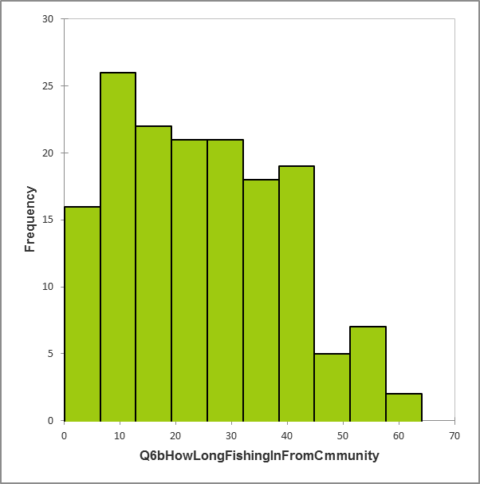
Figure 5: Distribution of the number of years spent fishing in the community where fisherfolk are located. The median number of years is 23, the average number is 25. The number of years ranges from 0 to 63. The intervals are 6.4 years.
The majority of respondents engage in fishing on a full-time basis. The percentage of part-time fishing ranges from 8% (St. Vincent and the Grenadines) to 20% (Jamaica). Part-time fishers reported a range of economic activities performed to supplement income from fishing. Many activities are allied to fishing (i.e., within the fish value chain) and predominantly in skilled trades and service sectors. Reported activities include the following:
- Skilled trades: Construction, carpentry, plumbing, auto mechanic, boat repair and maintenance
- Services: Gas pump attendant, taxi operator, water sports operator, massage therapist and domestic worker
- Other: Farmer, market vendor, small business owner and operator

- Formal training in fishing |  | Montego Bay (JAM) |  | Kingstown (SVG) |  | Roseau (DOM) |  | Total
 |  | Count | Column N % | Count | Column N % | Count | Column N % | Count | Column N %
 | Yes | 0 | 0.0% | 7 | 11.7% | 46 | 75.4% | 53 | 32.9%
 | No | 39 | 97.5% | 53 | 88.3% | 15 | 24.6% | 107 | 66.5%
 | N/A | 1 | 2.5% | 0 | 0.0% | 0 | 0.0% | 1 | 0.6%
 | Total | 40 | 100.0% | 60 | 100.0% | 61 | 100.0% | 161 | 100.0%
- Years fishing in the community |  | Montego Bay (JAM) |  | Kingstown (SVG) |  | Roseau (DOM) |  | Total
 |  | Count | Column N % | Count | Column N % | Count | Column N % | Count | Column N %
 | Up to 10 | 8 | 20.0% | 8 | 13.3% | 20 | 32.8% | 36 | 22.4%
 | 11 to 20 | 9 | 22.5% | 16 | 26.7% | 15 | 24.6% | 40 | 24.8%
 | 21 to 30 | 6 | 15.0% | 17 | 28.3% | 5 | 8.2% | 28 | 17.4%
 | 31 to 45 | 12 | 30.0% | 15 | 25.0% | 13 | 21.3% | 40 | 24.8%
 | Over 45 | 3 | 7.5% | 3 | 5.0% | 7 | 11.5% | 13 | 8.1%
 | N/A | 2 | 5.0% | 1 | 1.7% | 1 | 1.6% | 4 | 2.5%
 | Total | 40 | 100.0% | 60 | 100.0% | 61 | 100.0% | 161 | 100.0%
 | Average # of years | 26 |  | 26 |  | 23 |  | 25
- Fishing status |  | Montego Bay (JAM) |  | Kingstown (SVG) |  | Roseau (DOM) |  | Total
 |  | Count | Column N % | Count | Column N % | Count | Column N % | Count | Column N %
 | Full-time | 31 | 77.5% | 55 | 91.7% | 51 | 83.6% | 137 | 85.1%
 | Part-time | 8 | 20.0% | 5 | 8.3% | 10 | 16.4% | 23 | 14.3%
 | N/A | 1 | 2.5% | 0 | 0.0% | 0 | 0.0% | 1 | 0.6%
 | Total | 40 | 100.0% | 60 | 100.0% | 61 | 100.0% | 161 | 100.0%
Table 6: Summary of the percentage and frequency of fishing attributes (a-c) within the sample of fisherfolk in Montego Bay (Jamaica), Kingstown (St. Vincent and the Grenadines) and Roseau (Dominica); N/A = no answer or not applicable
Further characteristics of our sample of fisherfolk and their experiences and perceptions on day-to-day- fishing appear in Table 7. Throughout this section we refer to indicator values from this table by including the reference number in bolded brackets [#].
The information gleaned from respondents highlights a few opportunities to improve the strength of fishing livelihoods. We asked respondents to rate their level of satisfaction on income from fishing [1a], amount and type of fish caught [1b, 1g], availability of fishing equipment [1c], market for product [1f], ability to support their family from the proceeds of fishing [1h], the conditions of fishing grounds and landing sites [1i, 1j] and the ability to protect their livelihoods from hurricanes [1d]. Respondents were lukewarm about their satisfaction with five of these factors (i.e., around 50% registering satisfaction). The majority are satisfied with the types of fish being caught and are most dissatisfied with extension services [1e], the market for their product [1f] and the condition of landing sites [1j].
The majority of fisherfolk in our sample are registered fishers [2a] and about half own their fishing boats [2b]. Fishers who do not own boats get out to sea by boarding on available boats at landing sites (29 out of 79), going out fishing with a friend, family member or associate (28 out of 79); fishers also work a boat for other fishers (5 out of 79) and either borrow or rent boats (4 out of 79).

REF | Summary indicators | Definition | Unit | Fisherfolk
 |  |  |  | Total | Pilot study site
 |  |  |  |  | Montego Bay | Kingstown | Roseau
1 | Level of satisfaction with fishing | Proportion of respondents who are satisfied
1a | Income from fishing |  | % | 50% |  | 52% | 49%
1b | Amount of fish caught |  | % | 50% |  | 52% | 49%
1c | Availability of fishing equipment |  | % | 24% |  | 15% | 33%
1d | Ability to protect livelihoods from hurricanes |  | % | 41% |  | 45% | 36%
1e | Extension services |  | % | 16% |  | 7% | 25%
1f | Market for product |  | % | 22% |  | 15% | 30%
1g | Types of fish being caught |  | % | 76% |  | 72% | 80%
1h | Ability to support family from fishing |  | % | 58% |  | 57% | 59%
1i | Condition of fishing grounds |  | % | 52% |  | 42% | 62%
1j | Condition of landing site |  | % | 31% |  | 22% | 39%
2 | Fishing practices and preferences
2a | Registration | Proportion of respondents who are registered fishers | % | 86% | 83% | 87% | 87%
2b | Boat ownership | Proportion of respondents who own their fishing boats | % | 50% | 63% | 40% | 51%
2c | Days at sea - high season | Most frequently mentioned # days / week | days / week | 6 | 5 to 6 days | 7 days | 5 to 6 days
2d | Days at sea - low season | Most frequently mentioned # days / week | days / week | 3 | 1 to 2 days | 3 to 4 days | 3 to 4 days
2e | Duration of average trip | Most frequently mentioned # of hours / fishing trip | hours/trip | Up to 12 | Up to 12 | Up to 12 | Up to 12
2f | Preferred time of day | Proportion of respondents that fish in the daytime | % | 55% | 58% | 60% | 48%
 | Preferred species to fish
2g | Target species #1 | Most frequently mentioned target species | Group / species | Tuna
2h | Target species #2 | Second most frequently mentioned target species | Group / species | Dolphinfish
2i | Target species #3 | Third most frequently mentioned target species | Group /species | Snapper
2j | Most practiced fishing method | Proportion and most frequently mentioned fishing method | % & fishing method | 90% hook & line | 83% hook & line | 93% hook &line | 92% hook & line
2k | Most significant buyer of fish | Proportion of respondents and most frequently mentioned buyer |  | 71% community members | 75% community members | 82% fishing complex / coop | 85% community members
2l | Diversity of buyers | Buyers for which proportion of counts is over 25% |  |  | (1) Fish vendors; (2) community members | (1) Fish vendors; (2) community members; (3) fishing complex/coop | (1) Fish vendors; (2) community members; (3) restaurants
2m | Trip expense | Average expenses per trip | EC$/trip | 421 | 376 | 498 | 366
 |  | Range of expenses per trip (min) |  | 20 | 30 | 40 | 20
 |  | Range of expenses per trip (max) |  | 1880 | 860 | 1200 | 1880
2n | Most significant expense per trip | Most costly expense type, on average, and proportion of total expenses |  | Fuel 67% | Fuel 67% | Fuel 80% | Fuel 61%
3 | Perceptions on fishing performance
3a | Best months to fish [hook & line] | Three most frequently mentioned months | months |  | Jan, Feb, Sept, Oct | Feb, Jun, Jul, Aug | Jul, Aug, Sept
3b | Perceived changes in catch over fishing career | Proportion of respondents who perceived changes | % | 75% | 90% | 50% | 90%
3c | Nature of change in catch over fishing career | Most frequently mentioned type of change | Type of change | Less fish 52%
4 | Impact of Sargassum on fishing
 | Mostly positive | Proportion of respondents who reported the influx of Sargassum as mostly positive | % | 36% |  | 13% | 58%
Table 7: Summary indicators of a range of fishing activities and factors affecting fishing for the sample of fisherfolk we engaged in KAP research in Montego Bay (Jamaica), Kingstown (St. Vincent and the Grenadines) and Roseau (Dominica)

During the high season, fishers spend an average of 6 days at sea / week [2c]. In the low season, the effort reduces by about half, spending an average of 3 days at sea [2d]. Just over half of the fisherfolk in the sample report fishing predominantly in the day time [2f]. Further information on the breakout across pilot study sites appears in Annex 3: Additional information on fisherfolk activities. A majority of respondents fish for up to 12 hours daily [2e]. A preference for shorter trips (i.e., not multi-day) has been reported in other survey work (Beltran, 2017).
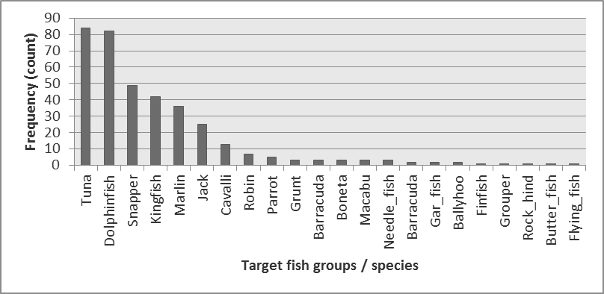
Figure 6: Target species identified by fisherfolk, ranked by frequency of response
We asked fisherfolk to tell us the top species they targeted when fishing [2g, 2h, 2i] and about their usage of a range of fishing methods and gear types [2j]. With regard to target species, this was an open-ended question so responses included a combination of local and common names for fish and often were not species-specific but referred to groupings (e.g., “snappers”). Figure 6 summarizes the distribution of fish species / groups targeted by respondents in our sample. Tuna (including specific mention of yellow fin tuna, Thunnus albacares) and common dolphinfish (Coryphaena hippurus) are the types of fish most targeted by fishers in our sample, with snappers (including specific mention of queen snapper, Etelis oculatus) in third place. The breakout of targeted fish shown here is simply illustrative of the sample of fisherfolk operating in Montego Bay, Kingstown and Roseau as a whole. Patterns are clearer for fishing methods / gear types, where an overwhelming majority report fishing via hook and line with most frequency. Differences between Jamaican and respondents from Eastern Caribbean are evident, with fishers sampled in Montego Bay also using fish pots in a significant way (see further breakdown in Annex 3: Additional information on fisherfolk activities).
We asked fishers a few questions on marketing and economic aspects of their fishing activities. A majority of fisherfolk sampled in Jamaica (75%) and Dominica (85%) sell their catch to community members [2k]. In St. Vincent and the Grenadines sales through the fishing complex occur in a significant way (about 82% of respondents). Fishers from Eastern Caribbean in our sample have a more diverse client base than fishers in Jamaica [2l]. At least a quarter of respondents from the Eastern Caribbean sell their catch to 3 different types of buyers, whereas Jamaican respondents only to 2. Table 7 also shows information on the cost of fishing [2m]. On average, fisherfolk in our sample spend about EC$421 of running costs per fishing trip, although the range spans two orders of magnitude (~EC$20 to EC$1880; this latter value could be considered an outlier, see further descriptive statistics in Annex 3). On average, fuel expenses make up more than half the total running costs (~67%), with bait coming in second (~12%) [2n].
We asked fisherfolk questions to elicit their perceptions on aspects of fishing performance, including the best months to fish and observations on changes in catch [3a, 3b, 3c]. In Jamaica (Montego Bay), fisherfolk responses on best months to fish using hook and line suggest a bi-modal distribution of best fishing months: January and February, then September and October (see Figure 7). In contrast, the distribution of best months to fish using hook and line gear for fisherfolk in Kingstown is more evenly distributed between January and September, with a slight peak in June and a slight decrease reported for the last calendar quarter. A majority of fisherfolk in Roseau identify July, August and September as the best months to fish using hook and line gear. In the surveyed sites, hook and line was the most common gear reported but others are in use as well (see Annex 3 for further information).
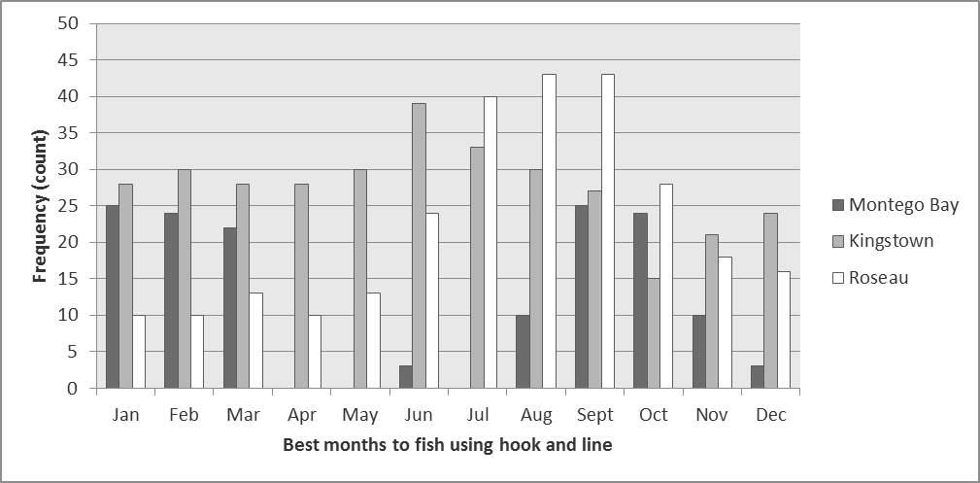
Figure 7: Best months to fish using hook and line gear, by frequency of responses by fisherfolk sampled in Montego Bay, Kingstown and Roseau
Concerning perceived changes in the amount of fish caught since starting to fish, a strong majority (90%) of fisherfolk from two of the pilot study sites (Montego Bay and Roseau) reported having seen changes, with a lower percentage reported by fisherfolk in Kingstown (50%). Figure 8 shows the direction and types of changes observed. By frequency, the most significant observed change is the reduction in fish available (60 out of 117 respondents or 51%). Fisherfolk have also observed more fish available and changes in the abundance of fish by season and location (35 out of 117 or 30%). Despite the focus of the question on harvest levels, respondents noted other changes including degradation of harvesting grounds and habitats and a more crowded economic activity.
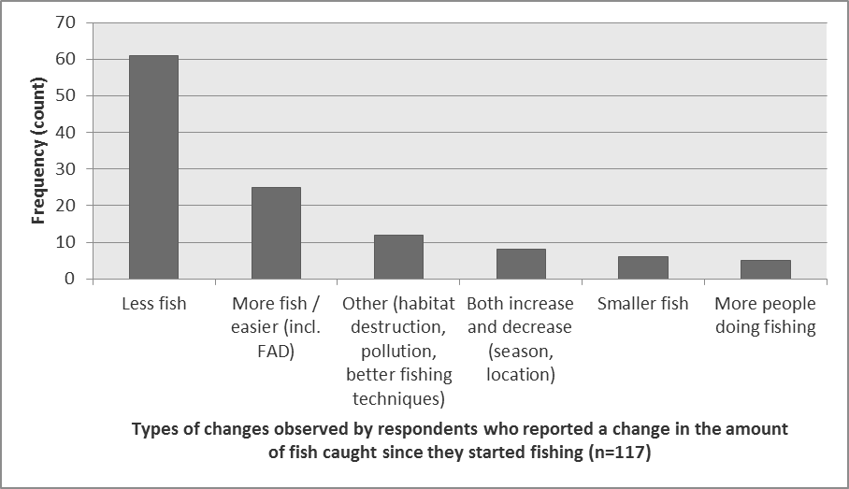
Figure 8: Direction and type of changes in the amount of fish caught observed by fisherfolk sampled in Montego Bay, Kingstown and Roseau. Note that fishers reported changes beyond the amount of catch.
The influx of Sargassum (Sargassum fluitans, S. natans) was an issue that was top of mind for stakeholders at the Regional Planning Workshop in April 2018. Therefore, we sought to capture (qualitatively) the impacts of the seaweed on fishing operations in Kingstown and Roseau [4]. On average, fishers report positive effects of Sargassum with slightly more frequency than negative or mixed effects. However, the differences in perspective between fishers in these two pilot sites are noteworthy, as fishers in Kingstown report mixed effects with most frequency (47%) and a majority of fishers in Roseau report positive effects (58%) (see breakout in Annex 3). Fishers observe that the presence of Sargassum increases the amounts of fish available and makes some species easier to access (dolphinfish and cavalli, explicitly mentioned). However, the seaweed also causes fishing lines and nets to tangle, obstructs or damages engines and equipment and requires more maintenance work on engines. A minority of fishers were neutral or not affected by Sargassum, with at least one mentioning that this was because of his focus on demersal fishing.

Managers
Managers who responded to the survey as part of the KAP research consisted of women and men in equal proportions (Table 8). Managers are diverse in their years of experience working in or supporting the fisheries sectors (Table 9) and, although a greater proportion of respondents reported working in Jamaica than any other PPCR country, all PPCR countries are represented (Figure 9).
Sex Total  Count Column N %  Female 13 50%  Male 13 50%  Total 26 100%  Table 8: Distribution of managerial-level respondents to the online survey, by sex | Years working in or supporting the fisheries sector Total  Count Column N %  2 to 5 years 6 25%  6 to 10 years 7 29%  11 to 15 years 4 17%  >15 years 7 29%  Total 24 100%  Table 9: Years of experience in the fisheries sector
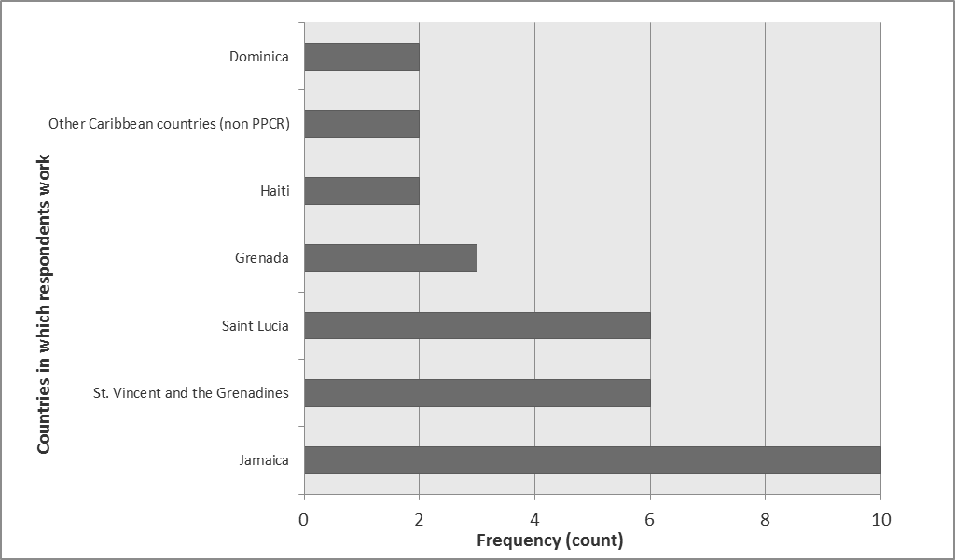  Figure 9: National representation of managerial respondents | Affiliation Total  Count Column N %  National government 12 39%  State or local government 1 4%  Non-governmental organization 11 39%  Private (self-employment, consulting) 4 14%  Other (regional organization) 1 4%  Total 28 100%  Table 10: Affiliations of managerial respondents
Most managers are public servants in national governments (12 of 28) and representative of non-governmental organizations (11 of 28) (Table 10). Respondents predominantly work in organizations responsible for natural resource management and conservation, fisheries management, marine and coastal zone management and enforcement of fisheries regulations. However, organizational responsibilities represented within the managerial sample are diverse (Figure 10). For example, the sample includes senior-level representatives from fishing cooperatives (vice president, liaison consultants) who also self-identify as fishers. Respondents reported working for the following organizations: Montego Bay Marine Park Trust, National Environment and Planning Agency (Jamaica), National Emergency Management Organization (St. Vincent and the Grenadines), White River Fish Sanctuary, The Nature Conservancy, 4BluC's (Saint Lucia), Goodwill Fishermen's Co-operative Society Limited (Saint Lucia), Bluefields Bay Fishermen's Friendly Society/Bluefields People’s Community Association (Jamaica), Fisheries Division (Dominica, Jamaica, St. Vincent and the Grenadines, Fisheries Department (Haiti, Saint Lucia) and the CRFM Secretariat.
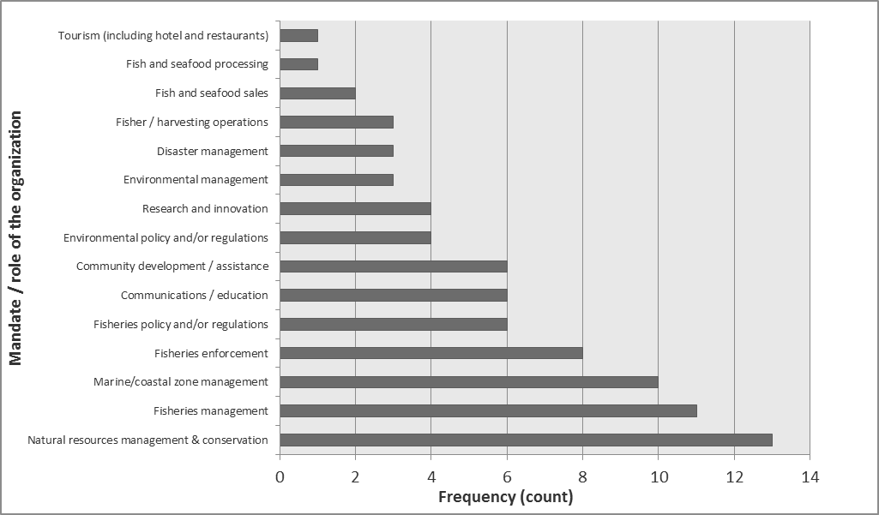
Figure 10: Distribution of managerial respondents’ organizational mandates
A majority of respondents are resource managers or directors / supervisors of their work units (Figure 11). The sample also includes scientists, fishers and business owners / operators / analysts.
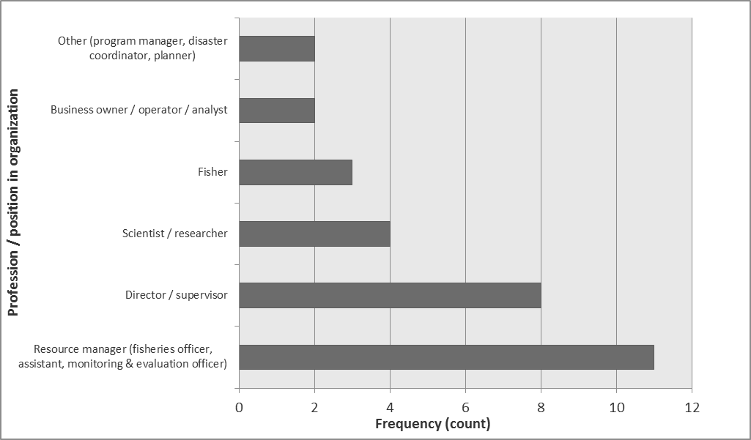
Figure 11: Distribution of managerial respondents’ professions or positions within their organizations

Policy Actors
Policy Actors who we succeeded in interviewing as part of this KAP research comprised of four individuals, with women and men in equal proportions. Their organizations and designations are as follows:
- Chief Fisheries Officer, Fisheries Division, Ministry of Agriculture, Forestry, Fisheries, Rural Transformation, Industry and Labour of St. Vincent and the Grenadines;
- Director of Fisheries, Fisheries Division, Ministry of Industry, Commerce, Agriculture and Fisheries of Jamaica;
- Acting Chief Fisheries Officer, Fisheries Division, Ministry of Agriculture, Lands, Forestry, Fisheries and the Environment of Grenada;
- Chief Fisheries Officer, Fisheries Division, Ministry of Agriculture, Fisheries, Physical Planning, Natural Resources and Cooperatives of St. Lucia.

Climate change results
This section presents the results of research focused on climate change knowledge, attitudes and practice for our three target audiences (fisherfolk, managers and policy actors). It also summarizes these groups’ perspectives on observed climate change impacts on the fisheries sector, responses to these impacts and climate change communications.

Fisherfolk
Table 11 is a summary of 12 indicators we considered in this research. This section of the report presents findings on each, indicating differences across pilot study sites, when warranted. Throughout this section we refer to indicator values from this table by including the reference number in bolded brackets [#].
Ref | Summary indicators | Definition | Unit | Fisherfolk
 |  |  |  | Total | Pilot study site
 |  |  |  |  | Montego Bay | Kingstown | Roseau
 | Sample size | # of fishers budgeted for sampling | n | 150 | 50 | 50 | 50
 | Response rate | % completed & partially completed surveys. It exceeds 100 in two cases since we obtained more completed surveys than was budgeted | % | 107 | 80 | 120 | 122
1 | Average knowledge score | Average composite knowledge score of respondents
1a | On climate change (CC) |  | % | 41 | 33 | 47 | 44
1b | On CC impacts / responses |  | % | 47 | 30 | 59 | 51
1c | On current action |  | % | 13 | 1 | 23 | 16
1d | Total / pilot study site |  | % |  | 21 | 43 | 37
2 | Level of knowledge | Composite knowledge score at the midpoint of the distribution of scores (median value) | % | 28 | 21 | 50 | 28
3 | Average attitude score | Average composite attitude score of respondents
3a | On urgency & importance |  | % | 59 | 69 | 50 | 57
3b | On roles & responsibilities |  | % | 75 | 75 | 77 | 72
3c | On ability to act / be protected |  | % | 39 | 24 | 44 | 48
3d | Total / pilot study site |  | % |  | 56 | 57 | 59
4 | Level of positive attitude | Composite attitude score at the midpoint of the distribution of scores (median value) | % | 59 | 57 | 61 | 61
5 | Average practice score | Average composite practice score of respondents
5a | On adaptation & DRR |  | % | 30 | 3 | 47 | 41
5b | On use of information |  | % | 77 | 98 | 67 | 66
5c | Total / pilot study site |  | % |  | 51 | 57 | 54
6 | Level of desired practice | Composite practice score at the midpoint of the distribution of scores (median value) | % | 50 | 50 | 63 | 54
7 | Perceived impact of climate hazards | Average significance score of respondents (5 = very significant impacts observed)
 | Hurricanes/storms |  | score /5 | 3.9 | 2.6 | 4.6 | 4.5
 | Coastal flooding |  | score /5 | 3.5 | 2.2 | 4.2 | 4.1
 | Coastal erosion |  | score /5 | 3.5 | 3.3 | 3.5 | 3.6
 | Changes in ocean currents |  | score /5 | 2.8 | 1.9 | 3.1 | 3.3
 | Coral bleaching |  | score /5 | 3.1 | 4.1 | 2.2 | 2.9
 | Invasive species |  | score /5 | 2.5 | 2.0 | 2.7 | 2.7
 | Fish migration |  | score /5 | 3.1 | 3.2 | 3.1 | 3.1
8 | Perceived feasibility of range of adaptation options for fishers | Average feasibility score of respondents
 | Fish Aggregating Devices (FADS) |  | score /5 | 4.7 | 4.3 | 4.9 | 4.8
 | Aquaculture (including mariculture) |  | score /5 | 3.1 | 3.0 | 4.1 | 2.2
 | Sports fishing / boat tours |  | score /5 | 3.5 | 4.1 | 3.0 | 3.5
 | Value-added processing |  | score /5 | 3.4 | 2.2 | 3.3 | 4.7
 | Improved post-harvest management |  | score /5 | 4.0 | 3.0 | 4.3 | 4.7
 | Target different species |  | score /5 | 3.5 | 3.1 | 3.1 | 4.2
 | Promote different fishing methods |  | score /5 | 4.1 | 3.9 | 3.8 | 4.5
 | Improved marketing |  | score /5 | 4.7 |  | 4.6 | 4.8
 | Aquaponics |  | score /5 | 2.3 |  |  | 2.3
9 | Best ways to provide climate change information to fisherfolk | Communication methods selected by 50% or more of respondents |  |  | Lectures / workshops 85% | Posters 65% | Lectures / workshops 62%
10 | Preferred agencies to involve in climate change awareness campaign | Top 3 most frequently mentioned type of agency |  | ENV, Fisheries, All govt ministries | Env. Agency; Fisheries Dpt.; All govt ministries | Emergency Mgt. Agency; Fisheries Dpt.; All govt ministries | All govt ministries; Fisheries Dpt.; Schools
11 | Smartphone usage | Proportion of ownership among respondents & most popular carrier | % | 53%, Digicel | 83%, Digicel | 40%, Digicel | 48%, Digicel
12 | Most used social media | Proportion of social media use and most frequently mentioned social media platform |  | 50%, WhatsApp | 45%, WhatsApp | 30%, WhatsApp | 74%, WhatsApp
Table 11: Summary indicators on climate change knowledge-attitudes-practice (KAP), perceived impacts and feasibility of responses and communications for fisherfolk we engaged in research in Montego Bay (Jamaica), Kingstown (St. Vincent and the Grenadines) and Roseau (Dominica)

Climate change knowledge
Figure 12 shows the distribution of composite climate change knowledge scores, expressed as a proportion of 1 instead of percentages. Fishers in Montego Bay, Kingstown and Roseau have a composite mean climate change knowledge score of 21%, 43% and 37% respectively [1d]. Scores for fisherfolk in Montego Bay show less of a spread than those for fisherfolk in the other two sites. Median composite scores for fisherfolk in Kingstown are highest [2], indicating that a greater proportion of fisherfolk attained higher scores than their peers in the other two sites.
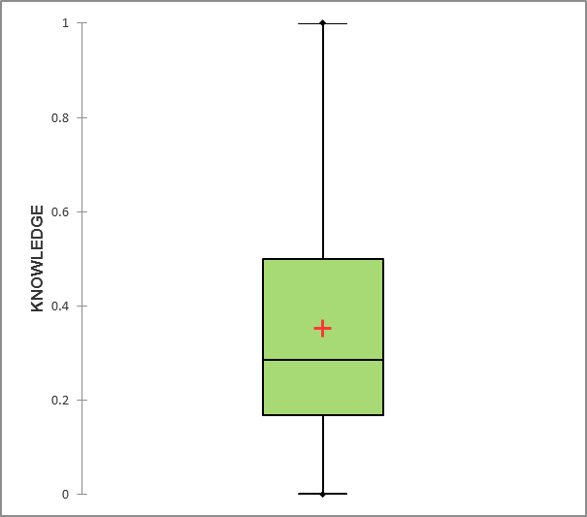A | 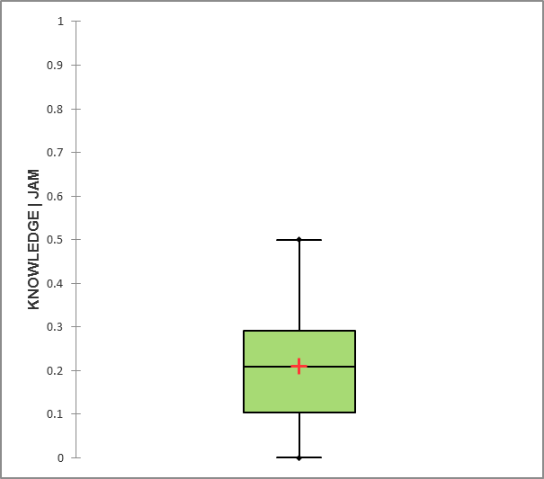B
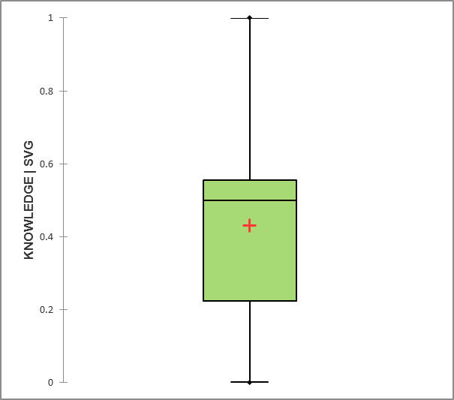C | 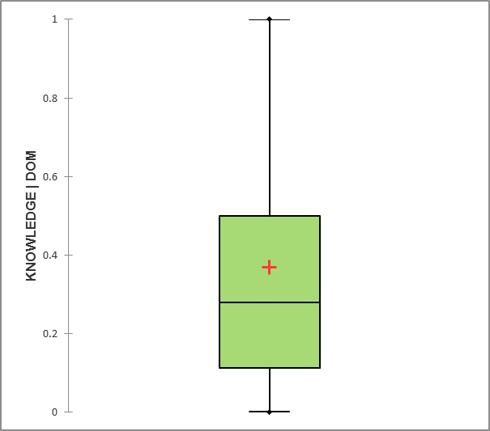D
Figure 12: Boxplots showing the distribution of composite climate change knowledge scores for (a) the sample as a whole; (b) fisherfolk in Montego Bay; (c) fisherfolk in Kingstown; and (d) fisherfolk in Roseau (n=160; 39; 60; 61, respectively). Composite scores are plotted on the y-axes and expressed as a proportion of 1, such that 1 = 100%. Median values are shown by the horizontal line in the box. Mean (average) values are shown by red crosses.
By considering the average values of underlying indicators (climate change knowledge; impacts & responses; awareness of current action) we observe the following:
Fisherfolk are more knowledgeable about climate-related impacts on fisheries and responses [1b] than they are of the causes of climate change [1a] and current government actions that could boost resilience [1c]. Patterns in understanding of climate change and its causes are similar across the three sites. Conversely, levels of knowledge of climate-related impacts, including gender-differences in vulnerability, and of relevant responses to adapt, are not as even. A greater proportion of fisherfolk in Kingstown and Roseau exhibited higher levels of knowledge in this category than fisherfolk from Montego Bay. Overall, the biggest weakness in knowledge is around actions government is taking to improve fisheries livelihoods. At least 75% of respondents either say they don’t know what governments are doing or assert governments are doing nothing.
In describing the term “climate change” fisherfolk provided a range of responses, emphasizing different aspects of the phenomenon (e.g., global, human-caused, physical changes, biological changes, changes in seasonality, fishing impacts). Table 12 provides examples of respondents’ explanations.
Montego Bay | Kingstown | Roseau
Global warming, anthropogenic  - Basically global warming  - Changes in the environment that is human-caused | Physical and biological changes  - Change in the weather pattern all around the world causing change in temperatures  - Changes in water temperature, bleaching of corals and, water temperature changing  - Changes in sea level, increased CO₂ levels  - More seaweed, sun and higher sea levels  - Different fish and migration patterns and higher temperatures | Physical and biological changes  - Climate changing over time  - Weather system change  - Currently climate is not the same  - Change in the normal functioning of the atmosphere  - Sea conditions changed cause of that  - The changing in the water temperature bleaching of corals, etc.
Global phenomenon  - The changes in the weather on a global scale  - The different weather changes over the world |  | Impacts on fishing (including harvest, marketing and consumption  - Change in texture and taste of fish
Physical changes  - Changes in weather/climate patterns, different weather patterns  - Change of wind pattern and currents and rainfall  - More flooding and increased heat | Seasonal variation and extremes  - Temperatures are changing seasons varying more, intense weather systems  - Place hotter and more rain come in dry season | Unpredictability and seasonal variation  - No season for anything  - Unpredictable weather
Unpredictability  - “Boy you cannot predict weather nowadays” | Impacts on fishing (including harvest, marketing and consumption)  - Tides are strong and the fish season changing  - Hardship and cannot go out to sea | Other  - Disturbance in ozone layer  - Events that take place after Hurricane Maria  - Climate in the world is changing due to hurricane activities
Table 12: Examples of fisherfolks’ responses to the question “Please explain what you understand by the term climate change?”
Explanations on what climate change means vary in nuance from “basically global warming” or “changes in weather patterns” to “I understand that climate change comes from global warming, which causes more flooding and temperature change”. Several respondents supplied explanations that were partially accurate, demonstrating somewhat of an understanding of climate change. But 75 out of 158 respondents could not describe the term at all (see Figure 13).
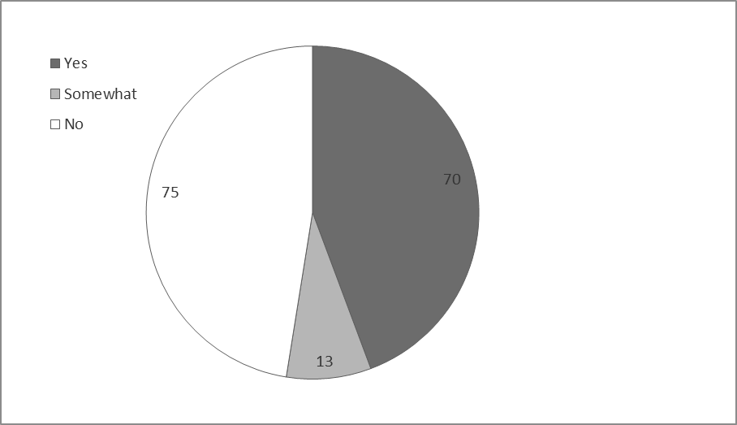
Figure 13: Assessed understanding of climate change based on respondents’ explanation of the term “climate change” (Yes=provided accurate definition; somewhat=provided partially accurate answer; no=could not describe the term, description was wrong) (n=158)
We asked fisherfolk in Montego Bay about the main causes of climate change and their responses revealed a lack of knowledge on the issue. Only one fisher was able to articulate that anthropogenic climate change was caused by burning of fossil fuels and land clearing. As is evident from Table 13 below, fisherfolks see a connection between human activities / development and global warming, but fail to identify the specific causal mechanisms. There is also some confusion between climate change and ozone layer depletion.
Montego Bay
Global warming  - Global warming and natural causes (the moon)  - Cause from global warming | Consequence of development  - Human action  - Development too close to the sea  - Development by mankind  - Humans using up the planet’s natural resources, causing an imbalance in nature  - Humanity’s negative approach to the environment like cutting down trees and improper waste disposal  - Pollution in the air and land  - “Large factories that keep pollution waste such as chemical waste bags”  - “The many things that are going up in the atmosphere and the way we are getting rid of our garbage by dumping and burning”
Emissions sources
- Carbon dioxide released from factories and cars and pollution
- Burning of fossil fuel, cutting down and not replanting trees
Ozone-layer depletion
- Destruction of the ozone layer by excessive carbon
- Depletion of the ozone layer by gas from our waste
Table 13: Examples of fisherfolks’ responses to the question “What do you think are the main causes of climate change?”
We examined fisherfolks’ understanding of climate change impacts by reviewing their examples of (1) environmental situations they would use to explain climate change to peers, (2) consequences to the fisheries sector of climate change impacts and (3) actions fishers can take to reduce the impacts of climate change. The strongest examples of environmental situations to use to explain climate change were ones that characterize impact pathways, such as “fish migrating to new areas due to change temperature and ocean current”, “usual fish stock changing due to temperature in water” and “fish are in deeper water so fishermen have to travel longer distances to fish”. About a third of the sample of fisherfolk provided these types of examples. Just over a third of the sample of fisherfolk listed a change in climate condition as an example, such as “hot weather”, “change in ocean current”, “stronger hurricanes”. The weakest examples in conveying the meaning of climate change were those that focused on environmental degradation caused by development, such as “cutting down of the mangroves to build hotels and condos in vogue”, “hotel built too close to the sea” or “the burning of garbage”.
We asked fisherfolk in Montego Bay about fisheries-sector impacts of climate change. Their responses revealed moderate knowledge on the issue and good potential to harness local observations of changes to the state and condition of fished resources. About a quarter of respondents (8 of 33 who replied to this question) drew connections between physical and biological changes, such as “fish will be moving away from our ground to seek more [thermally] comfortable space”, and “the hurricane that we are now having creates more damage to the reef and we see less fish”. About half of the respondents (18 of 33) simply report a decline in available fish. The rest (7 of 33) mainly refer to irresponsible fishing (“a couple more decades of bad practices and there will be no more fish”).
Fisherfolks’ responses to our question on things fishers can do to reduce the impacts of climate change / reduce the impact of hurricanes suggest a base level of knowledge on actions that build coping and adaptive capacity from which to build (see Table 14). The conflation between actions to address climate change impacts and general environmental actions is also apparent. This is not surprising since the portrayal of climate change as an environmental issue is longstanding. Some fisherfolk express fatalism and disempowerment through their responses. These sentiments included the following: “all we can do is report what we see is taking place in our area”, “nothing without the help of those in authority”, “very little - this is bigger than them”.
Montego Bay (climate change impacts) | Kingstown and Roseau (hurricane impacts)
Information, education & communication  - Information and education  - Educate ourselves about climate change  - Make fishers more aware of climate change  - Fishers need to be provided with more information on how to help  - Speak about its impact on a one to one basis | Information, education & communication  - Communicate with each other more  - Informing everyone as much as possible  - Acquire knowledge and educate themselves on such occurrences  - Educate themselves and be on alert all the time  - Implement training programs  - Implement a system to inform all fishers
Preparedness  - Heed weather warning  - Heed early warnings  - Stay aware | Preparedness  - Educate themselves and keep up to date on weather patterns  - Have a radio or device so as to help up to date and alert  - Have an emergency kit  - Be aware and stock up on material, food and necessary supplies  - Remove boats from coastal areas  - Work together and cooperate
Accountability  - “Realize that all of us is going to suffer from the end result so make sure we do our little bit”  - “Give more help to fishermen and become more concerned about fishermen rights”  - Enforce environmental regulations | Prevention and asset protection  - Put in place a program in hurricane disaster prevention  - Ensure your fishing equipment is properly secured  - Keep equipment in safety zones  - Use specially-designated areas to secure boats during storms  - Build resilient houses  - Build sea defence wall
Environmental actions
- Dispose of garbage properly
- Stop dumping waste in the sea
- Try to live more environmentally friendly
- Be more environmentally aware
- Pay attention to how we treat our beaches by keeping them clean
Table 14: Examples of fisherfolks’ responses to the question “What are some of the things you think fishers can do to reduce the impacts of climate change [hurricanes / storms] on your community?”
In addition, since climate change impacts affect women and men differently by virtue of physiology and societal roles and expectations, we explored fisherfolks’ knowledge of gender-differentiated vulnerability to climate change. Since the sample is overwhelmingly male, these responses represent a predominantly male perspective. A majority of respondents (72% or 114 of 158) either don’t see or don’t know about gender-based differences. A common response is that “climate change is a general occurrence that does not consider sex”. Nevertheless, about a quarter of respondents (39 of 158) acknowledge differences in how climate change affect men and women on the grounds of physique (“women are unable to withstand the conditions at sea”), stereotypes about tolerance to physical effects (“female are more delicate and feel the effects more than males”), women’s traditional roles as fish vendors (“less fish available for vendors if the fishers catch is low”, “females await fish to sell”) and roles men play in society (“men have more responsibilities”).
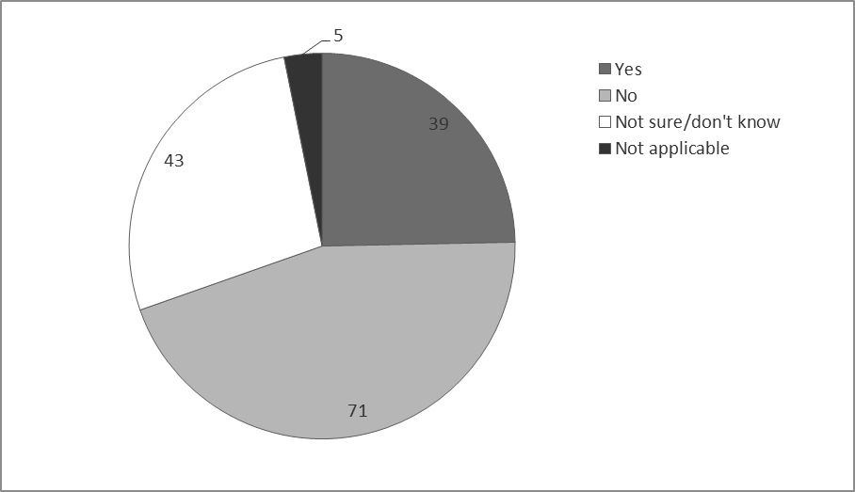
Figure 14: Fisherfolks’ responses to the question “do you think climate change affects male and female fisherfolk in different ways?” (n=158)
When asked about the types of program or projects that the government was already undertaking to improve the livelihood of fishers their community, 75% of respondents said none, nothing or I don’t know. The rest of fisherfolk mentioned the following types of initiatives: safety-at-sea training, implementation of FADs, construction of a building for seafood marketing, compensation after Hurricane Maria and small business loans.

Climate change attitudes
Figure 15 shows the distribution of composite climate change attitude scores for the global sample (A) and for each of the three fishing sites (B, C, D), expressed as a proportion of 1 instead of percentages. Fishers in Montego Bay, Kingstown and Roseau have a composite average attitude score of 56%, 57% and 59% respectively [3d]. Median composite scores for fisherfolk in Roseau are highest [4], indicating that a greater proportion of fisherfolk attained higher scores than their peers in the other two sites. Composite scores for fisherfolk in Montego Bay and Roseau show less of a spread than those for fisherfolk in Kingstown.

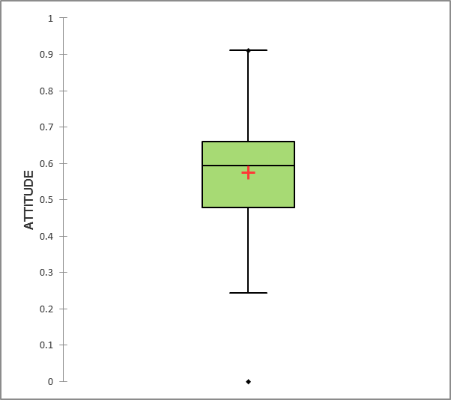A | B
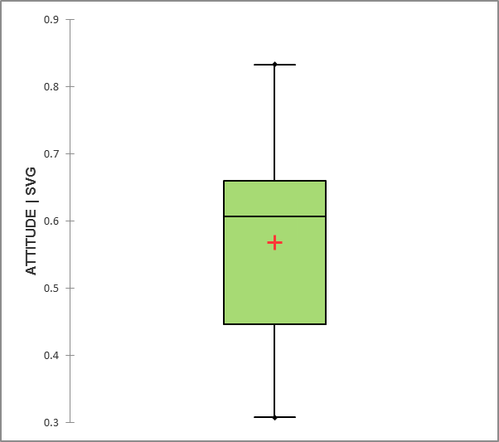C | 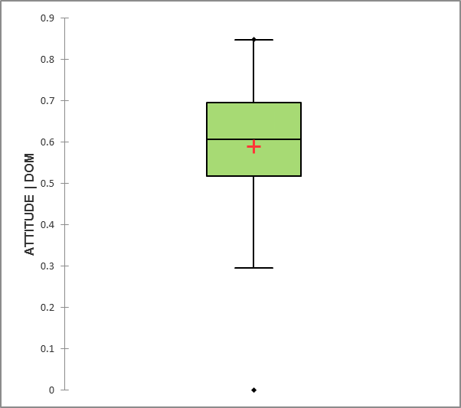D
Figure 15: Boxplots showing the distribution of composite climate change attitude scores for (a) the sample as a whole; (b) fisherfolk in Montego Bay; (c) fisherfolk in Kingstown; and (d) fisherfolk in Roseau (n=161; 40; 60; 61, respectively). Composite scores are plotted on the y-axes and expressed as a proportion of 1, such that 1 = 100%. Median values are shown by the horizontal line in the box. Mean (average) values are shown by red crosses.
By considering the mean values of underlying indicators (urgency & importance; roles & responsibilities; ability to act / be protected) we observe the following:
Fisherfolks’ attitudes toward shared responsibility for action [3b] are more positive than they are for problem awareness [3a] and ability to act or be protected [3c]. Attitude scores toward confidence in ability to act / be protected are spread across low and high scores, with a greater proportion of respondents in Montego Bay registering lower scores. Respondents across all study sites have a high appreciation that action on climate change is an issue of shared responsibility. In terms of recognizing climate change as a key threat to fisheries, higher proportions of respondents in Montego Bay and Roseau register scores toward the higher end of the range than in Kingstown.
Information in Table 15 and Table 16 below sheds light on the nature of these differences in attitudes toward climate change as a key threat. On average, across the three pilot study sites, fishers do not see climate change as a top problem facing the fisheries sector. Day-to-day and economic issues – fuel price, market for catch and equipment cost –emerge as the most important problems. Results show important differences across sites. For example, fishers in Montego Bay see piracy and climate change as bigger problems than their peers in Kingstown and Roseau (Table 15).
Regarding stated levels of concern about the impacts of climate change, 78%, 52% and 64% of fishers from Montego Bay, Kingstown and Roseau, respectively, are “very concerned” (Table 16). It’s worth noting that a greater proportion of fishers from Kingstown are “somewhat concerned” and “unconcerned” than fishers in the two other sites.
Problems facing the fisheries sector |  | Montego Bay (JAM) |  | Kingstown (SVG) |  | Roseau (DOM) |  | Total
 |  | Count  N | % | Count  N | % | Count  N | % | Count  N | %
 | Fuel price | 35 | 87.5% | 52 | 86.7% | 36 | 59.0% | 123 | 76.4%
 | Equipment cost | 35 | 87.5% | 19 | 31.7% | 18 | 29.5% | 72 | 44.7%
 | Market for catch | 4 | 10.0% | 46 | 76.7% | 34 | 55.7% | 84 | 52.2%
 | Poor fishing practices | 20 | 50.0% | 7 | 11.7% | 5 | 8.2% | 32 | 19.9%
 | Piracy | 16 | 40.0% | 1 | 1.7% | 1 | 1.6% | 18 | 11.2%
 | Climate change | 12 | 30.0% | 4 | 6.7% | 9 | 14.8% | 25 | 15.5%
 | Low catch | 23 | 57.5% | 17 | 28.3% | 6 | 9.8% | 46 | 28.6%
 | N | 40 | 100.0% | 60 | 100.0% | 61 | 100.0% | 161 | 100.0%
Table 15: Distribution of responses by fisherfolks sampled in Montego Bay, Kingstown and Roseau to the question “what do you think are the most serious problems facing the fisheries sector today?”

Concern about the impacts of climate change |  | Montego Bay (JAM) |  | Kingstown (SVG) |  | Roseau (DOM) |  | Total
 |  | Count | Column N % | Count | Column N % | Count | Column N % | Count | Column N %
 | Very concerned | 31 | 77.5% | 31 | 51.7% | 39 | 63.9% | 101 | 62.7%
 | Somewhat concerned | 9 | 22.5% | 24 | 40.0% | 17 | 27.9% | 50 | 31.1%
 | Unconcerned | 0 | 0.0% | 5 | 8.3% | 4 | 6.6% | 9 | 5.6%
 | N/A | 0 | 0.0% | 0 | 0.0% | 1 | 1.6% | 1 | 0.6%
 | N | 40 | 100.0% | 60 | 100.0% | 61 | 100.0% | 161 | 100.0%
Table 16: Distribution of responses by fisherfolks sampled in Montego Bay, Kingstown and Roseau to the question “How concerned are you about the impacts climate change?”
Fisherfolk acknowledge that a range of stakeholders have responsibility for addressing climate change (Table 17). However, according to their responses fishers tend to accord a greater degree of responsibility to external actors: industrialized countries, government officials and policymakers and the tourism sector. Responsibility of actors along the fish value chain is seen as lowest for fish processors and highest for fisheries non-governmental organizations and fisherfolk organizations.
Responsibility for addressing climate change |  | Montego Bay (JAM) | Kingstown (SVG) | Roseau (DOM) | Total
 |  | Average score | Average score | Average score | Average score
 | Harvesters | 3.5 | 2.9 | 3.5 | 3.3
 | Fish processors | 1.7 | 2.8 | 2.9 | 2.5
 | Fisheries officers | 4.7 | 4.1 | 4.4 | 4.4
 | Policymakers | 4.9 | 4.5 | 4.4 | 4.6
 | Fisheries NGOs CBOs | 3.0 | 3.9 | 3.5 | 3.5
 | Private sector |  | 4.0 | 3.0 | 3.5
 | Fisherfolk organizations |  | 4.0 | 4.0 | 4.0
 | Industrialized countries |  | 4.6 | 4.1 | 4.4
 | Tourism stakeholders | 4.6 | 4.5 | 3.6 | 4.2
 | N | 35 | 60 | 61 | 156
Table 17: Distribution of responses by fisherfolks sampled in Montego Bay, Kingstown and Roseau to the question “How much responsibility would you say these groups have in addressing climate change impacts in the fisheries sector?” 1=minor responsibility; 5=major responsibility
We asked fishers in Montego Bay about their satisfaction with steps being taken to address climate change impacts in the fisheries sector. Their responses revealed low levels of satisfaction, with no respondents expressing they were “very satisfied”, about a tenth of respondents (4 of 40) “satisfied” or “neutral” and just over a quarter (11 in 40) “dissatisfied”. Over half of respondents (25 of 40) either didn’t know or didn’t answer. Low levels of satisfaction could well relate to equivalent levels of knowledge on initiatives that are unfolding. We did not test this association explicitly due to the small sample size (and counts under 5).
We asked fishers in Kingstown and Roseau a series of questions related to recovery after a storm, including assistance after a recent storm and beliefs about access to safety nets in case they needed help. Responses indicate that the most significant contribution to coping capacity lies in the ability to lean on social safety nets. Just over half of respondents (66 of 121) stated they did have close family/friends that they could depend on if they needed extra help. Conversely, post-event assistance and access to cash savings may be harder to come by. Over half of respondents (77 of 121) claimed no one had reached out to help them after the storm hit and about half (69 of 120) would find it difficult or very difficult to get extra cash to pay for damages and losses after a storm.

Climate change practice
Figure 16 shows the distribution of composite climate change practice scores for the global sample (A) and for each of the three fishing sites (B, C, D), expressed as a proportion of 1 instead of percentages. Fishers in Montego Bay, Kingstown and Roseau have average composite practices score of 51%, 57% and 54% respectively [6c]. Median values of fisherfolk in Kingstown are highest [4], indicating that a greater proportion of fisherfolk attained higher scores than their peers in the other two sites. Composite scores for fisherfolk in Montego Bay were estimated based on two survey elements as opposed to six, which is manifest in the peculiar distribution in Figure 16B.

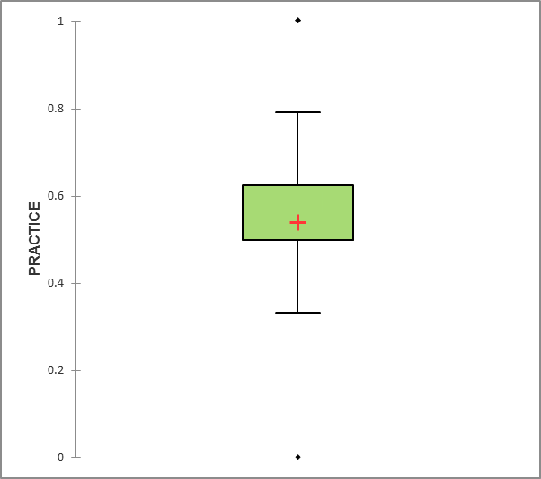A | 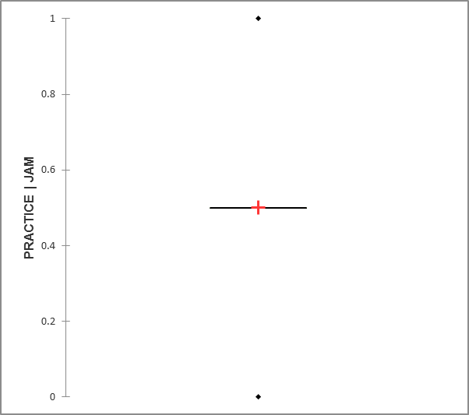B
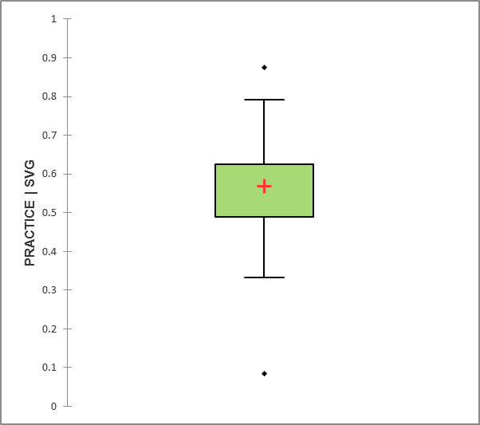C | 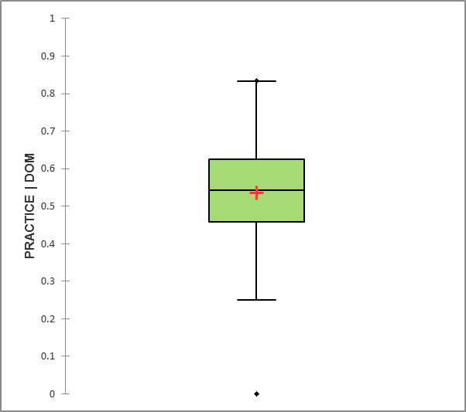D
Figure 16: Boxplots showing the distribution of composite climate change practice scores for (a) the sample as a whole; (b) fisherfolk in Montego Bay; (c) fisherfolk in Kingstown; and (d) fisherfolk in Roseau (n=161; 40; 60; 61, respectively). Composite scores are plotted on the y-axes and expressed as a proportion of 1, such that 1 = 100%. Median values are shown by the horizontal line in the box. Mean (average) values are shown by red crosses.
By considering the mean values of underlying indicators (adaptation & DRR practices; use of information) we observe the following:
Fisherfolk exhibit behaviours that are helpful in adapting to climate change [6b] but report low levels of action to deal with climate change or prepare for an extreme event [6a]. A small proportion of respondents across the three sites report using desirable practices related to adaptation and disaster risk reduction (DRR). Levels of interest in climate change information exhibited opposite patterns, with a high proportion of respondents registering scores toward the high end of the range.
We explored adaptation and DRR by asking respondents in Montego Bay to relate actions of community members to deal with climate change and respondents in Kingstown and Roseau to tell us about actions they took when they found out about a recent storm. A majority of fishers in Montego Bay (29 of 40) reported no actions or actions more broadly environmental (e.g., waste reduction); the rest did not answer the question. Fishers in Kingstown and Roseau reported relevant actions to prepare in higher proportions: over three quarters of respondents (99 of 119) claimed they either secured their own or others’ boats, shifted their boats and fishing equipment to higher ground or stocked up on food, water and other essentials. A few respondents (9 of 119) either didn’t have time to prepare or took no action.
Table 18 provides a breakdown of responses by fisherfolk in Kingstown and Roseau to a series of questions related to emergency preparedness. We used these questions as proxies to gauge practices in adaptation and DRR. Fishers’ responses suggest a high level of confidence in their preparedness to deal with storms yet relatively low adoption of measures to reduce disaster risk. Levels of training in DRR and penetration of home and property insurance are particularly low.
Practices |  | Kingstown (SVG) |  | Roseau (DOM) |  | Total
 |  | Count N | Column % | Count N | Column % | Count N | Column %
 | Emergency kit & other protection supplies? (yes) | 21 | 36% | 20 | 33% | 41 | 35%
 | Training in DRR? (yes) | 4 | 7% | 8 | 13% | 12 | 10%
 | Insurance? (yes) | 3 | 5% | 7 | 12% | 10 | 8%
 | Concern over own preparedness? (very little, little) | 43 | 74% | 33 | 55% | 76 | 64%
 | Concern over neighbors' preparedness? (very little, little) | 44 | 76% | 34 | 57% | 78 | 66%
 | Totals | 58 | 100% | 60 | 100% | 118 | 100%
Table 18: Distribution of responses by fisherfolks sampled in Kingstown and Roseau to questions related to emergency preparedness
Fishers registered strong interest in receiving more information about climate change impacts. Almost all respondents (91% or 147 of 161) responded positively when asked this question. Additionally, about three quarters of respondents (72% or 117 of 161) shared their telephone number with field assessors, so that we could contact respondents about future project activities. These behaviours, taken together with the examples of actions volunteered by respondents (recall examples from Table 14), suggest potential openness to climate change education and outreach.
The section on perspectives on communications explores the issue of how best to reach out to and engage fisherfolks through this project. However, we did consider results on information sources through which fishers found out about a recent storm (see Figure 17) as part of our assessment of climate change practice. A preferred practice is to rely on a source supplying official, reliable information, such as that provided through government-issued warnings transmitted via the radio, television and government websites. Further, consulting several sources can help triangulate conflicting information. A high percentage of respondents (70% or 85 of 121) reported finding out about the storm through the radio. And most respondents received the information from more than one source. A minority of respondents (7% or 9 of 121) either heard from only one source or didn’t receive the information at all.
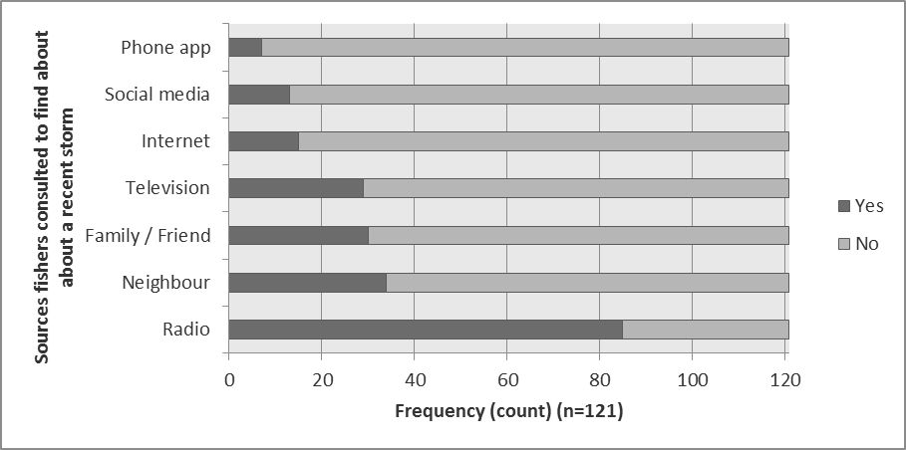
Figure 17: Responses provided by fishers in Kingstown and Roseau to the question “how did you find out about the storm?” (n=121)

Perspectives on impacts and viable responses
We asked fisherfolks about observed impacts of climate-related hazards [7]. Summary results are in Figure 18. From the perspective of fishers in our sample, hurricanes / storms, coastal flooding and coastal erosion have caused the most significant adverse impacts on their communities or fishing areas. Slow-onset changes like spread of invasive species and changing ocean currents have caused little impact, according to our sample of fisherfolk.
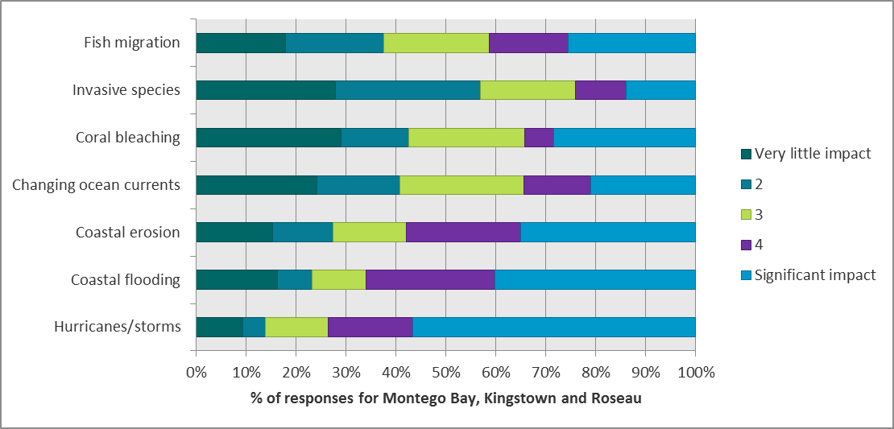
Figure 18: Combined responses provided by fishers in Montego Bay, Kingstown and Roseau to the question “on a scale of 1 to 5, how much would you say the following climate hazards have negatively affected your community / fishing area?” (n=157)
Local observations of adverse impacts of climate-related hazards differ by site [7]. The series of bar charts in Figure 19 below break out these local variations. Not surprisingly, fishers in Montego Bay rate coral bleaching as the climate hazard causing the most significant impact, with coastal erosion coming in second. Hurricanes / storms and coastal flooding are causes of most significant impact according to fishers Kingstown and Roseau. These differences in perspectives and experiences across sites can help guide differentiations in communications for PPCR countries in Lesser Antilles / Eastern Caribbean compared to larger islands in the Western Caribbean.
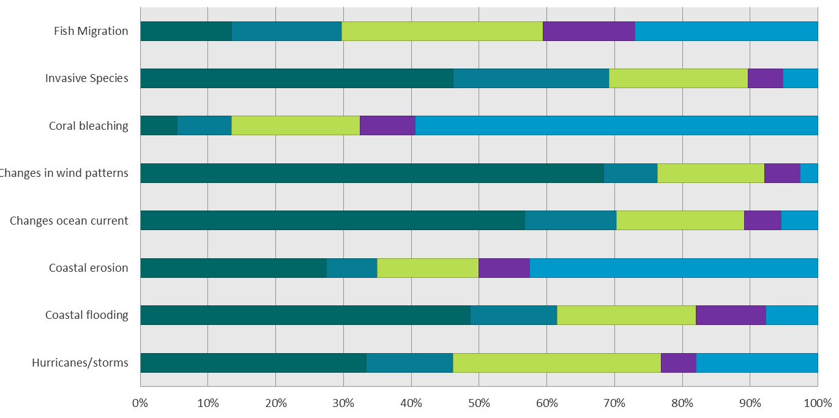
Montego Bay (n=37)
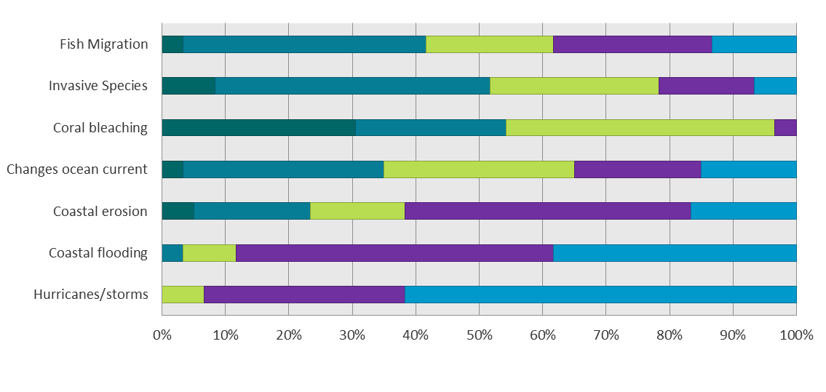
Kingstown (n=60)
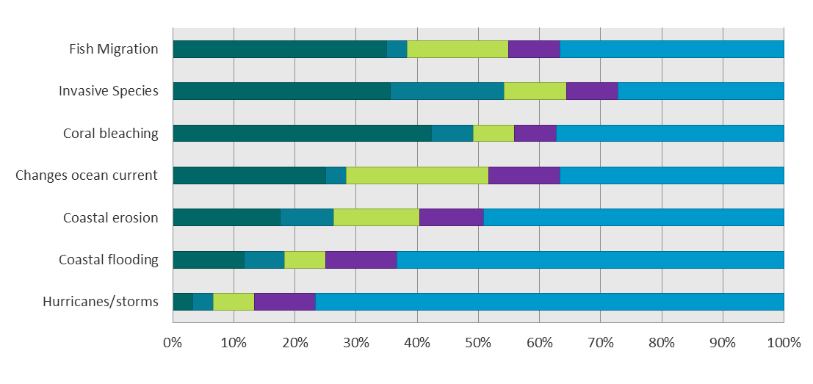
Roseau (n=61)
Figure 19: Breakdown of responses provided by fishers in Montego Bay, Kingstown and Roseau to the question “on a scale of 1 to 5, how much would you say the following climate hazards have negatively affected your community / fishing area?” Blue = significant impact; purple=moderate impact; light green=neutral; dark blue=little impact; dark green=very little impact
We also asked fisherfolks to score the feasibility of a range of adaptation options for fishers on a scale of 1 to 5 (Table 19) [8]. On average, our sample of fishers see the use of fish aggregating devices (FADs), improved marketing, promotion of different fishing methods and improved post-harvest management (e.g., waste reduction) as the most feasible options to pursue as part of a portfolio of adaptation measures. Fishers in all sites scored FADs as highly feasible – this is the option that received highest scores. Beyond this shared view, perspectives on feasibility of options differ across sites. In Montego Bay sports-fishing / boat tours received the second-highest aggregate score, yet this option is not among the most feasible for fishers in Kingstown and Roseau. This could reflect the level of coupling of tourism activities with fisheries, which may be more strongly coupled in Montego Bay than in the two other sites. Fishers in Kingstown and Roseau show similar patterns in their ratings of most feasible options. The biggest difference is in their consideration of aquaculture.
 | Perceived feasibility of range of adaptation options for fishers | Unit | Total | Montego Bay | Kingstown | Roseau
 | Fish Aggregating Devices (FADS) | score /5 | 4.7 | 4.3 | 4.9 | 4.8
 | Aquaculture (including mariculture) | score /5 | 3.1 | 3.0 | 4.1 | 2.2
 | Sports fishing / boat tours | score /5 | 3.5 | 4.1 | 3.0 | 3.5
 | Value-added processing | score /5 | 3.4 | 2.2 | 3.3 | 4.7
 | Improved post-harvest management | score /5 | 4.0 | 3.0 | 4.3 | 4.7
 | Target different species | score /5 | 3.5 | 3.1 | 3.1 | 4.2
 | Promote different fishing methods | score /5 | 4.1 | 3.9 | 3.8 | 4.5
 | Improved marketing | score /5 | 4.7 |  | 4.6 | 4.8
 | Aquaponics | score /5 | 2.3 |  |  | 2.3
Table 19: Summary responses to the question “on a scale of 1 to 5, how feasible do you think the following options are?” (n=161) Note that the options “improved marketing” and “aquaponics” were not included in all survey questionnaires

Perspectives on communications
We elicited information on communication preferences and vehicles that could be most effective to reach out to fisherfolk [9]. When taken as a sample as a whole, fishers see face-to-face engagement through lectures and workshops as the best way to provide climate change information to fisherfolk. Just over half of respondents (55% or 89 of 161) marked this option as the most effective format; printed media (posters, pamphlets / brochures) follow in frequency (Table 20). The break out of responses by site suggests a low appreciation of artistic expression as an effective format and of faith-based organizations as effective vehicles for climate change communications with fisherfolk.
Best ways to provide information about climate change to fisherfolk |  | Montego Bay (JAM) |  | Kingstown (SVG) |  | Roseau (DOM) |  | Total
 |  | Count | Column N % | Count | Column N % | Count | Column N % | Count | Column N %
 | Pamphlets / brochures | 14 | 35% | 26 | 43% | 8 | 13% | 48 | 30%
 | Posters | 10 | 25% | 39 | 65% | 7 | 11% | 56 | 35%
 | Short videos | 8 | 20% | 9 | 15% | 13 | 21% | 30 | 19%
 | Bulletins | 4 | 10% | 9 | 15% | 17 | 28% | 30 | 19%
 | Lectures / workshops | 34 | 85% | 17 | 28% | 38 | 62% | 89 | 55%
 | Jingle | 1 | 3% | 1 | 2% | 1 | 2% | 3 | 2%
 | Songs | 1 | 3% | 7 | 12% | 2 | 3% | 10 | 6%
 | Faith-based organization | 0 | 0% | 0 | 0% | 2 | 3% | 2 | 1%
 | Poetry | 0 | 0% | 0 | 0% | 0 | 0% | 0 | 0%
 | N | 40 | 100% | 60 | 100% | 61 | 100% | 161 | 100%
Table 20: Summary responses to the question “what do you think are the most effective ways of communicating with fisherfolk in your community?” (n=161)
We further asked fishers in Montego Bay, Kingstown and Roseau for ideas on who should be involved in climate change communications with fisherfolk [10]. Table 21 shows the distribution of responses provided by fishers in the three sites. The role of government shows up strongly in these responses. About a third of respondents (32% or 51 of 161) think all ministries should be involved in general, and specifically the Fisheries Department, Emergency Management Agency and Environment Agency. Non-government actors mentioned with some frequency (a count of 5 or more across the 3 sites) include cooperatives / fishing complex, tourism operators and teachers / schools.
Agencies that should be involved in climate change communications with fisherfolk |  | Montego Bay (JAM) |  | Kingstown (SVG) |  | Roseau (DOM) |  | Total
 |  | Count | Column N % | Count | Column N % | Count | Column N % | Count | Column N %
 | Agriculture Department | 2 | 5% | 1 | 2% | 0 | 0% | 3 | 2%
 | Artists | 0 | 0% | 0 | 0% | 1 | 2% | 1 | 1%
 | Coast Guard | 0 | 0% | 1 | 2% | 0 | 0% | 1 | 1%
 | Cooperative / Fishing Complex | 1 | 3% | 9 | 15% | 3 | 5% | 13 | 8%
 | Emergency Management Agency | 0 | 0% | 27 | 45% | 0 | 0% | 27 | 17%
 | Environment Agency | 13 | 33% | 0 | 0% | 0 | 0% | 13 | 8%
 | Fisheries Department | 10 | 25% | 22 | 37% | 14 | 23% | 46 | 29%
 | Fishers | 3 | 8% | 1 | 2% | 0 | 0% | 4 | 2%
 | Government (all ministries) | 5 | 13% | 18 | 30% | 28 | 46% | 51 | 32%
 | Health Department | 0 | 0% | 0 | 0% | 1 | 2% | 1 | 1%
 | International Organization | 0 | 0% | 0 | 0% | 1 | 2% | 1 | 1%
 | Media | 0 | 0% | 0 | 0% | 1 | 2% | 1 | 1%
 | Weather Services | 0 | 0% | 0 | 0% | 1 | 2% | 1 | 1%
 | Mobile Provider | 0 | 0% | 0 | 0% | 1 | 2% | 1 | 1%
 | Private sector | 1 | 3% | 1 | 2% | 0 | 0% | 2 | 1%
 | Researchers | 0 | 0% | 0 | 0% | 1 | 2% | 1 | 1%
 | Teachers and Schools | 1 | 3% | 0 | 0% | 4 | 7% | 5 | 3%
 | Tourism operators (hotels, marine parks, dive shops) | 5 | 13% | 0 | 0% | 0 | 0% | 5 | 3%
 | N | 40 | 100% | 60 | 100% | 61 | 100% | 161 | 100.0%
Table 21: Summary responses to the question “please specify the stakeholders/agencies that should be involved in a climate change awareness campaign for the fishers in your community.” (n=161)
To understand patterns of telecommunications and new media usage, we asked about smartphone ownership [11] and use of different social media platforms [12]. On average, half of respondents have smartphones (Table 22). Smartphone ownership is significantly higher among fishers in Montego Bay than in the other two sites, with 83%, 40% and 48% of respondents from Montego Bay, Kingstown and Roseau, respectively, responding positively to the question on smartphone ownership. The most popular mobile carrier is Digicel, with the greatest proportion of Digicel subscribers in Kingstown (see indicator [11] in Table 11). On average, about half of the respondents are social media users, although usage among fishers is lowest in Kingstown and highest among fishers in Roseau (Table 23). Among social media users, WhatsApp seems to be the platform most commonly used.
Smartphone ownership |  | Montego Bay (JAM) |  | Kingstown (SVG) |  | Roseau (DOM) |  | Total
 |  | Count | Column N % | Count | Column N % | Count | Column N % | Count | Column N %
 | Yes | 33 | 83% | 24 | 40% | 29 | 48% | 86 | 53%
 | Total | 40 | 100% | 60 | 100% | 61 | 100% | 161 | 100%
Table 22: Summary responses to the question “Do you have a smartphone?” (n=161)
Use of social media platforms |  | Montego Bay (JAM) |  | Kingstown (SVG) |  | Roseau (DOM) |  | Total
 |  | Count | % | Count | % | Count | % | Count | %
 | None | 22 | 55% | 42 | 70% | 16 | 26% | 80 | 50%
 | WhatsApp | 12 | 67% | 17 | 94% | 27 | 60% | 56 | 35%
 | Facebook | 1 | 6% | 6 | 33% | 18 | 40% | 25 | 16%
 | Snapchat | 0 | 0% | 3 | 17% | 5 | 11% | 8 | 5%
 | Total | 40 |  | 60 |  | 61 |  | 161
Table 23: Summary responses to the question “Which of the following [social media platforms] do you use?” (n=161)

Linkages between variables
As an input to the design of the communications and stakeholder engagement strategy we explored patterns in knowledge, attitude and practice (KAP) scores. Figure 20 and Figure 21 show the distribution of average KAP scores by level of education (schooling) and age. Aside from sex, these are the socio-demographic variables most commonly explored to explain differences in levels of climate change knowledge, attitude and practice. Other KAP studies in the Caribbean have shown a positive correlation between education levels and climate change knowledge (e.g., PIOJ 2013). This pattern bears out in our dataset as well (Figure 20), where average composite knowledge scores are about 15 percentage points greater for fisherfolk with post-secondary education than they are for all other levels of education. Patterns in education levels and average composite scores concerning climate change attitudes and practice are less pronounced. And it stands to reason, since the formation of attitudes and behaviours are greatly influenced by experience.
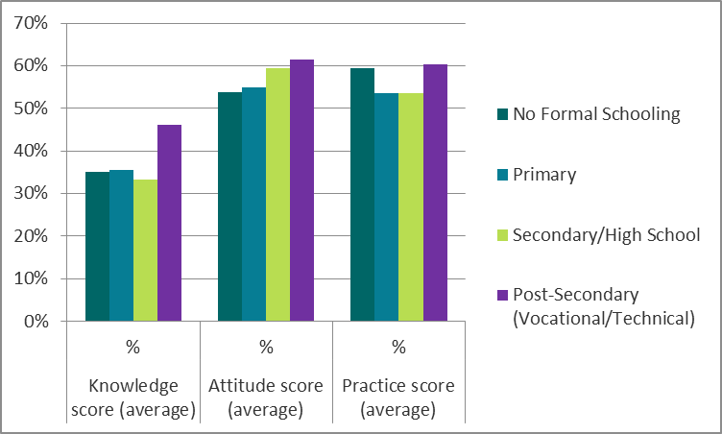 | 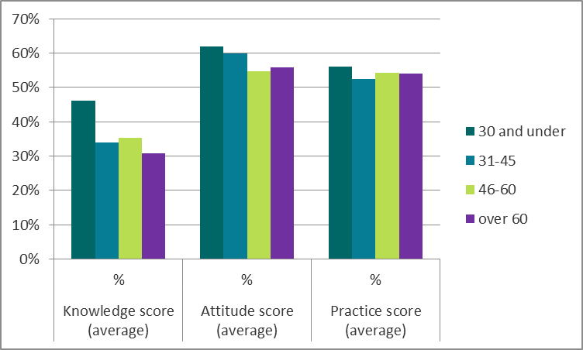
Figure 20: Relationship between level of schooling and average KAP scores (n=156) | Figure 21: Relationship between age and average KAP scores (n=158)
Age arose as a factor to consider in designing and implementing communications activities during the Regional Planning Workshop in April 2018. Stakeholders at that workshop suggested that young fisherfolk, being more tech savvy, had more capacity to acquire information on climate change than older fisherfolk. They also observed that young fishers exhibited openness to embrace best practices (e.g., practices for safety at sea) more so than their older counterparts. Our data suggest that young fisherfolk (30 years old and less) are more knowledgeable about climate change than older cohorts; this group’s average practice score is also slightly higher. Younger cohorts (30 and under, 31-45) also exhibit positive attitudes at slightly higher rates than fisherfolk over 45. Notwithstanding some of the observed patterns in the data, of 5 socio-demographic variables tested separately – age, level of schooling, fisher registration, employment status (full or part time fishing) and number of years fishing – none showed statistically-significant associations with levels of knowledge, attitude or practice.
Additional Chi-square and Pearson correlation tests revealed statistically-significant associations between the variables shown in Table 24. Three findings are worth noting and factoring into the design and implementation of our communications and stakeholder engagement strategy.
 | Understanding of CC | Awareness of gendered nature of CC | Personal concern about CC | Composite practice score
Length of time spent fishing in a community |  | χ2 (8 )= 17.46, p= 0.02645
Understanding of CC |  | χ2 (4 )= 19.87, p= 0.0005 | χ2 (4)= 18.68, p= 0.002
Personal concern about CC |  | χ2 (4 )= 15.40, p= 0.0015
Composite knowledge score |  |  | χ2 (2)= 9.19,  p= 0.0115 | Correlation coefficient=0.373  p= < 0.0001
Composite attitude score |  |  |  | Correlation coefficient=0.352  p= < 0.0001
Composite practice score | χ2 (2)= 13.71,  p= 0.002 | χ2 (2)= 11.09, p= 0.004 | χ2 (2)= 6.42,  p= 0.0345
Table 24: Statistically-significant associations between categorical variables and correlation coefficients corresponding to interval variables
First, awareness that there are differences in how men and women are affected by climate change is influenced by fishing experience as well as understanding of, concern about and practices regarding climate change. This does not mean that fisherfolk sampled agree with or are pursuing actions toward gender equality but it does suggest an openness to accept that women and men in the fisheries sector face differentiated vulnerabilities to climate change and may respond in diverse ways (for example, due to differences in risk perception, Smith, 2018).
Second, attitudes about climate change, including levels of personal concern about impacts on the fisheries sector, are malleable in that they can be influenced by acquiring climate change knowledge and adopting desirable behaviours (from a preparedness and adaptive perspective). There is abundant literature on gaps between stated attitudes and behaviour, and whether attitudinal changes are a pre-requisite for changes in behaviour (e.g., Chaiklin 2011), which we are considering in the design of the communications and stakeholder engagement strategy.
Third, there is an intimate relationship between attitudes and practice but this relationship is complex, activating both internal (e.g., beliefs, upbringing, identity, access to information) and external (e.g., social norms) factors. One strategy that has emerged in scholarship on climate change communications is linking attitudes and behaviour through shared values (see Crompton and Lennon 2018). Raising awareness of climate change and promoting effective climate actions are a typical response to narrow the gap between perceptions and actions (e.g., Wei et al. 2014, in the case of health professionals). Baptiste (2018) studied factors driving climate change perceptions and behaviours among fishers in Jamaica and that research emphasized knowledge as a key driver for attitudes and behaviour. Baptiste also discussed the connection between lived experience (e.g., of negative environmental effects) and propensity to change behaviour.

Managers
Table 25 is a summary of 9 indicators we considered in this research. This section of the report presents findings on each. Because of the low response rate for this target group our approach is to identify broad patterns of potential importance for project activities instead of emphasizing quantitative aspects of the analysis. Throughout this section we refer to indicator values from this table by including the reference number in bolded brackets [#].
REF | Summary indicators | Definition | Unit | Managers
 |  |  |  | Total
 | Sample size | Convenience sample, compiled database of managers [Managers] | n | 112
 | Response rate | Percentage of completed and partially completed surveys or interviews | % | 24%
13 | Average knowledge score | Average knowledge score of respondents
13a | On climate change |  | % | 63
13b | On climate change impacts / responses |  | % | 42
13c | On current action |  | % | 56
13d | Composite score |  | % | 53
14 | Level of knowledge score | Composite knowledge score at the midpoint of the distribution of scores (median value) | % | 53
15 | Average attitude score | Average attitude score of respondents
15a | On urgency & importance |  | % | 76
15b | On roles & responsibilities |  | % | 59
15c | On levels of capacity relative to risk |  | % | 83
15d | Composite score |  | % | 73
16 | Level of positive attitude | Composite attitude score at the midpoint of the distribution of scores (median value) | % | 79
17 | Average practice score | Average practice score of respondents
17a | On adaptation & DRR |  | % | 70
17b | On use of information |  | % | 60
17c | Composite score |  | % | 65
18 | Level of desired practice | Composite practice score at the midpoint of the distribution of scores (median value) | % | 66
19 | Perceived impact of climate hazards | Average significance score of respondents (5 = very significant impacts observed)
 | Hurricanes/storms |  | score /5 | 3.9
 | Coastal flooding |  | score /5 | 3.6
 | Coastal erosion |  | score /5 | 3.9
 | Changes in ocean currents |  | score /5 | 3.1
 | Coral bleaching |  | score /5 | 3.6
 | Invasive species |  | score /5 | 3.5
 | Fish migration |  | score /5 | 3.5
20 | Perceived importance of options to reduce climate change impacts in the fisheries sector | Average importance score of respondents
 | Fish Aggregating Devices (FADS) |  | score /5 | 3.2
 | Aquaculture (including mariculture) |  | score /5 | 4.4
 | Promote different fishing methods |  | score /5 | 4.6
 | Target different species |  | score /5 | 4.0
 | Value-added processing |  | score /5 | 4.3
 | Improved marketing (including different species) |  | score /5 | 4.1
 | Protect assets from extreme weather |  | score /5 | 4.7
 | Early warning systems |  | score /5 | 4.6
 | Education and awareness campaigns |  | score /5 | 4.8
 | Integrate climate change risk in management plans |  | score /5 | 4.6
 | Increasing uptake of insurance |  | score /5 | 4.3
21 | Best ways to provide climate change information to fisherfolk | Communication methods selected by 50% or more of respondents |  | Short videos 75%; Jingle 69%; Lectures / workshops 63%; Posters 50%
Table 25: Summary indicators on climate change knowledge-attitudes-practice (KAP), perceived impacts and feasibility of responses and communications for managerial-level respondents to online surveys

Climate change knowledge
According to our analytical framework, managers have an average composite climate change knowledge score of 53% [13d]; the median composite score is also 53% [14]. By looking at average scores for underlying indicators we observed that managers are more knowledgeable about the causes of climate change [13a] and current government actions that could boost resilience [13c] than they are of climate-related impacts on fisheries and responses [13b]. The proportion of respondents achieving low and high average scores related to current government actions is almost evenly split. Conversely, levels of knowledge of climate change and its causes and of climate-related impacts, including gender-differences in vulnerability, are not as even. More than half of respondents received an average score on understanding of climate change and its causes toward the high end of the range; conversely, only about a quarter of respondents received score toward the high end of the range on understanding of climate-related impacts.
In describing the term “climate change” managers tended to highlight the temporal dimension of the problem, its anthropogenic link and examples of physical and biological changes. Descriptions ranged in level of detail provided. Table 26 includes examples of respondents’ explanations.
Managers
Time
- Any change/deviation from the normal weather conditions over a long-term/ observation period
- Change in climate over a period of time
- This refers to the differences that presently occur in climatic conditions as compared to previous times in the past. For example having more intense dry periods now as opposed to past years
Greenhouse gas emissions
- Change in global climate patterns due mainly to increased carbon dioxide levels from use of fossil fuels
- Changes to atmosphere and ocean due to increased carbon
- A change in climate patterns either local, regional and global due to the increased levels of carbon dioxide in the atmosphere and produced by the use of fossil fuels
- Change in climate patterns over time attributed to the use of fossil fuels
Causal pathways
- Change in climate over a period of time: increase temperatures, sea level rise, destruction of ozone layer, more intense storms and drought, which result in emergencies
- The long term change in weather /climate mostly caused by anthropogenic effects resulting in the increased warming of the earth’s temperature. These increased temperatures have resulting in increased sea levels, more extreme weather variations and other long term effects
- Climate change is a consequence of human activities leading to CO₂ concentrations increasing into the atmosphere and increasing temperature and decreasing pH in oceans. Those physical and chemical parameters negatively affect aquatic organisms. Sea levels are also increasing. All those aspects have consequences on the food security for human and animals
Table 26: Examples of managers’ responses to the question “Please explain what you understand by the term climate change?”
We asked managers about the main causes of climate change and the responses of about three quarters of respondents were accurate (17 of 22). The rest either attributed climate change to natural occurrences, a creator (God) or broader socio-economic phenomena like globalization or industrialization.
We examined managers’ understanding of climate change impacts by reviewing their examples of (1) consequences to the fisheries sector from climate hazards and (2) key climate change-related messages to highlight to small-scale fishers. The strongest examples of consequences to the fisheries sector from climate hazards were ones that actually built on the climate hazards we listed to observed or potential consequences to the sector, such as “damage to fishing vessels, equipment and docking facilities by storms or severe weather”, “invasive species of fish and weeds that affect fish catch” and “traditional species are migrating because of warmer temperatures and coral bleaching”. About half of the respondents gave such examples (10 of 22). The weakest examples were overly generic (e.g., “negative economic impacts”) or repetition of climate hazards listed as part of the question.
Managers’ responses to our question on key climate-change related messages to highlight to small-scale fishers suggest a good level of knowledge on how to make the case for adaptation to fisherfolk, through framing as an economic / livelihoods issue and by sharing action-driven messages (Table 27). Responses also suggest low levels of understanding among some respondents on how climate change impacts and adaptation differ from broader issues of environmental degradation.
Managers
Shared responsibility  - Climate change is everybody's business -less fish, less catch, less money  - Climate change is inevitable - everyone has a part to play | Ecosystem-livelihood links  - The importance of coral reef health to fisheries
Responsible development and fishing  - Land based pollution will affect fish population -i.e., fisherman's income  - Economic importance of sustainable fishing  - Stop pollution  - Adopt good agricultural practices  - Reduce over fishing  - Pollution is destroying the fisheries habitat  - Change the way they do business | Adaptation imperative and action  - The need to adapt, re-organize and be resilient to climate change impacts  - The sharing of information to the sector that shows overwhelming evidence that climate is changing  - Build resilience and implement adaptations  - Invest to protect livelihood, boats and gear  - Work with your fisherfolk organization to make climate change-related issues such as shoreline protection, adjustments to physical fisheries infrastructure, and adjustments to fishing operations (change of boats, fishing grounds, use of renewable energy, fisher insurance) an election issue
Livelihood impacts
- Livelihood impact - how climate can impact income and providing for your family
- Damage to equipment and investments
- Climate change is changing your catch
- Show the impacts and effect on livelihoods and primary production
Table 27: Examples of managers’ responses to the question “What do you think are three key climate-change related messages to highlight to small-scale fishers in the country / countries where you work?”
Just as we did for fisherfolk, we explored managers’ knowledge of gender-differentiated vulnerability to climate change. A majority of respondents (72% or 16 of 22) either are not sure about gender-based differences or left the question unanswered. Responses indicate some awareness of different roles between men and women in the fish value chain (e.g., “Fish vendors are predominantly female and very important to the sales from fishers. They are also often boat owners.”).

Climate change attitudes
Managers have a composite average climate change attitude score of 73% [15d] and a median composite score of 77% [16]. In examining average values for underlying indicators we observe that managers’ attitudes toward problem awareness [15a] and capacity levels relative to risk [15c] are more positive than they are for shared responsibility for action [15b]. The proportion of respondents registering positive attitudes toward recognizing climate change as a key threat to fisheries are almost evenly split between the low and high end of the range. Respondents have a high regard for confidence in ability to act, with a strong majority of respondents achieving scores toward the high end of the range. Attitudes are least positive when it comes to recognizing that action on climate change is an issue of shared responsibility.
Information in Table 28 and Table 29 provides underlying context on attitudes toward climate change as a key threat. Managerial respondents to the online surveys see climate change as the top problem facing the fisheries sector, on par with pollution. Concerning stated levels of concern about the impacts of climate change, the majority of respondents (83% or 15 of 18) are “very concerned”. These results are not surprising given the self-selection bias demonstrated by managers in responding voluntarily to this survey (i.e., managers who responded are likely to feel strongly about climate change issues to be begin with).
Problems facing the fisheries sector |  | Total
 |  | Average score
 | Climate change | 4.8
 | Pollution | 4.8
 | Depleted stocks of marine species | 4.5
 | Habitat loss or destruction | 4.3
 | Increased input and labour costs | 4.3
 | Invasive species | 4.2
 | Conflicting uses of marine and coastal resources | 4.2
 | Changes in consumer preferences | 4.1
 | Bycatch | 4.0
 | Conflicting regulations | 3.9
 | Disease | 3.8
Table 28: Distribution of managerial-level responses to the question “what do you think are the most serious problems facing the fisheries sector today?” (n=10)
Concern about the impacts of climate change |  | Total
 |  | Count | Column N %
 | Very concerned | 15 | 83%
 | Somewhat concerned | 3 | 17%
 | Unconcerned | 0 | 0%
 | N | 18 | 100%
Table 29: Distribution of managerial-level responses to the question “How concerned are you about the impacts climate change?” (n=18)
Managers see a range of stakeholders as having responsibility for addressing climate change. The perception exists among some that government has the main responsibility for acting: 16 of 18 respondents registered this view (Table 30). When asked to rate levels of responsibility by stakeholder, managers allocated an almost equivalent level of responsibility to fisheries officers, policymakers and fisherfolk, on average (Table 31).

Main responsibility for addressing climate change in the fisheries sector |  | Total
 |  | Count | Column N %
 | Government | 16 | 89%
 | Community organizations | 10 | 56%
 | Private sector | 9 | 50%
 | Citizens | 6 | 33%
 | Industrialized countries | 6 | 33%
 | Everyone | 5 | 28%
 | International NGOs | 3 | 17%
 | N | 18
Table 30: Distribution of managerial-level responses to the question “Who do you think is mainly responsible for addressing climate change in the fisheries sector?” (n=18)

Responsibility for addressing climate change |  | Total
 |  | Average score
 | Fisheries officers | 4.1
 | Policymakers | 4.1
 | Fisherfolk (i.e., fishers, fish vendors) | 4.0
 | Fisheries NGOs CBOs | 3.8
 | Fish processors | 3.7
 | Tourism stakeholders | 3.5
 | N | 18
Table 31: Distribution of managerial-level responses to the question “How much responsibility would you say these groups have in addressing climate change impacts in the fisheries sector?” 1=minor responsibility; 5=major responsibility (n=18)
We asked managers about their satisfaction with the steps being taken to address climate change impacts on the fisheries sector in the country / countries where they work. Their responses revealed relatively high levels of satisfaction. Although no respondents expressed they were “very satisfied”, 14 of 18 (about three quarters of respondents) were “satisfied” or “neutral”. One respondent was “very dissatisfied” and provided a detailed explanation for why: “it appears that climate change is a secondary issue and very little work is being done on the ground to combat climate change, both in terms of ensuring there is a high degree of resilience and habitats are not further degraded, but also in terms of putting in measures to combat the already apparent effects of climate. There also needs to be more emphasis placed on tracking the effects at a local level so that management of its effects can be adapted to the local/ community level situation”.

Climate change practice
Managers have a composite average climate change practice score of 65% [17c] and a composite median score of 66% [18]. In assessing average values of underlying indicators we observe that managers report behaviours that are helpful in adapting to climate change more often than not, including integrating climate change into strategic and operational decisions [17a] and accessing climate information from reliable sources [17b]. The proportion of respondents registering desirable practices related to adaptation and disaster risk reduction (DRR) is almost equally distributed between high and low ends of the range, with a slightly greater proportion of respondents achieving a high score. Concerning use of climate change information, a majority of respondents achieved low scores.
We explored adaptation and DRR by asking respondents to relate actions people in the fisheries sector were undertaking to deal with climate change, to tell us about their current practice in incorporating climate change into strategic or operational decisions and to recommend strategies and operational measures to reduce the impacts of climate change on the fisheries sector. The strongest responses were those suggesting that a portfolio of actions were being taken, from improving fisheries management (gear, training in sustainable practices), to diversifying livelihoods and operations and improving risk communication across the value chain. Seven in ten respondents claim to integrate climate change in their decisions. Further, seven in ten recommend strategies and measures that specifically address climate risk. Some of those same respondents recommend strategies to reduce non-climate stressors. A minority recommend generic practices or GHG mitigation measures. Table 32 contains examples of respondents’ recommendations on future actions.
Managers
Resource management & conservation policy instruments  - Ease fishing pressure & create seasonal 'No-Take' zones  - Preserve coastal areas / more sustainable development  - Develop storm water/ breakwater management practices  - Build sustainable infrastructures to reduce run-off waste  - Manage water quality and reef protection  - Habitat restoration of coastal ecosystems  - Increased law support in upholding fish / wildlife laws  - Strengthen coastal fish landing and processing facilities | Fishing regulatory instruments  - More stringent enforcement capacity with adequate funding  - Proper enforcement on fishery regulations  - Implementation of size restrictions for reef fish  - Enforceable requirements to utilize larger mesh size  - Smart gears and techniques  - Change in catch technique and gear
Market-based instruments  - Insurance coverage for vessels and equipment  - Financing mechanisms  - Value chain improvements | Information, education and communication  - Change in the culture and dependency on reef fishery  - Training on alternative species or use of marine resources  - Public education targeting consumers as the market is driven by their preference for size and species  - Increased risk communication - information sharing and how it impacts livelihood  - Increased early warning system for fishers  - Increased resource valuation methods to better communicate the importance of affected ecosystems to everyday lives  - Public awareness and fisher education
Institutional change and advocacy
- Incorporating climate change into all project designs
- Lobbying the government
- Improving enforcement of legislation and fast tracking of the fisheries bill
- Resilience planning
- Development of a National CC Policy and Plan
GHG mitigation and pollution abatement
- Retrofit factories to achieve cleaner emissions
- Cleaner emission from vehicles
- No slash and burn to clear farm land
- No burning of waste
Table 32: Examples of managers’ responses to the question “what strategies and operational measures do you think should be considered to reduce the impacts of climate change on the fisheries sector in the country / countries where you work?”
Mangers consult a range of sources to get information related to climate change. We asked managers to identify sources they used, as a close-ended question. We only received 10 responses to this question. About a third of respondents (3 of 10) indicated they turned to CRFM and the Caribbean Community Climate Change Centre (5Cs), among others. All but one respondent report consulting more than one source of information on climate change. Overall, websites, academic literature and government / NGO reports are the top three sources selected by respondents.

Perspectives on impacts and viable responses
We asked managers about the adverse effect to the sector of climate-related hazards [19]. Summary results are in Figure 22. Managers rate hurricanes / storms, coral bleaching, coastal erosion and invasive species as hazards that have caused most significant impact in the countries where they work. Perspectives on ocean acidification are diverse; it received ratings at all levels of the scale and in almost equal proportions. The high level of impact registered for coral bleaching is influenced by the extent of Jamaican representation in the sample.
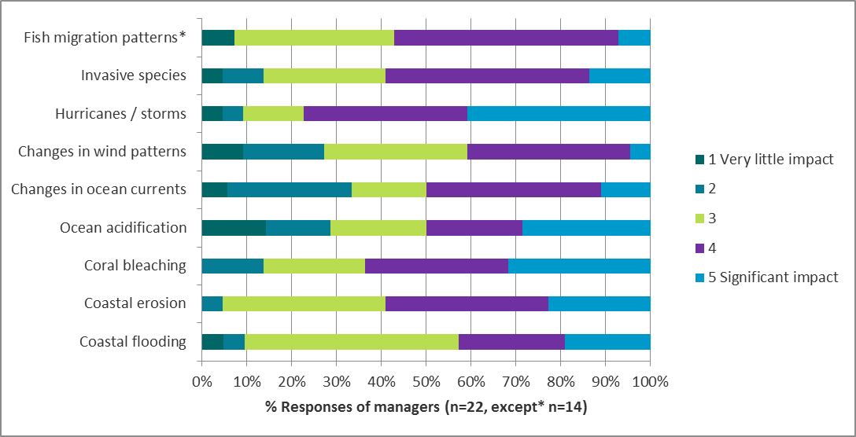
Figure 22: Responses provided by managers to the question “how much would you say the following changes have negatively affected the fisheries sector in the country / countries where you work? (Rate on a scale of 1 to 5; 1=no impact...5=extreme impact)”
We also asked managers about their personal level of concern over climate-change related threats to the fisheries sector. Summary results are in Figure 23. The response rate on this question was low so caution is warranted in drawing inferences. Managers are somewhat to very concerned about 5 of the 13 listed threats. These threats span ecological (biodiversity, habitat), social (food security, health) and economic (harvesting income) domains. Managers are least concerned about the increased presence of migrant fishers, business interruption and the disruption of critical services – all secondary or indirect threats from climate change.
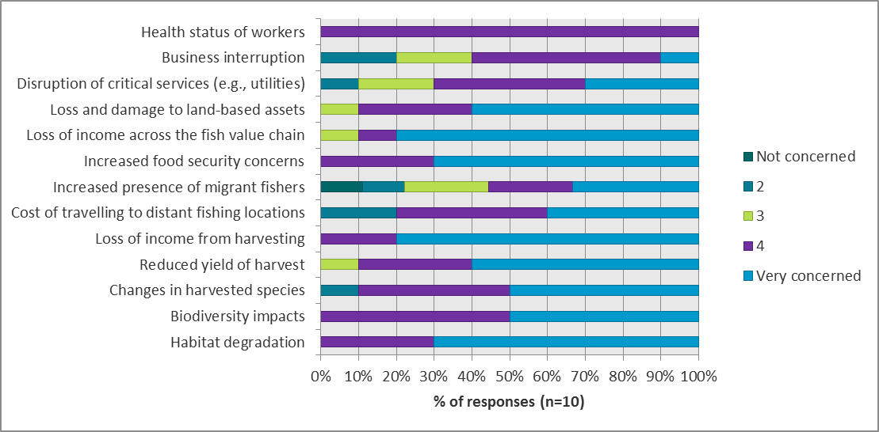
Figure 23: Responses provided by managers to the question “what is your personal level of concern about the following climate change-related threats to the fisheries sector? (Rate on a scale of 1 to 5; 1=not concerned; 5=very concerned)”
With respect to the perceived importance of a range of adaptation options for the fisheries sector [20] education and awareness campaigns as well as protection of assets from extreme weather received the highest average scores (Table 33). Promoting different fishing methods, early warning systems and integration of climate change into management plans were next in importance and seen as equally so. The least important option, according to average scores, was the use of FADs. This was the option considered most feasible by fisherfolk in our sample.
Perceived importance of options to reduce climate change impacts in the fisheries sector | Unit | Total
Education and awareness campaigns | score /5 | 4.8
Protect assets from extreme weather | score /5 | 4.7
Promote different fishing methods | score /5 | 4.6
Early warning systems | score /5 | 4.6
Integrate climate change risk in management plans | score /5 | 4.6
Aquaculture (including mariculture) | score /5 | 4.4
Value-added processing | score /5 | 4.3
Increasing uptake of insurance | score /5 | 4.3
Improved marketing (including different species) | score /5 | 4.1
Target different species | score /5 | 4.0
Fish Aggregating Devices (FADS) | score /5 | 3.2
Table 33: Summary responses by managers to the question “how important do you think the following options will be in reducing climate change impacts in the fisheries sector over the next 10 years? (Rate on a scale of 1 to 5; 1=not at all important; 5= extremely important)”
Finally, we asked managers to identify the most significant challenges their organization faces in addressing climate change (Figure 24). The top three challenges respondents noted relate to capacity: the cost of adapting (the implication being it’s too expensive for them to adapt), insufficient staff resources and technical capacity. Managers did not register opposition from stakeholders or the public or lack of organizational leadership as challenges to action, indicating good potential to move forward if other structural (e.g., legal mandate, political will) and capacity-related assets are in place. Except for one respondent, managers do not see the lack of information on climate change (e.g., temperature trends, outputs of climate models) as a challenge to acting. Information gaps may lie in evidence that links climate change to biophysical and socio-economic shifts; half of the respondents identified lack of climate impact information as a challenge.
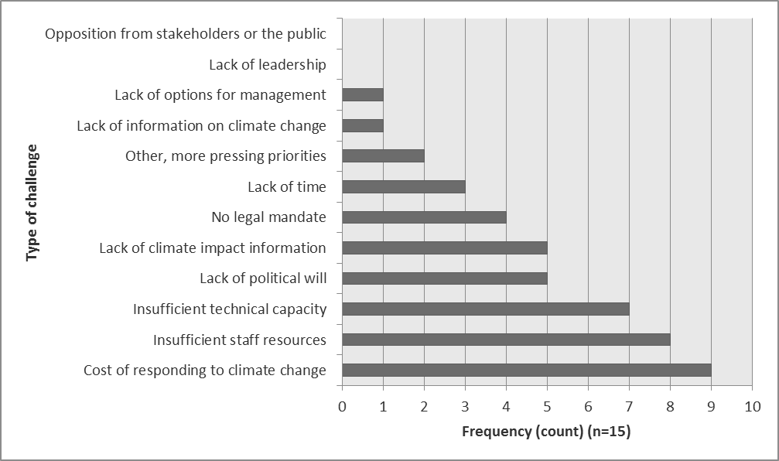
Figure 24: Responses provided by managers to the question “what challenges does your organization face in addressing climate change?”

Perspectives on communications with fisherfolk
Most managers’ organizations play roles in outreach to fisherfolk or directly engage with fisherfolk. Therefore, to build on their communications experience, we asked respondents about the most effective way of providing climate change information to fisherfolk (Table 34) [21]. Overall, managers in our sample see short videos as most effective, with three quarters of respondents (75% or 12 of 16) marking this option. Jingles and face-to-face engagement through lectures and workshops follow in frequency, with over half of respondents marking these options. Half of the respondents see posters are the most effective format. As was the case with fisherfolk, artistic expression and faith-based organizations rate poorly as effective vehicles for climate change communications with fisherfolk.
Most effective ways of providing climate change information to fisherfolk |  | Total
 |  | Count | Column N %
 | Short videos | 12 | 75%
 | Jingle | 11 | 69%
 | Lectures / workshops | 10 | 63%
 | Posters | 8 | 50%
 | Pamphlets / brochures | 5 | 31%
 | Faith-based organization | 4 | 25%
 | Songs | 3 | 19%
 | Poetry | 1 | 6%
 | N | 16
Table 34: Summary responses to the question “what are the best formats for providing information about climate change to fisherfolk in the country / countries where you work?” (n=16)
Further, we asked managers about the most effective media for communications with fisherfolk and word of mouth clearly stood out (Table 35). Radio and community meetings / workshops were next in frequency with over 60% (9 of 15) or more of respondents selecting these options. A minority of managers selected communications via text messages and newspaper as most effective media.
Most effective media to communicate with fisherfolk |  | Total
 |  | Count | Column N %
 | Word of mouth | 14 | 93%
 | Radio | 13 | 87%
 | Community meetings or workshops | 9 | 60%
 | Television | 7 | 47%
 | Social media (e.g., Facebook, Instagram) | 4 | 27%
 | Newspaper | 2 | 13%
 | Text messaging | 1 | 7%
 | N | 15 | 100%
Table 35: Summary responses to the question “what to you think are the most effective ways of communicating with fisherfolk in the country / countries where you work?” (n=15)

Policy Actors
Table 36 is a summary of 6 indicators we considered in this research. This section of the report presents findings on each. These findings stem from in-depth interviews with 4 senior-level representatives of the Caribbean Fisheries Forum and are indicative of the views of this target stakeholder group. Throughout this section we refer to indicator values from this table by including the reference number in bolded brackets [#].
REF | Summary indicators | Definition | Unit | Policy actors
 | Sample size | All members of the CRFM Ministerial Council and Caribbean Fisheries Forum of the 6 PPCR countries | n | 12
 | Response rate | Percentage of completed and partially completed surveys or interviews | % | 33%
22 | Knowledge areas | Qualitative summary of responses to related questions
 | On climate change |  | Qual | Definitions of climate change focus on long term changes in weather patterns and resulting effects. The cause of climate change is attributed to GHG emissions by human activities, with one exception.
 | On climate change impacts / responses
23 | Attitude areas | Qualitative summary of responses to related questions
 | On roles & responsibilities |  | Qual | Unanimous in seeing adaptation as a responsibility shared by all stakeholders. Confidence in ability to act or improve the situation dampened by gaps in capacity ($, human resources), scientific understanding, monitoring and ability to detect CC signal as well as implementation of specific measures.
 | On levels of capacity relative to risk
24 | Practice areas | Qualitative summary of responses to related questions
 | On adaptation & DRR |  | Qual | Climate change is starting to be “mainstreamed” into fisheries and aquaculture policy. Enabling tools include adaptation plans. Responsible fishing, diversification and fisher involvement in monitoring are desired practices. The expectation is to use PPCR project information as inputs to education, project finance and measuring adaptation effectiveness.
 | On use of information
25 | Perceived impact of climate hazards | Average significance score of respondents (5 = very significant impacts observed)
 | Hurricanes/storms |  | score /5 | 4.0
 | Coastal flooding |  | score /5 | 3.3
 | Coastal erosion |  | score /5 | 3.5
 | Changes in ocean currents |  | score /5 | 2.7
 | Coral bleaching |  | score /5 | 3.3
 | Invasive species |  | score /5 | 3.3
 | Fish migration |  | score /5 | 2.7
26 | Best ways to provide climate change information to fisherfolk | Communication methods selected by 50% or more of respondents |  | Lectures / workshops; Radio; Posters
27 | Preferred agencies to involve in climate change awareness campaign | Top 3 most frequently mentioned type of agency |  | Fisheries Cooperatives; Tourism Operators; ENV/SD**
Qual=qualitative **ENV/SD=Ministries, departments and agencies with a mandate for environment and / or sustainable development. Government Fisheries Department or Units were taken as a given.
Table 36: Summary indicators on climate change knowledge-attitudes-practice (KAP), perceived impacts and communications issues analyzed from interviews with policy actors

Climate Change Knowledge, Attitudes and Practice
When asked to describe the term “climate change” all respondents answered accurately, although the level of detail of their responses varied. The simplest response equated climate change to the effect of global warming and the most detailed response referred to long-term changes in weather patterns and their effects. Responses to a question on the causes of climate change were also accurate, with the exception of one respondent who continued to mention the effects instead of focusing on human activities and greenhouse gas emissions [22].
Attitudes [23] on roles and responsibilities to address climate change were shared across respondents, with a consensus view that all stakeholders played important roles. Even so, the recognition exists of the coordination or catalytic role of government. One respondent asserted that “while government has a lead role, it needs to be supported by all other stakeholders”.
Respondents exhibit a moderate level of satisfaction with the steps being taken to address climate change impacts in the fisheries sector. Reasons for this include the following:
- Gaps in project management capacity and the ability to maximize benefits flowing from regional projects
- Lack of scientific information, which is a barrier to turning uncertainty (on what to adapt to and where) into an assessment of risk
- Until recently most large adaptation projects focused on land-based sectors and problems
- Even in cases where risk and types of responses are clear, low policy and advocacy capacity slows down action
Organizational challenges in addressing fisheries adaptation stated by respondents often related to capacity (financial, human resources, implementation and research). Table 37 below highlights examples of specific organizational challenges mentioned by policy actors, many of which are common to adaptation progress generally and not unique to adaptation in the fisheries sector in the Caribbean.
Lack of awareness | - There’s not sufficient recognition of climate change and its multiple impacts and risks
Insufficient staff resources and technical skills | - The biggest challenge is human resources. Climate change is a new area for the fisheries staff.  - We need more training and an infusion of new persons with appropriate training.
Lack of detailed information on climate change and its impacts | - We need relevant, accurate data to be able to request funding that is earmarked for climate change projects. One of the greatest challenges is making the distinction between anthropogenic versus natural causes of impacts.  - Lack of detailed information that can guide us to make informed decisions.
No legal / institutional mandate | - Climate change is not adequately mainstreamed in government, so there are a lot of gaps.  - Implementation of adaptation has been slow and sporadic
Table 37: Examples of policy actors’ responses to the question “What is your organization’s greatest challenge in addressing climate change related to fisheries?”
We further asked respondents about gaps / challenges in fisheries adaptation that were not being addressed. From the perspective of policy actors we interviewed challenges that are either unaddressed or inadequately addressed include awareness of fisherfolk, lack of specificity of policy and management tools and weaknesses in status and trend and effectiveness monitoring. Table 38 highlights respondents’ ideas on solutions to address these challenges.
Gaps not being addressed | Ideas on solutions
The need to increase fishers’ awareness of climate change, its impacts and adaptation measures | - Improving effectiveness and efficiency of communication and transmission of messages. Time is a real challenge.
Policies do not speak specifically to climate change and therefore do not address practical processes to mitigate or adapt to climate change | - Devising practical solutions and standard arrangements, including thresholds and delineation of at-risk zones to guide wise decisions  - Creating financial incentives for fishers to mitigate the risk of disaster upfront rather than wait to respond to the destruction caused by the disaster (traditional approach). Switching to proactive strategies
Research and monitoring to understand the impacts of climate change on habitat and stocks and track migration of fished species | - Establishing partnerships (e.g., with academia) as an alternative way of financing research programs for fisheries management  - Strengthening institutions and ongoing staff training to improve monitoring and evaluation (M&E) capacity
We are implementing adaptation measures but have limited ways of understanding their impact / effectiveness | - Putting M&E systems in place  - Improving capture of baseline information about what is happening, as a way to inform planning  - Engaging fishers in supporting monitoring so as to build on their local knowledge of their environment
Table 38: Examples of policy actors’ responses to the question “What are some of the gaps/ issues around climate change and fisheries that are not being addressed (adequately)?”
With respect to practices [24], all countries reported fisheries legislation and regulations that can enable adaptation, although the degree to which these instruments specifically address climate change varies. National climate change policies and sector-specific adaptation plans are also referenced and all countries represented in the sample have these. Potential measures to reduce risk and future impacts of climate change in the sector highlighted by respondents include the following:
- Boosting research, monitoring, information and knowledge management systems, on a partnered basis
- Using the knowledge and science base to devise models that illustrate management thresholds and triggers
- Retraining fishers in safety at sea techniques to cope with rougher seas and unpredictable weather
- Climate-proofing fisheries infrastructure, vessels and equipment used for fishing
- Increasing penetration of (property) insurance among fishers
- The 30+ measures in St. Lucia’s sector-specific adaptation plan
Respondents offered a number of suggestions on things fishers could do to reduce the impacts of climate change on their communities. Responses clustered in five themes: (1) responsible fishing, (2) organization (e.g., fishing cooperatives), (3) diversification (of species, methods), (4) optimization and improving value added and (5) informing authorities.
With regard to the potential use of information resulting from this project, respondents see the benefit of having access to up-to-date assessment information, but clarity on how to use the information in fisheries management is critically important.

Perspectives on impacts
We asked policy actors about the adverse effect to the sector of climate-related hazards [25]. Summary results are in Figure 25. Respondents rated hurricanes / storms as the hazards that have caused most significant impact in their countries. Patterns across respondents are less clear for other climate-related hazards since the summary results capture perspectives from four individuals from four different countries. For example, fish migration is an issue perceived as having caused very little to little impact AND significant impact. With their responses, policy actors expressed most uncertainty about the effect of gradual changes (ocean acidification, changes in wind patterns and ocean currents).
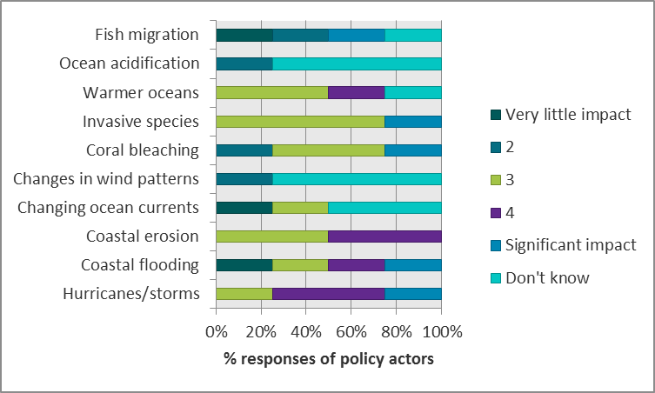
Figure 25: Responses provided by managers to the question “on a scale of 1 to 5, how much would you say the following climate hazards have negatively affected your community / fishing area?” (n=157)

Perspectives on communications with fisherfolk
According to policy actors, face-to-face engagement (workshops, town halls) and radio are the best ways to reach fisherfolk to provide information on climate change [26]. For it to be effective face-to-face engagement and training needs to “meet fisherfolk where they are”, not be too formal and ensure fisherfolk get sufficient airtime to be able to fully express themselves. Radio use can be effective but messages need to be specific and embedded in shows that fishers like. Printed materials, like posters and pamphlets, received some mention as effective formats as well, while cautioning on the need to take literacy constraints into account.
Key climate change messages to communicate to small-scale fishers offered by policy actors include the following:
- Climate change impacts and GHG mitigation / adaptation affect them financially through their livelihoods
- Irresponsible fishing, overfishing exacerbates the impacts of climate change and that protecting species means protecting their livelihood
- Ask them to report unusual currents, color of sea water, temperature at the time fish are caught, coral bleaching events, Sargassum influxes and fish kills
- Fishers are a rich source of information. Capacity building should be paired with collection of traditional / local knowledge
Aside from government Fisheries Units, agencies to involve in climate change awareness campaign [27] include fisheries complexes / cooperatives, tourism stakeholders (hoteliers, dive associations, sports fishery operators) and government stakeholders responsible for land and watershed management or with the overall mandate for climate change.

Key Findings and Recommendations
This section provides key findings in the context of study objectives, conclusions and recommendations for project communications.

Key findings
Knowledge, attitudes and practice
The KAP study identified strengths and weaknesses in knowledge of climate change.
Fisherfolk in Montego Bay (Jamaica), Roseau (Dominica) and Kingstown (Saint Vincent and the Grenadines) were more knowledgeable about impacts of, and responses to climate change on fisheries than they were of either the causes of climate change and government actions that could boost resilience.
- About a third of fisherfolk related examples of climate change impacts on fisheries consistent with impact pathways in scientific and technical studies on the issue, such as changes in fish stocks due to changes in water temperatures and fish migrating to deeper waters. Fisherfolk are observing environmental changes and in some cases can link physical / climatic changes to biological (fish) and socio-economic impact.
- About half of fisherfolk could not accurately define the term climate change, when asked.
- In Montego Bay, when asked about the main causes of climate change, fisherfolk provided responses primarily linking human development to negative environmental impacts but only one fisher (out of 40) correctly identified the cause of anthropogenic climate change. Low levels of fisherfolk awareness of the causes of climate change emphasize the importance of linking messages on adaptation and greenhouse gas mitigation.
- Fisherfolk have some awareness of actions to take to build adaptive or coping capacity, particularly when dealing with severe weather. In describing actions fishers could take to deal with climate change impacts (Montego Bay) and the impact of hurricanes (Roseau and Kingstown), information, communication & education as well as preparedness (early warnings and awareness, in particular) were strategies mentioned by both groups.
- Awareness of the gendered nature of climate change vulnerability is low. A majority of fisherfolk (114 of 158) either did not see differences in climate change effects on male and female fisherfolk or did not know whether there were differences. It is worth noting that because our main research effort focused on harvesters, the views of female fisherfolk are largely missing in this KAP study (outside of what was related indirectly). Statistical analysis of survey results suggests that awareness of differences in how men and women are affected by climate change is influenced by fishing experience as well as understanding of, personal concern about and practices regarding climate change.
- Overall, the biggest weakness in knowledge is around actions government is taking to improve fisheries livelihoods. At least three quarters of respondents either did know what governments were doing or asserted that governments are doing nothing. The other quarter of respondents mentioned initiatives like safety-at-sea training, implementation of FADs, construction of a building for seafood marketing, compensation after Hurricane Maria and small business loans.
Compared to fisherfolk, managers and policy actors had a good technical appreciation of the causes and definitions associated with climate change. Three quarters of managers and of policy actors provided accurate explanations of the causes of climate change. Managers showed an appreciation of the temporal dimension of the problem as well as physical and biological impacts of relevance to fisheries.
Managers’ responses to our question on key climate-change related messages to highlight to small-scale fishers suggested a good level of knowledge on how to make the case for adaptation to fisherfolk, through framing as an economic / livelihoods issue and by sharing action-driven messages on shared responsibility, responsible fishing, livelihood impacts and connections to ecosystem resilience, among others.
In their responses, fisherfolk and managers alike sometimes conflated climate change impacts and broader issues of environmental degradation (e.g., improper waste disposal, ozone depletion, agricultural runoff).
Climate change attitudes differed between fisherfolk and managers / policy actors, as shown by the following key findings. However, results require careful interpretation. Measuring levels of satisfaction with action on climate change is complex because each respondent (and each affinity group of respondents) will have their own knowledge and mental model of the risks faced, relevant actions to address the risks and the effectiveness of these actions. One specific example is the question used to gauge respondents’ level of satisfaction with the steps being taken to address climate change impacts in the fisheries sector. This type of question requires respondents to know about the status of climate action and contemplate the relative effectiveness of the action relative to climate risk, which they would also need to understand. The key informant interviews with policy actors were beneficial in this sense because we were able to tease out why this group was moderately satisfied.
- Fisherfolks’ attitudes on climate change as a key threat are mixed. Overall, fisherfolk did not identify climate change as among the most serious problem fisherfolk are confronting today. Amongst seven possible factors that could be considered “serious problems facing the fisheries sector” climate change did not rank in the top three in any of the fishing areas (5th in Jamaica, 6th in SVG and 4th in Dominica). Fuel price was the top concern in all cases, which was not surprising as it was reported to account for more than half of operational costs on average. At the same time, 78%, 52% and 64% of fishers from Montego Bay, Kingstown and Roseau, respectively, stated they were “very concerned” about the impacts of climate change.
- Managers, in contrast to fisherfolk, generally saw climate change as the number one threat facing the fisheries sector, on par with pollution. 83% of managers stated they were “very concerned” about the impacts of climate change.
- Fisherfolk tend to have a defeatist attitude about what can be done. Limited evidence suggests that some fisherfolk have awareness of what to do to prepare for extreme events yet also express sentiments such as “nothing can be done”.
- Fisherfolk also tend to ascribe greater responsibility for addressing climate change impacts to external actors: industrialized countries, government officials and policymakers and the tourism sector. In their survey responses managers indicated that the main responsibility for addressing climate change lies with the government. In contrast, policy actors felt that all stakeholders played important roles.
- Fisherfolk expressed low levels of satisfaction with steps being taken to address climate change impacts in the fisheries sector. A quarter of fisherfolk (of 40) from Montego Bay were “dissatisfied” with how climate change was being addressed; half either did not answer the question or stated they did not know. In Kingstown and Roseau, fisherfolk indicated that (informal) social safety nets were most important in shaping their capacity/ability to cope with natural hazards. Over half of respondents (77 of 121) claimed no one had reached out to help them after the recent storm hit and about half (69 of 120) would find it difficult or very difficult to get extra cash to pay for damages and losses after a storm.
- Compared to fisherfolk, managers across the region had higher levels of satisfaction about measures being taken to address climate change impacts in the sector. About three quarters of managers were “satisfied” with actions being taken.
- Policy actors expressed moderate levels of satisfaction with fisheries-sector action on climate change impacts, highlighting the following reasons behind this assessment: (1) gaps in project management capacity and the ability to maximize benefits flowing from regional projects; (2) a lack of scientific information, which is a barrier to turning uncertainty (on what to adapt to and where) into an assessment of risk; (3) the focus of large adaptation projects on land-based sectors until recently; (4) low policy and advocacy capacity as a barrier to action even in cases where risk and types of responses were clear.
Fisherfolk and managers reported behaviours and practices that are helpful in adapting to climate change and managing disaster risks. Policy actors related accomplishments in establishing an enabling environment for adaptation and demonstrated clarity in policy and management directions.
- Fisherfolk across the three study sites reported actions they or their community were taking that build capacity to adapt to climate risk. There were lower levels of community action reported in relation to climate change adaptation (Montego Bay) compared to emergency/storm preparedness (Roseau and Kingstown). We surmise that fisherfolk are more aware / clearer on actions to take to address rapid-onset events as opposed to longer-term, gradual changes in climate and biophysical conditions. Nevertheless, there is room for improvement in increasing the uptake of measures to manage rapid-onset events since fisherfolk from Roseau and Kingstown reported low adoption of measures to reduce disaster risk. Levels of training in DRR and penetration of home and property insurance are particularly low.
- Managers reported behaviours that are helpful in adapting to climate change more often than not, including integrating climate change into strategic and operational decisions and accessing climate information from reliable sources.
- Managers also provided a number of ideas on strategies and operational measures that should be considered to reduce the impacts of climate change on the fisheries sector in the country / countries where they work. Suggestions covered the gamut of policy tools including resource management & conservation policy instruments; fishing regulatory instruments; market-based instruments; institutional change and advocacy; and information, education and communication. GHG mitigation and pollution abatement were also mentioned.
- Policy actors asserted that climate change was starting to be “mainstreamed” into fisheries and aquaculture policy and that enabling tools include adaptation plans (or instruments specifically designed to manage climate change risk). Responsible fishing, diversification and fisher involvement in monitoring are desired practices. On this last point, policy actors acknowledged that fisherfolk are rich sources of local knowledge.
- Regarding the use of climate information, fishers showed openness to climate change education and outreach. They registered a strong interest in receiving more information about climate change impact, with almost all fisherfolk (91% or 147 of 161) responded positively when asked this question. Fisherfolk preferred to rely on official sources of information (e.g., government issued warnings transmitted via radio, television or online). Policy actors have clear expectations on the intended uses of information from this PPCR Project: inputs to education, project finance and measuring adaptation effectiveness.
Perceived impact of climate hazards and of the relevance and feasibility of options to reduce climate change impacts in the fisheries sector
- Climate-hazard perception varied among fisherfolk by site, with Montego Bay fishers placing more importance on coral bleaching and coastal erosion (being in a carbonate dominated marine production area) compared to fisherfolk from Kingstown and Roseau, who generally reported hurricanes/storms, coastal flooding and coastal erosion as the most significant impacts on communities and fishing areas. Overall, slower-onset changes that require closer monitoring (e.g., invasive species; fish migration; changing currents) are not perceived to have significant impact.
- Similarly, managers reported fish migration, changes in wind and ocean patterns, and invasive species as of lower concern than hurricanes/storms, coral bleaching, ocean acidification, coastal erosion and flooding. Policy actors also expressed most uncertainty about the effect of gradual changes (ocean acidification, changes in wind patterns and ocean currents). This is not surprising since slow-onset changes, by definition, can only be detected over the long term and require sustained monitoring.
- All fisherfolk scored FADs the highest in terms of feasible adaptation options, which is in stark contrast to the rank given by the managers (lowest rated). Other highly-scored options given by fisherfolk included improved marketing, promotion of different fishing methods and improved post-harvest management. Managers rated education campaigns as well protection of assets from extreme weather with the highest average scores. Perceptions on the relative importance of adaptation options are complementary. Fisherfolk are concerned about specific technologies and assets they can use to adapt to climate change as individuals and managers may be thinking about generic and specific strategies and tactics that support adaptation at the systems-level (see Figure 26).
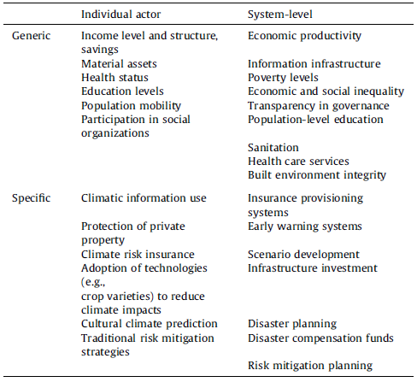
Figure 26: Examples of different manifestations of (adaptive) capacity at two organizational levels (Source: Eakin et al. 2014)
Perceived challenges in addressing climate change issues related to fisheries
- Policy actors and managers offered perspectives on challenges to making progress on adaptation. These included capacity gaps (e.g., management, knowledge, weaknesses in advocacy / the quality of participation in policy development), the cost of adapting (the implication being that it is too expensive for them to adapt) and other institutional challenges, such as a lack of specificity in their policy instruments and limited ability to monitor the effectiveness of adaptation actions.
- Further, we asked policy actors about challenges that are either unaddressed or inadequately addressed and they highlighted awareness of fisherfolk, lack of specificity of policy and management tools and weaknesses in status and trend and effectiveness monitoring.
Climate change communications
- The survey confirmed that fisherfolk generally agreed that government (e.g., government ministries, environmental agencies and fisheries departments) should be involved in climate change communications. Although the role of government is clearly prominent, other key partners in information dissemination to fisherfolk include fishing cooperatives / complexes and tourism operators.
- Fishers and policy actors alike regard face-to-face engagement (e.g., workshop/lectures) as the best way to provide climate change information to fisherfolk. Printed media (posters, pamphlets/ brochures) follow in frequency. This is in contrast to the preferred communication strategy of managers, who see short videos as most effective, followed by jingles, face-to-face communications and posters. Managers did agree that word-of-mouth was the most effective means of communications with fisherfolk.
- Information on ownership and use of smartphones suggests this channel (e.g., use of Whatsapp or text messages) would be an effective way to disseminate climate change information to fisherfolk in the region. However, smartphone ownership does differ across the region, which is an important consideration in communications planning. In Montego Bay 83% of the respondents reported owning smartphones; in Kingstown and Roseau less than half of the respondents reported owning smartphones.

Conclusions and Recommendations
Table 39 presents recommendations stemming from our consideration of KAP study results. Not all recommendations can be addressed through Project communication activities, in light of time and resources available. We identify recommendations in scope of our work program with an asterisk.
Conclusion | Recommendation | Description
Fisherfolk are observing changes in environmental conditions that are affecting fishing livelihoods. Policy actors highlight the importance of tapping into fisherfolks’ local knowledge in support of the sector’s adaptation. Lack of monitoring data is a challenge in making adaptation progress. | Engage fisherfolk in “citizen science” to boost the region’s monitoring capacity on climate change impacts and effectiveness of adaptation measures | In the short term, assess the potential to equip a few selected fisherfolk with instruments (e.g., thermometer) and training to report key conditions observed while at sea, such as unusual currents, color of sea water, temperature at the time fish are caught, coral bleaching events, Sargassum influxes and fish kills.
 |  | **In the longer term, design a monitoring program that engages a network of trained fisherfolk and leverages partnerships (e.g., with academia) as alternative ways of financing research and monitoring for fisheries management. Monitoring indicators should be regionally relevant and nationally-applicable, with sampling and data collection techniques attuned to capacities
Fisherfolk lack understanding of the causes of global climate change. Without this understanding the role of GHG mitigation is downplayed, as are fisherfolks’ roles as part of the solution | Increase understanding of the global scientific basis for climate change and of the connections between GHG mitigation and adaptation responses | *Integrate messages on the causes of anthropogenic climate change alongside messages on climate change impacts and the role of adaptation and GHG mitigation
 |  | *Infuse messages about individual’s “power to act” on climate change in communications
 |  | *Develop information, education and communication (IEC) material for use by managers for engaging with fisherfolk
Stakeholders can conflate environmental degradation and climate change issues | Clarify the relationship between environmental degradation and vulnerability to climate change impacts | *This conflation between environmental degradation and climate change is an opportunity to draw attention to “non-climate stressors” in IEC materials. Use familiar “non-climate stressors” (coastal pollution, overfishing, unplanned coastal development) to illustrate ways they can exacerbate vulnerability to climate change.
 |  | *In IEC materials drawing attention to key linkages across sectors. In Montego Bay, for example, fisherfolk relate a deep concern about the impacts of (tourism sector) development on their fisheries livelihoods.
Responses to climate change impacts are being developed in PPCR countries and initiatives to support livelihoods of fishers are in place but awareness of these efforts among fisherfolk appears low. | Build on success stories, mini-case studies of local, national and regional strategies and actions to build climate resilience across the fisheries sector. | *Engage trusted intermediaries in delivering information to fisherfolk on government action to support climate resilience. Trusted intermediaries include fishing organizations, cooperatives, grassroots organizations and tourism operators. Any (electronic) IEC materials should be made available to this group of stakeholders for further dissemination.
 |  | *Coordinate outreach and communications activities and products with regional and national PPCR focal points, leveraging success stories and lessons from across the region.
KAP study results for fisherfolk do not incorporate the perspectives of female fishers. | Ensure communications activities and products are gender aware. | *Understand gender dynamics in Caribbean fisheries from secondary sources, including relative roles across the fish value chain and differences in risk perception.
 |  | *Make special provisions for equitable (1) participation of males and females in communication activities and (2) access to project outputs. For example, in testing communications messages in focus group discussions ensure diversity in representation and lead separate all-male and all-female discussions to uncover differences in framings, examples and imagery that could work best.
In understanding how to work collaboratively toward climate-smart fisheries, stakeholders could benefit from an understanding of some of the best practices and lessons in overcoming capacity and institutional barriers. | Showcase a diversity of practices and lessons from across the region and Small Island Developing States in other global regions. | **Compile good practices and lessons learned on climate adaptation of fisheries in SIDS and make these available on the Project database, taking care not to duplicate efforts of the Caribbean Community Climate Change Centre.
 |  | *Showcase lived experiences from stakeholders at all levels in IEC materials, such as brochures and video documentaries.
 |  | *Explore the development of IEC materials aimed at improving the capacity for advocacy among management, planning and policy professionals.
Climate change is not the most serious problem fisherfolk are confronting today. | Ensure information on climate change and adaptation strategies offer familiar messages & imagery and connect to today’s issues of concern | *Develop communication strategies with familiar messages and imagery so as to develop recognizable links between the realities of fisherfolk and fishing communities and the awareness campaign.
 |  | *Build on the key climate-change related messages for small-scale fishers that managers suggested in the KAP study. For example, “climate change is everybody's business -less fish, less catch, less money.”
 |  | Climate-smart adaptation options put forward in IEC materials and other Project activities should build on current practice and options perceived as feasible and / or important, as indicated in the KAP study.
Extreme weather events are more salient to fisherfolk and other stakeholders than gradual changes in climate conditions and related fisheries impacts. | Increase awareness of the short-term AND long-term implications of climate change impacts for the Caribbean fisheries sector | *Centre climate change communication on practical solutions that correspond with the current needs of fisherfolk in the region and are flexible within how these solutions can respond to climate change (i.e., avoid maladaptive practices).
 |  | *Integrate the message that climate change is a long-term problem as a key message in communication and media campaign.
 |  | *Integrate messages on the uncertainty of climate change projections and the importance of sustained monitoring, and of flexibility and adaptability in the long-term measures selected.
The KAP study showed that respondents were interested in having posters and short videos to help raise awareness of climate change issues and inspire action. | Ensure the communication campaign integrates both static visuals and multi-media products, and includes a mixed dissemination strategy. | Develop posters and thematic brochures. Develop a video documentary.
The KAP study also provided information on the best approaches to reach fisherfolk (face-to-face engagement, via smartphone). |  | Because of timing and budget constraints, face-to-face engagement with fisherfolk will not be possible on a large scale, which clarifies our role in producing communication packages and toolkits for others to use.  Outreach to fisherfolk can be through (1) social media and direct appeal via Whatsapp or text messaged and (2) intermediaries, such as fisheries extension officers, fishing cooperatives / complexes and tourism operators.
Table 39: Recommendation matrix (* = feasibility of implementation as part of the Project’s communication activities; **= possible contributions under other Project Work Packages)

References
Baptiste, A.K. 2018. Climate change knowledge, concerns, and behaviors among Caribbean fishers. J Environ Stud Sci (2018) 8:51–62.
Belize Environmental Technologies [BET]. (Nd). Knowledge, Attitude and Practice Survey Consultancy for the Belize Marine Conservation and Climate Adaptation Project. Prepared for the Belize Fisheries Department.
Beltran, C.S (2017). Annex III: “Results and analysis of cost structure in fishing operations in CRFM Member States and FAO-GEF/REBYC-II LAC Project participating countries. Study: “Impacts of rising cost factors in fishing operations in the CRFM Member States”.
Caribbean Regional Fisheries Mechanism [CRFM]. (2012). Diagnostic Study to Determine Poverty Levels in CARICOM Fishing Communities - Policy Document. CRFM Technical & Advisory Document, Number 2012 / 3, Volume II. 25p.
Chaiklin, H. (2011). "Attitudes, Behavior, and Social Practice," The Journal of Sociology & Social Welfare: Vol. 38 : Iss. 1 , Article 3. Available at: https://scholarworks.wmich.edu/jssw/vol38/iss1/3
Crompton, T. and Lennon, S. (2018). Values as a Route to Widening Public Concern About Climate Change. In W. Leal Filho et al. (eds.), Handbook of Climate Change Communication: Vol. 1, Climate Change Management, https://doi.org/10.1007/978-3-319-69838-0_21
Kemper, EA.; Stringfield, S.; Teddlie, C. (2003). Mixed methods sampling strategies in social science research. In: Tashakkori, A.; Teddlie, C., editors. Handbook of mixed methods in the social and behavioral sciences. Sage; Thousand Oaks, CA: 2003. p. 273-296.
Palinkas, L., Horowitz, S.M., Green, C.A., Wisdom, J.P., Duan, N. and Hoagwood, K. (2015). Purposeful sampling for qualitative data collection and analysis in mixed method implementation research. Adm Policy Ment Health. 2015 September ; 42(5): 533–544. doi:10.1007/s10488-013-0528-y
Smith, R-A (2018). Risk perception and adaptive responses to climate change and climatic variability in northeastern St. Vincent. J Environ Stud Sci (2018) 8:73–85.
Wei, J. et al. (2014). Perception, attitude and behavior in relation to climate change: A survey among CDC health professionals in Shanxi province, China. Environmental Research, Volume 134, October 2014, Pages 301-308.
Wieber, F., Thürmer, J.L. and Gollwitzer, P.M. (2015). Promoting the translation of intentions into action by implementation intentions: behavioral effects and physiological correlates. Front. Hum. Neurosci., 14 July 2015 | https://doi.org/10.3389/fnhum.2015.00395

Annex 1: Agenda for training of field assessors
- Introduction and project overview

- Methodology, expectations and compensation
- Research strategy
- Role of the interviewer
- Compensation

- Ethical considerations
- Consent
- Confidentiality
- Anonymity
- Respect

- Good practices when conducting interview
- Familiarize yourself with the questionnaire
- Do not begin the interview with personal questions
- The interview should be conversational in nature
- Ensure that the respondent feels relaxed
- Ensure that the respondent understands the question
- Legibility of hand writing
- Pay attention to different types of questions (e.g., multiple response, open-ended)
- Encourage the respondent to completes all questions

- Understanding the questionnaire items

- Role-play exercise (mock interview)

- Questions/comments about the process

Estimated time: 1.5 to 2 hours

Annex 2: Data collection instruments
To be inserted

Annex 3: Additional information on fisherfolk activities

Days at sea / week - low season |  | Montego Bay (JAM) |  | Kingstown (SVG) |  | Roseau (DOM) |  | Total
 |  | Count | Column N % | Count | Column N % | Count | Column N % | Count | Column N %
 | 1-2 days | 21 | 52.5% | 13 | 21.7% | 10 | 16.4% | 44 | 27.3%
 | 3-4 days | 14 | 35.0% | 28 | 46.7% | 26 | 42.6% | 68 | 42.2%
 | 5-6 days | 2 | 5.0% | 19 | 31.7% | 14 | 23.0% | 35 | 21.7%
 | 7 days | 1 | 2.5% | 0 | 0.0% | 11 | 18.0% | 12 | 7.5%
 | N/A | 2 | 5.0% | 0 | 0.0% | 0 | 0.0% | 2 | 1.2%
 | Total | 40 | 100.0% | 60 | 100.0% | 61 | 100.0% | 161 | 100.0%

Days at sea / week - high season |  | Montego Bay (JAM) |  | Kingstown (SVG) |  | Roseau (DOM) |  | Total
 |  | Count | Column N % | Count | Column N % | Count | Column N % | Count | Column N %
 | 1-2 days | 0 | 0.0% | 1 | 1.7% | 5 | 8.2% | 6 | 3.7%
 | 3-4 days | 5 | 12.5% | 13 | 21.7% | 14 | 23.0% | 32 | 19.9%
 | 5-6 days | 22 | 55.0% | 11 | 18.3% | 25 | 41.0% | 58 | 36.0%
 | 7 days | 9 | 22.5% | 35 | 58.3% | 16 | 26.2% | 60 | 37.3%
 | N/A | 4 | 10.0% | 0 | 0.0% | 1 | 1.6% | 5 | 3.1%
 | Total | 40 | 100.0% | 60 | 100.0% | 61 | 100.0% | 161 | 100.0%

Time of day for fishing |  | Montego Bay (JAM) |  | Kingstown (SVG) |  | Roseau (DOM) |  | Total
 |  | Count | Column N % | Count | Column N % | Count | Column N % | Count | Column N %
 | Day | 23 | 57.5% | 36 | 60.0% | 29 | 47.5% | 88 | 54.7%
 | Night | 3 | 7.5% | 1 | 1.7% | 1 | 1.6% | 5 | 3.1%
 | Both | 5 | 12.5% | 21 | 35.0% | 20 | 32.8% | 46 | 28.6%
 | N/A | 9 | 22.5% | 2 | 3.3% | 11 | 18.0% | 22 | 13.7%
 | Total | 40 | 100.0% | 60 | 100.0% | 61 | 100.0% | 161 | 100.0%

Fishing methods used |  | Montego Bay (JAM) |  |  |  | Kingstown (SVG) |  |  | Roseau (DOM) |  |  | Total
 |  | Count |  | Column N % |  | Count |  | Column N % | Count | Column N % |  | Count | Column N %
 | Hook and line | 33 |  | 82.5% |  | 56 |  | 93.3% | 56 | 91.8% |  | 145 | 90%
 | Nets | 8 |  | 20.0% |  | 2 |  | 3.3% | 11 | 18.0% |  | 21 | 13.0%
 | Spear gun | 9 |  | 22.5% |  | 1 |  | 1.7% | 3 | 4.9% |  | 13 | 8.1%
 | Fish pots | 27 |  | 67.5% |  | 1 |  | 1.7% | 21 | 34.4% |  | 49 | 30.4%
 | Total (n) | 40 |  |  |  | 60 |  |  | 61 |  |  | 161
Who fish is sold to |  |  | Montego Bay (JAM) |  |  |  | Kingstown (SVG) |  | Roseau (DOM) |  |  | Total
 |  |  | Count |  | Column N % |  | Count | Column N % | Count |  | Column N % | Count | Column N %
 | Fish vendors |  | 11 |  | 27.5% |  | 41 | 68.3% | 24 |  | 39.3% | 76 | 47%
 | Community members |  | 30 |  | 75.0% |  | 32 | 53.3% | 52 |  | 85.2% | 114 | 71%
 | Hotel / guesthouse |  | 5 |  | 12.5% |  | 7 | 11.7% | 7 |  | 11.5% | 19 | 12%
 | Fishing complex / coop |  |  |  |  |  | 49 | 81.7% | 11 |  | 18.0% | 60 | 37%
 | Restaurant |  | 16 |  | 40.0% |  | 6 | 10.0% | 16 |  | 26.2% | 38 | 24%
 | Total (n) |  | 40 |  |  |  | 60 |  | 61 |  |  | 161

Average expenses per fishing trip |  | Montego Bay (JAM) | Kingstown (SVG) | Roseau (DOM) | Average
 |  | EC$ | EC$ | EC$ | EC$
 | Fuel | 316 | 518 | 258 | 364
 | Ice | 25 | 24 | 38 | 29
 | Food | 43 | 32 | 33 | 36
 | Bait | 51 | 72 | 43 | 55
 | Boat rental | 35 | N/A | 50 | 43
 | Total expenses (average) | 395 | 595 | 365 | 452
 | Total expenses (min) | 32 | 40 | 20 | 31
 | Total expenses (max) | 903 | 6,370 | 1,880 | 3,051
 | Total (n) | 25 | 59 | 61 | 145

Amount of fish considered a "good" catch |  | Montego Bay (JAM) | Kingstown (SVG) | Roseau (DOM) | Average
 |  | Pounds | Pounds | Pounds | Pounds
 | Average amount | 147 | 816 | 487 | 483
 | Min amount | 40 | 120 | 15 | 58
 | Max amount | 500 | 6000 | 4000 | 3,500

Impact of Sargassum |  | Kingstown (SVG) |  | Roseau (DOM) |  | Total
 |  | Count | Column N % | Count | Column N % | Count | Column N %
 | Mostly positive | 8 | 13% | 35 | 58% | 43 | 36%
 | Mostly negative | 19 | 32% | 15 | 25% | 34 | 28%
 | Both positive & negative | 28 | 47% | 6 | 10% | 34 | 28%
 | Neutral / not affected | 5 | 8% | 4 | 7% | 9 | 8%
 | Total | 60 | 100% | 60 | 100.0% | 120 | 100%

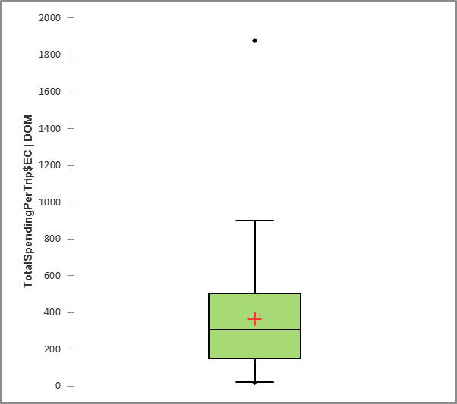 | 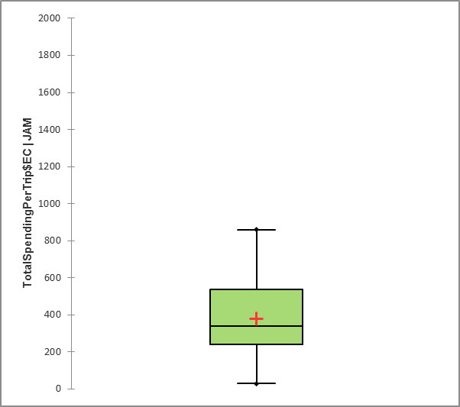
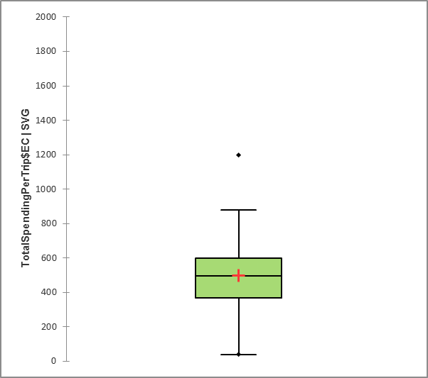
Figure 27: Boxplots showing statistics on reported total costs per trip for fisherfolk in Roseau, Montego Bay and Kingstown (n=61, 40, 60 respectively). Values are in EC$.

Caribbean countries with national PPCR initiatives are Dominica, Grenada, Haiti, Jamaica, Saint Lucia, and Saint Vincent and the Grenadines.
Members of the Working Group comprise of national representatives and representatives of the CRFM Secretariat, including alternates (A): Mr. Jullan DeFoe, Derrick Theophile (A), Mr. Crafton Isaac, Mr. Roger Charles, Ms. Anginette Murray, Ms. Allena Joseph, Mrs. Patricia Hubert Medal (A), Mr. Shamal Connell, Dr Susan Singh-Renton and Ms. June Masters (A).
Amplifiers refer to individuals, like fisheries officers, with great potential to amplify research results among their networks and constituencies.
The data collection instrument used with fisherfolk in the Eastern Caribbean used “impacts from hurricanes / storms” instead of climate change impacts.
Steps taken could be by the individual, community or government.
There can be gaps between people’ stated intentions and action but this gap is mitigated when individuals receive information or plan out implementation: when, where and how to do something (e.g., Wieber et al., 2015). In this case, it was clear that the Project team would be providing the climate change information to respondents via the communication channels they had self-identified as most effective.
Additional background on box and whisker plots, including rules for defining outliers, is available here: https://www.sfu.ca/~jackd/Stat203_2011/Wk02_1_Full.pdf
By formal training we refer to training received through Cooperatives, Government, NGOs in relation to respondent’s fishing operations.
This also served as a means of verification of completed surveys and to follow up directly with fishers if clarification is required for any response provided.

