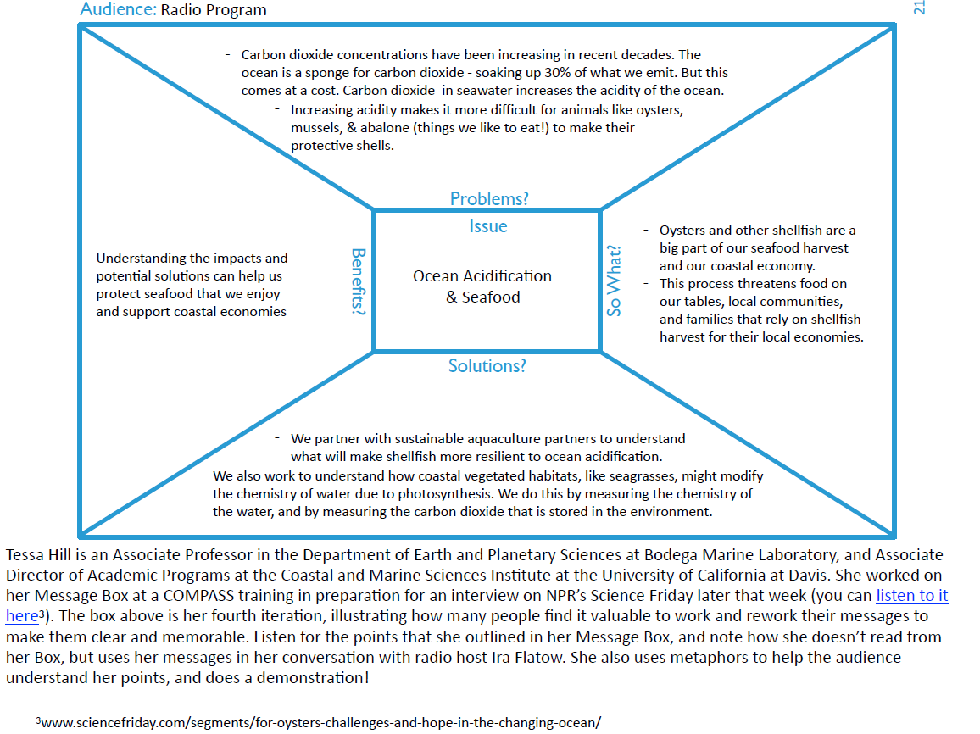
THE STORY BOX - A Worked Example from the COMPASS Story Box Workbook

