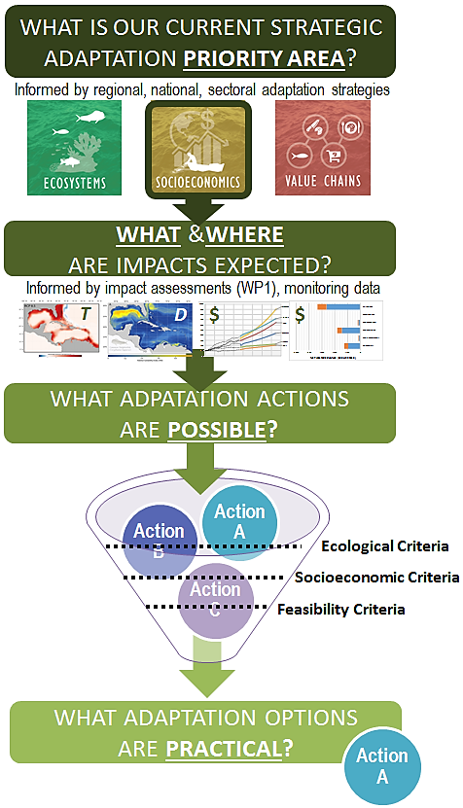
Figure 1: An illustration of the process for selecting among potential adaptation options.
Selecting Adaptation Options and Creating An Action Plan: From The Possible To The Practical

The general nature of a structured approach to adaptation planning is illustrated in Figure 1. It involves reviewing adaptation goals and objectives, selecting high-level strategic priorities that align with goals and objectives to focus the scope of action planning, considering the outcomes of prior impact / vulnerability / risk assessments and monitoring initiatives for selected strategic priorities, characterizing the set of potential adaptation actions that address those strategic priorities, and applying a set of prioritization or evaluation criteria to determine which ones are most suitable for implementation. This process can be repeated to address different focal areas for adaptation in the present and repeated when revising plans, as knowledge and conditions change in the future.

Review Adaptation Goals and Objectives
The first step in this process is to review the goals and objectives of a broader regional, national, or sectoral adaptation plan or strategy. All choices about actions to implement should be, first and foremost, governed by whether there is a realistic expectation that the action will result in an outcome that contributes to achieving a stated objective. It is perhaps surprising how often decisions are made without consideration of objectives – if such decisions result in a desirable outcome it is more due to good fortune than good planning.

Establish Strategic Priorities to Focus Adaptation Planning
Climate change will bring about many effects in the fisheries sector, but some of these may more urgent to address through adaptation than others. Examples include climate change effects that may pose immediate risks to personal safety, key sectoral infrastructure or critical marine habitats. Regional, national, or sectoral adaptation plans or strategies may include guidance on which types of climate change effects should be addressed first.

Review Current Understanding of Climate Change Effects for Focal Areas
Deciding on a course of action will depend on understanding the mechanism and magnitude of the climate change effect that is expected to occur. This step can draw on insights from other parts of this “Fishery-Related Ecological and Socio-Economic Assessments of the Impacts of Climate Change and Variability and Development of an Associated Monitoring System” project. If the expected effects are large, or changes observed to date through monitoring suggest the impact is greater than forecasted, the need for action and the scale of response will be greater. However, it is important to note that the inverse does not necessarily imply that no action is required. In some cases, places, species, or practices that are found to be more resilient may be important candidates for adaptation investments.

Identify Potential Actions to Address Focal Adaptation Needs
See the separate handout describing a range of potential adaptation options. That handout cross references adaptation options to specific climate change effects addressed, climate-smart fisheries adaptation objectives they would help to meet, and related monitoring approaches that could be implemented to increase the knowledge base around this climate effect.

Define and Apply Evaluation Criteria to Potential Adaptation Actions
In this step, the portfolio of potentially relevant adaptation options for a given effect is compared to a set of evaluation criteria to select the subset of actions with most implementation promise. This step can be carried out using a wide range of techniques, from a simple set of qualitative screening questions, to a semi-quantitative scoring framework used in Multi-Criterion Analysis (MCA), to more fully quantitative cost-benefit and physical modelling of alternative management outcomes for specific classes of actions Examples of evaluation criteria typically used in selecting among adaptation options are provided in Table 1 below. This will be the most difficult step in the process, as it depends on many factors, some of which can only be judged subjectively. While this step will be challenging, it will also be where the opportunity for creative solutions to emerge, especially ones that involve community empowerment and local ownership of the actions.

Table 1: Example criteria for prioritizing among potential climate change adaptation options
Overarching Evaluation Considerations | Evaluation Criteria | Evaluation Sub-Criteria
Conservation Goals  How well do the alternatives help achieve agreed-upon marine conservation goals and objectives? | Conservation of critical habitats supporting fisheries production | Improvement in productivity of critical habitat
 |  | Increase in total area of critical habitat
 |  | Increase in spatial protection of critical habitat
 | Biodiversity | Reduction in illegal harvests
 |  | Reduction in harvest of vulnerable species
 |  | Diversification of fisheries harvests
 | Climate change mitigation potential | Improvement of carbon storage (e.g., via marine vegetation)
 |  | Reduction of carbon emissions from the sector
Societal Goals  How well do the alternatives help achieve social, cultural, and economic goals and, or provide co-benefits to other sectors? | Equity and benefits sharing | Generation of employment
 |  | Contribution to economic diversification
 |  | Contribution to co-benefits to other economic sectors occurring in the same area (e.g., tourism)
 |  | Contribution to recovery from climate impacts
 | Safety and well-being | Reduces risks to personal safety
 |  | Improves food quality and security
 | Physical assets | Reduces risks to coastal infrastructure
Feasibility  How practicable or realistic is it to implement the each alternative? | Legal and institutional frameworks | Alignment with existing adaptation strategies
 |  | Compliance with national policy and regulations
 |  | Regulatory complexity (e.g., level of jurisdictional overlap, need for lengthy permitting or legislative reform process)
 |  | Access complexity (e.g., land ownership, access, right of way)
 | Stakeholder support | Community support
 |  | Local implementation partners
 | Capacity | Access to expertise needed for implementation
 |  | Access to sufficient personnel for implementation, enforcement, and monitoring
 | Cost | Implementation costs
 |  | Long-term operating costs
 |  | Cost-sharing opportunities
 | Implementation Risk | Data needs
 |  | Technical feasibility
 |  | Likelihood of achieving benefits
Climate-Smart Considerations  How robust are the adaptation actions themselves to climate change impacts and variability other than those they are intended to address? | Linkage to impacts and vulnerabilities | Actions linked to known impact pathways
 | Time horizons | Relevance to short-term and long-term needs
 |  | Alignment between timing of benefits and timing of anticipated climate impacts
 | Robustness to other climate impacts not targeted by the focal action | Robust to changes in the physical environment
 |  | Robust to changes in fish distribution
 |  | Robust to changes in fishing distribution
 | Robustness to uncertainty | Robust under multiple climate scenarios
 |  | Robust to variation in funding or capacity over time
 |  | Robust to changes in nearby land ownership and use

