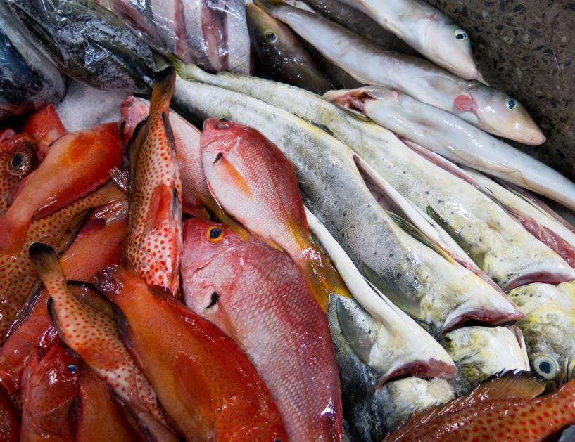

Fish for Today and Tomorrow – Video Documentary
Discussion Guide
August 2019
Produced by ESSA Technologies Ltd. for the Investment Plan for the Caribbean Regional Track of the Pilot Programme for Climate Resilience (PPCR) as part of the Fishery-Related Ecological and Socio-Economic Impact Assessments and Monitoring System Project

Acknowledgements
Production of the Fish for Today and Tomorrow video documentary and this discussion guide would not have been possible without the leadership of Ava-Gail Gardiner, Communications Specialist of the ESSA Consulting Team. The concept and execution of the video documentary benefitted from the perspectives and time invested of dozens of representatives of the Caribbean fisheries sector, from development partners to policy professionals to fisheries officers to fisherfolk. We are so grateful for your openness to engage with us and truly hope this video documentary inspires novel action to build climate resilience in the region.

PREFACE
This is the discussion guide to be used in conjunction with the video documentary ‘FISH FOR TODAY AND TOMORROW’.
This guide seeks to explore the impacts of climate change on fisheries in the Caribbean; to highlight some of the key findings of the Fishery-Related Ecological and Socio-Economic Impact Assessments and Monitoring System Project (otherwise referred to as the PPCR Regional Fisheries Project); and to promote climate action that is timely, appropriate and supported by/ anchored in science.
It is anticipated that this guide and the video documentary that it references will be used to generate lively discussions in ways that will promote heightened awareness, learning and pro-action as stakeholders across the fisheries sector confront the realities of climate change, and anticipate the future. These tools are intended to enable reflection on the contents of the video documentary in a way that enhances participants’ understanding of climate change and fisheries, which in turn will influence changes in attitudes and behaviour, including support for changes in policy and management toward climate-smart fisheries.
The guide consists of two (2) sections, which corresponds to Parts 1 and 2 of the video documentary. Most issues mentioned in this guide are addressed in the video documentary. However, a few questions raise broader concerns and may prompt further discussion and research.
Facilitators are encouraged to familiarize themselves with the extensive information that has been generated under the PPCR Regional Fisheries Project, which will be available at: http://portal.crfm.int/ as of November 2019.

Part 1

Introduction
The Narrator mentions some of the factors that are putting pressure/ affecting fisheries in the Caribbean.
Q1: What are some of these influences?
Overfishing, pollution, habitat degradation, and now the impacts of climate change…
Q2: Have any of them affected you, or your livelihood/ fishing activities?

Q3: What is “climate change”?
The Facilitator can use this opportunity to open up a discussion on “climate change.” Encourage participants to give their definitions/ explanations for climate change.
Use this opportunity to clarify the term and to debunk any myths/ misperceptions.

N.B. Refer to Powerpoint Presentation on Climate Change and Fisheries for points/ outline for a discussion.

Kingslyn Scott, the fisherman articulates his experience of going to sea over the past fifty years and his observation of how things have changed.
Q4: What do you think he means when he talks about “changes at the bottom of the sea”?
Encourage participants to articulate their thoughts/ elaborate on the changes that they are seeing or experiencing.
Q5: What signs of climate change are you seeing in the sea and coastal environment?
Science indicates a change in the patterns of ocean currents as a result of thermal expansion of seawater, additional energy in a warmer atmosphere and additional pressure on ocean beds as a result of sea level rise…
Mention/ reiterate these themes and encourage participants to share what they know of these phenomena.
Raphael Gabriel, the fisherman, mentions that climate change is destroying the coral reefs… is this entirely true?
With respect to reef degradation, you can note the connection between warmer waters and coral bleaching and coral disease and the importance of healthy reefs to sustain healthy fisheries. Reference can also be made to mass bleaching events (like the regional 2005 event) becoming more frequent. Ask participants for local data to evidence this occurrence.
Q6: What are some of the other factors (other than climate change) that are causing the degradation/ decline of reefs across the Caribbean?
Q7: What are some of the (emerging) issues that indicate that the climate is changing in the Caribbean?
To help participants to delve deeper into the issue, the Facilitator can highlight/ enumerate different ecosystems…e.g., shoreline/ beaches, mangroves, coral reefs, deep sea.

The influx of Sargassum has often been referenced as an emerging issue that some have linked to climate change, with positive and negative consequences for fisheries.
Encourage participants to share their experiences/ observations with Sargussum.
Q8: Has Sargassum been beneficial or detrimental to your activities/ enterprises?

Climate Change & the Fisheries Value Chain
This is a good place for the Facilitator to broaden the discussion, encouraging participants to start to consider the “Big Picture” impact of climate change…
Q1: How are these changes in the sea and coastal environment affecting you, or fishers in your community/ country?
It’s important for participants to be able to express not just what they see and experience but also how these phenomena make them feel. By understanding and tapping into people’s emotions it’s possible to identify levers for self-efficacy and empowerment, as well as what might motivate people to act.
Q2: How are these issues affecting other persons along the fisheries value chain?
Depending on the audience, this might be an opportunity to explain/ outline the fisheries value chain (refer to Paper D by Khan et al. in the CRFM Research Paper Collection linked to this Project). The Facilitator can choose to delve into critical issues now, or note them for later discussion.
Q3: What economic impacts are these issues having/ anticipated to have in the short, medium and long term?
Q4: What do these changes mean for the economy of your community, country, the wider Caribbean region?

“Where are the women?”
So far. we have not seen any women featured in the documentary.

Q1. Do women work in the fishing industry in your community/ country?
Q2. If so, what roles do women play in fishing? How and why are they important to the fishing industry?
Q3. Do you think climate change affects women differently from men? If so, how?
Gender is an issue that is often overlooked in fisheries. This is an opportunity for the Facilitator to encourage participants to think about the issues of gender within the fishing industry and specifically within the context of a changing climate.
N.B. It’s important for people to reflect on the kinds of inequalities across the fisheries value chain and what the implications are for vulnerability to climate change impacts and capacity to adapt.

“Where are the fish going?”
The Narrator states that fish catches are changing…
With respect to fish migration reference can be made to regional studies that show that Caribbean waters are becoming much less favourable habitat for certain key commercial species (like dolphinfish, yellow tail tuna etc.) with just a 1 degree C rise in average temperature. Fish are migrating to environments that match their preferences, generally north and into cooler waters.
Q1: What are some of the trends/ movements that are anticipated?
Q2: Some fish may move north – why?
Q3: Which species will be affected? And why are they likely to move north? What are the push/ pull factors?
Q4: Some fish may go deeper – why?
Q5: Many fish may go extinct – why?

A Different Way of Fishing
The Narrator indicates that young people are fishing differently. Hudson Toussaint, Fisher points out that fishers in the past “did the same kind of fishing using the same techniques”, but he figures that he “can do things differently”.
Q1: What do you think he means by “doing things differently”?
Q2: What are some of the things that fishers can do to make their operations more efficient, more cost-effective and/ or productive?

The video mentions Fish Aggregating Devices (FADS). A FAD is a manufactured object used to attract ocean going pelagic fish such as marlin, tuna and dolphin fish (mahi mahi). They usually consist of buoys or floats tethered to the ocean floor with concrete blocks. FADs attract fish for numerous reasons that vary by species.
Q3: Why have FADs become popular?
Depending on the audience, the Facilitator can encourage a deeper discussion about FADs…
Q4: What are the pros and cons of using a FAD?
Q5: Is it just “a fad”, i.e. a trend that will soon pass or are they here to stay? Are FADs environmentally sustainable?
Q6: Can FADs be used as a measure to adapt to climate change? And if so, how are they to be managed and integrated into a sectoral strategy?
The Facilitator can open up the conversation on the theme of “developments in fishing”, tying in new technologies. Ask the participants to give examples of new technologies and explain how they work/ how they add value to the practice of fishing…
In the video, the Narrator highlights the Fisheries Early Warning and Emergency Response system (FEWER).
Q7: What features make FEWER unique? How does FEWER add value to the practice of fishing in the (Eastern) Caribbean?
Q8: Have any of you used FEWER? How has your experience been with the App?
The Facilitator can open up the discussion on FEWER, encouraging the group to debate the pros vs cons of FEWER.
Q9: Is there room for improvement in the App? If so, how would you want to see it improved?
Q10: What are some of the strategies that you/ we can employ to ensure the sustainability of the fisheries industry in your country, and the wider Caribbean region?

- Safety at Sea
Towards the end of Part 1, Hudson Toussaint, the young Fisherman indicated purchase of gear. The Facilitator can use this as an opportunity deeper into the theme of “Safety at Sea”.
Or before showing Part 2, the Facilitator can use this juncture to explore the theme of “Safety at Sea” in depth.
Q1: What critical safety gear should be on board every fishing vessel?
Prompt audience to enumerate these items…
Q2: What additional risks do you think climate change poses for fishers?

Part 2
As the fisheries sector confronts the realities of a changing climate, we have to be more aware of the importance of comprehensive climate-smart fisheries planning, which includes adaptation to long-term changes, disaster risk mitigation and management.
Depending on the audience, the Facilitator can use the opportunity to encourage participants to share their experiences of a hurricane or other disaster caused by natural hazards…
- Risk Management
Q1: How did you fare in the storm/ hurricane?
Mention a specific storm or extreme weather event to help elicit recall of that event.
Q2: What lessons did you learn?
Q3: What would you do differently, if faced with a similar situation today?
Hudson Toussaint, the fisher raised the critical issue of the lack of access to insurance.
Q4: Is insurance widely available in your country?
Q5: Do you know of an existing solution for fishers?
If there are policy-makers in the audience, this might be an opportunity for the Facilitator to direct the discussion towards finding such a solution…See: Caribbean Catastrophe Risk Insurance Facility, https://www.ccrif.org/

Note that in July CCRIF issued the Caribbean Oceans and Aquaculture Sustainability Facility (COAST) fisheries parametric insurance policies to two of its member governments – Grenada and Saint Lucia. The COAST insurance policies provide coverage for fisherfolk and other players in the fisheries industry to enable them to recover quickly after weather-related events.
Q6: What cue can other Caribbean countries take from the COAST insurance scheme?
Jullan Dafoe, Senior Fisheries Officer enumerates the extensive loss of fishing boats and gear and of critical fisheries infrastructure in Dominica that was caused by Hurricane Maria, but he also highlights the issue of loss of livelihoods…
This is an opportunity for the Facilitator to lead participants into a deeper exploration of livelihoods and economic and social vulnerabilities of persons involved in the fisheries sector.
Where Jullan Dafoe speaks to “alternatives” (finding other sources of employment/adding value to existing product(s) as a pillar for building climate resilience)… encourage participants to explore what this means in real terms…
Referencing where Jullan Dafoe mentions Dominica’s focus on becoming the world’s first climate resilient country, the Facilitator can use the opportunity to broaden the discussion about climate-resilience… e.g., what does this mean for the reconstruction of buildings and infrastructure?
- The Importance of Data
Derrick Theophille, Fisheries Resource Assessment Officer mentions the different ways/ means fisheries data was stored, and which forms survived Hurricane Maria.
Q1: What key lessons were learnt about data management in the aftermath of Hurricane Maria?
Q2: What measures can be taken to reduce the loss of data?
In the Caribbean region, we still face significant challenges in the collection and storage of data in digital format. Here the Facilitator can prompt participants to consider what practical measures can be taken for speeding up the process of digitization…
Q3: What more can be done to improve/accelerate the process of digitizing records?
Q4: What kind of support is needed and at what level(s)?
Q5: What is the role of fisherfolk in data collection either at sea or market?
Q6: How can data collection and analysis help to influence better policy-making?

Segway to the segment of the video focused on Saint Lucia…

- Policy and Planning for Climate Change
The Facilitator can use this opportunity to discuss the importance / value of a multi-stakeholder, consultative process for planning for climate change adaptation.
Q1: What is the importance of having a National Adaptation Plan?
Q2: How does a NAP help a country to address climate change?
Q3: What is the value of sectoral adaptation plans or strategies and action plans, or SASAPs to a Caribbean country that is planning for climate change?
Q4: What are some of the key features of a SASAP for the Fisheries sector? Who should be involved in its preparation?
Q5: How can we link the fisheries sector with other key sectors – water, agriculture, tourism?
For fisheries in the Caribbean to be truly sustainable we must find a balance between protection of our marine resources, and the efficient use of these resources.
Q6: What are some of the measures you would suggest that we adopt at the community level, at the national level, and at the regional level to make our fisheries more sustainable?
The Narrator mentions integrated management of the land and sea to reduce the impact of climate change on Caribbean countries.
Q7: What do you think this means in practical terms?

Alva Lynch, Castries Fisheries Cooperative Official, highlights that his organisation is actively involved in a project to improve the quality standards at the Castries Fisheries Landing Site, and to reduce the carbon footprint of fishers.
This is a good point to lead into a general discussion about taking responsibility regarding preventing further climate change (mitigation) and taking action to reduce its impact (adaptation). Much of the discussion so far will have focused on adaptation so here the Facilitator can guide discussion on mitigation as a way to wrap up the session.
Q8: What actions can you take to reduce your carbon footprint?
The Facilitator can lead the participants to explore this theme by considering their habits/ actions in different spheres: at home, at work, in their community, in their country…

